7
Language and Regional Variation
Sociolinguistics

The Standard Language
The standard language is an idealized variety of language because it has no specific region. It is the variety associated with administrative, commercial and educational centers, regardless of region.
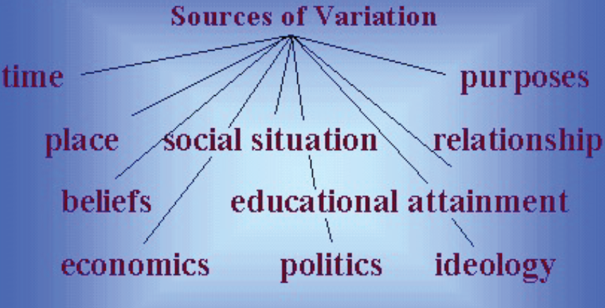

Accents & Dialects
We all speak with an accent. We might feel that some speakers have very distinct types of accent while others may have more subtle or less recognizable accents, but every language-user speaks with an accent.

The term “accent” is restricted to the description of aspects of pronunciation that identify where an individual speaker is from, regionally or socially.

The term “dialect” is used to describe features of grammar and vocabulary as well as aspects of pronunciation.

Dialectology
Dialectology is the study of dialects to distinguish between two different dialects of the same language and two different languages.

Regional Dialects
The existence of different regional dialects is widely recognized and often the source of humor for those living in different regions. Some regional dialects clearly have stereotyped pronunciation associated with them.

Isoglosses and Dialect Boundaries
Dialectologists produce a dialect map or dialect of a region, on which dialect differences are geographically plotted. The black dots mark dialect areas. But a line drawn on the map separating the areas is called Isogloss.

An isogloss represents a boundary between the areas with regard to that one particular linguistic item.

If a very similar distribution is found for another two items, such as a preference for pail to the north and bucket to the south, then another isogloss can be drawn on the map.
When a number of isoglosses come together, a solid line, indicating a dialect boundary, can be drawn.

The Dialect Continuum
It tends to obscure the fact that, at most dialect boundary areas, one dialect or language variety merges into another.

We can view regional variation as existing along a dialect continuum rather than as having sharp breaks from one region to another.
Speakers who move back and forth across this boarder area, using different varieties with some ease, may be described as bidialectal “i.e. speaking two dialects”.
NOTICE
When we talk about people knowing two distinct languages, we describe them as bilingual.

Bilingualism and Diglossia
In a bilingual country, a member of a minority group grows up in one linguistic community, mainly speaking one language (e.g. Welsh in Britain), but learns another language (e.g. English) in order to take part in the larger dominant linguistic community.
A rather special situation involving two distinct varieties of a language, called diglossia, exists in some countries. In diglossia, there is a “low” variety, acquired locally and used for everyday affairs, and a “high” variety, learned in school and used for important matters.

Language Planning
Many countries are often assumed to be monolingual “speaking one language”, e.g. United States. However, the majority of the population in Texas will be more likely to listen to radio broadcasts in Spanish.
This fact has large repercussions in terms of the organization of the government and educational system. Such organization is called language planning.

Pidgins and creoles
A pidgin is a variety of a language that developed for some particular purpose, such as trading, among groups of people who had a lot of contact, but who didn’t know each other’s languages.
A pidgin is described as “English pidgin” if English is the lexifier language, that is, the main source of words in the pidgin. Example of English pidgin:
tu buk (two books)
di gyal place (the girl’s place)

When a pidgin develops beyond its role as a trade or contact language and becomes the first language of a social community, it is described as a creole.
A creole initially develops as the first language of children growing up in a pidgin-using community and becomes more complex as it serves more communicative purposes.

The Post-Creole Continuum
Just as there was development from pidgin to creole, known as creolization, there is now often retreat from the use of the creole by those who have greater contact with a standard variety of language.
Where education and greater social prestige are associated with a “higher” variety (e.g. British English in Jamaica) a number of speakers will tend to use fewer creole forms and structures. This process is known as decreolization.
Between these two extremes may be a range of slightly different varieties, some with many and some with fewer creole features. This range of varieties, evolving after the creole has come into existence, is called the post-creole continuum.

