Lecture 1
Psycholinguistics
Overview
Psycholinguistics
Definitions
Branches and Goals
Language Processing
Language Acquisition
Neurolinguistics
Definitions:
Psychology - Linguistics-
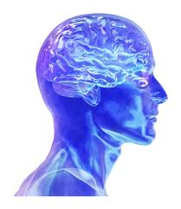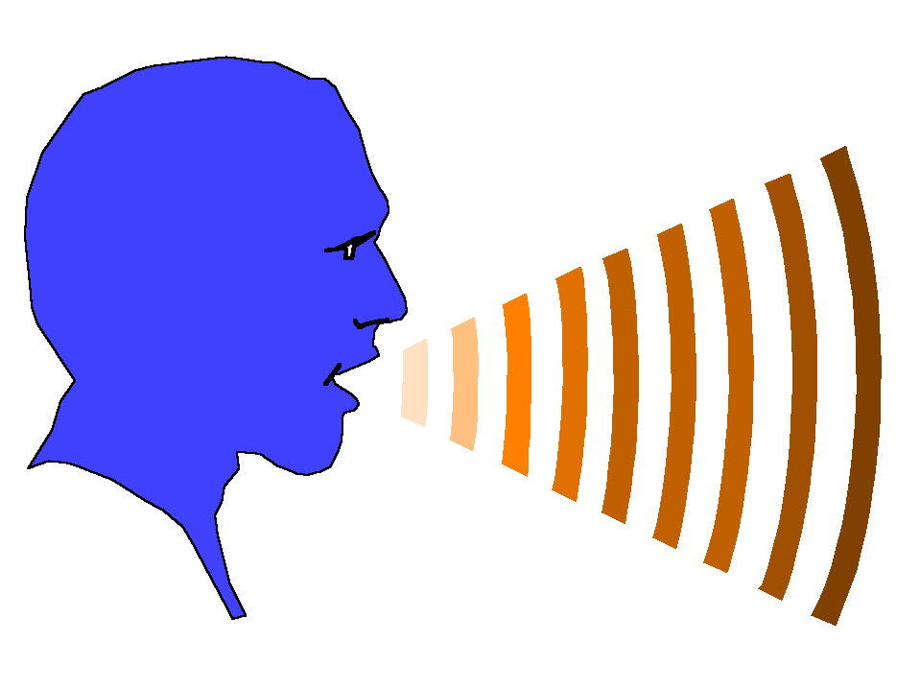

Psycholinguistics""
Linguistics:
Psycholinguistics:
1 2 3
Sociolinguistics Historical linguistics Computational Linguistics
Linguistics:
3 2 1
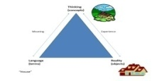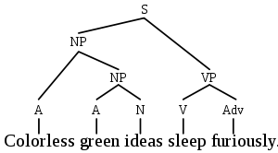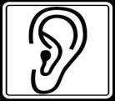
Phonetics Morphology Semantics
Phonology Syntax Pragmatics

Branches and Goals :
Language processing 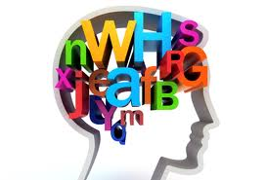1-
Language acquisition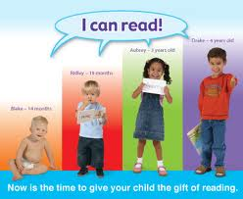2-
Neurolinguistics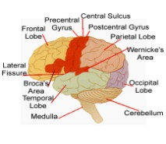3-
Language Processing: 1-
Speech production 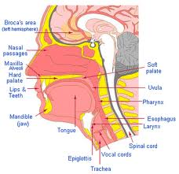A-
Comprehension 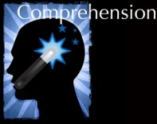B-

Language acquisition:2-
A: Acquisition studies
B: Strategies
C: Phases
Neurolinguistics:3-
The CNS 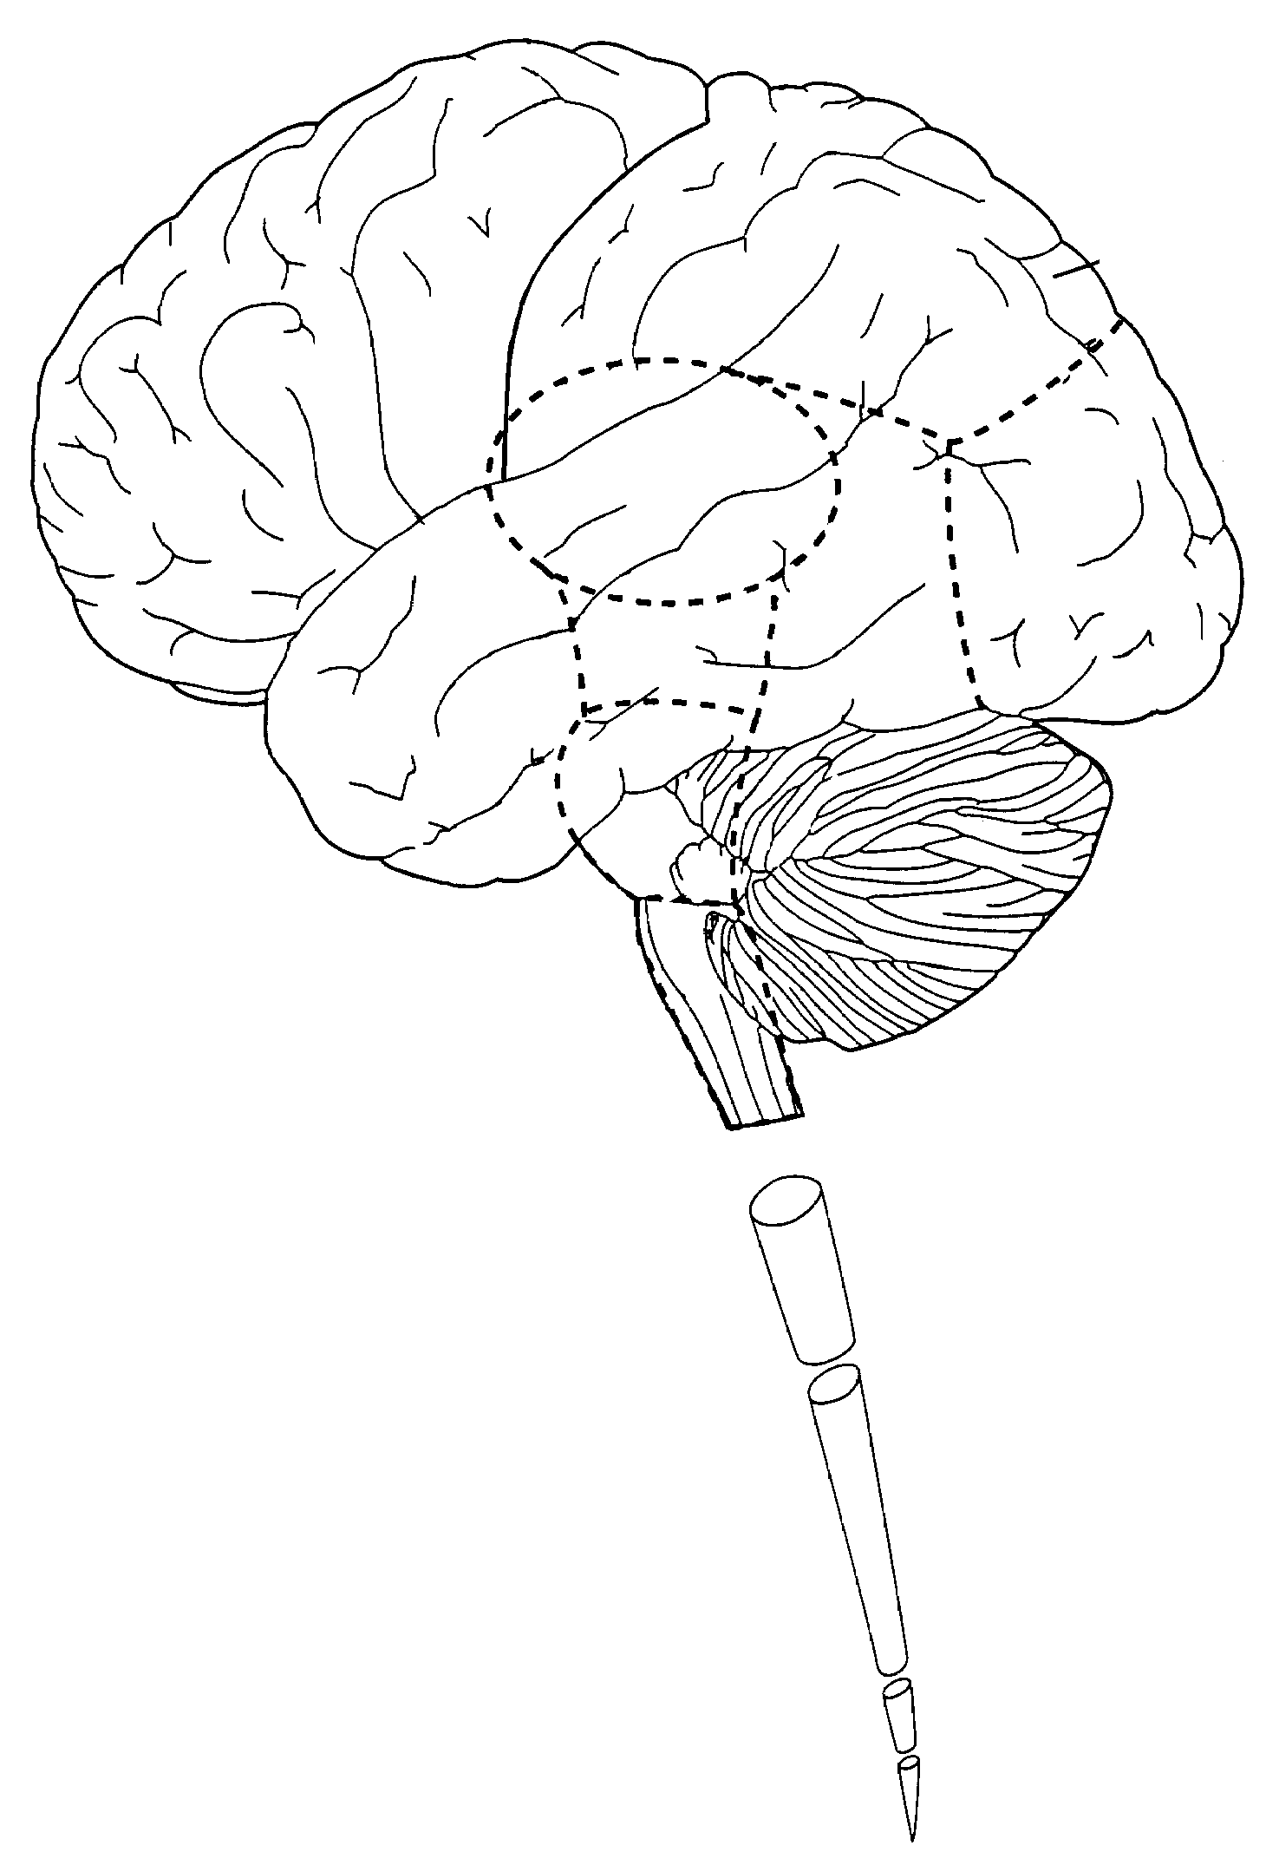A-
Brain centres 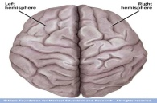B-
Language disorders 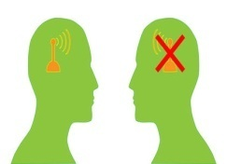C-

Definitions:
Semantics: The study of the meaning of words and sentences
Syntax: The study of grammatical arrangement of words in a sentence or phrase or the study of sentence structure
Phonology: The study of the sound systems of languages
Pragmatics: The study of the factors influencing how language is used in a social context
linguistics: The scientific study of the language
Psychology: The scientific study of the human mind
Psycholinguistics: The study of language in relation to mental processes
Psycholinguistics or psychology of language is the study of the psychological and neurobiological factors that enable humans to acquire, use, comprehend and produce language.

Lecture 2
Language
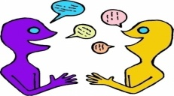
Language enables us to express our thoughts, ideas, and feelings to others and also to understand theirs. Linguistics is the scientific study of this rich and varied human ability. It seeks among others to answer a number of fundamental questions; for example , what is the nature of language?
Language – Definition:
Language is the institution whereby humans communicate and interact with each other by means of habitually-used, oral-auditory, arbitrary symbols.
(R.A. Hall. 1968 An Essay on Language. New York.
LANGUAGE:
Let's look at key words in more detail.
- Humans: language is confined to humans? Animals communicate with one another, however, all animal communication systems lack the ability to communicate about anything beyond the here and now. So language is confined to humans in a strict sense.
- Communication and interaction: certainly, animals communicate and interact, yet the communications system the humans use is more complicated than that of animals.
- Language is used habitually: people use language everywhere and every day and usually with little cognitive effort. Words and sentences seem to follow out of the mouth in a subconscious almost automatic way.
- Language is used oral-auditorily: the oral-auditory channel; communication via the mouth and the ear is the most important mode of human communication and English has reserved a special label for it namely speech.
PROPERTIES OF HUMAN LANGUAGE:
Mode of Communication:1-
Vocal-auditory
Interchangeability: 2-
Individuals who use a language can both send and receive any permissible message within that communication system.
3- Semanticity:
Words or signs or symbols stand for other things (e.g., objects, actions, or concepts); the symbols or words should evoke a mental representation of the objects that they symbolize.
4- Arbitrariness:
There is no logical connection between the form of the signal and its meaning. The symbols that stand for things have no inherent relationship with the thing they stand for (e.g., different languages actually have different symbols for the same thing, pomme = apple)
Animal communication: a strong link between the signal and message: an animal wishes to warn off an opponent may simulate an attacking attitude-cats
In human language: Mostly no link between the signal and the message. The symbols used are arbitrary.
Onomatopoeic words are exceptions: miuow…
5- Discreteness:
Messages in the system are made up of smaller, repeatable parts; the sounds of language are perceived categorically, not continuously.
6-Displacement:
linguistic messages may refer to things remote in time and space, or both, from the site of the communication.
  - Animals: communicate in the immediate environment only. For ex. A bird utters its danger cry when danger is present like baby’ emotional cries of pain, hunger…
  - Human language can cope with any subject whatever, and it does not matter how far away the topic of conversation is in time and space.
- 7- Productivity – Creativity:
Animals can send and receive very limited messages
Humans can produce infinite novel utterences.
8. Acquisition through traditional transmission
Most animals automatically know how to communicate without learning= Genetically inbuilt. (Genetically inbult to develop in human). Bee-dancing is the same in colonies in diffrent part of the world.
Human language is culturally transmitted. A human being brought up in isolation doesn’t acquire language. Also there is innate predisposition towards language in a new-born child. This latent potentiality is activated by long exposure to language.
LANGUAGE:
- -It is a grass roots phenomenon. It is the original wiki which aggregates the contributions of hundreds of thousands of people who invent jargon and slang
and new constructions some of them get accumulated into the language as people seek out new ways of expressing their thoughts. That's how we get a language in the first place.
- 6000 languages spoken on Earth-
- Language is a window into the human mind. -
Language is not:
- -Written language: spoken language is found in all human cultures writing was invented by the Canaanites 3700 years ago.
- Proper grammar -
- Thought
- Language is not thought but, can affect thought -
- -Linguistics has long been interested in the Linguistic Relativity Hypothesis or the Sapir- Whorf Hypothesis
- ( named after the two linguists who formulated it) namely that language can affect though.
- Language systematically influences how one perceives and -
- conceptualizes the world.
- There is a lot of controversy over the status of the Linguistic Relativity Hypothesis, but no one believes that language is the same thing as thought and that all of our mental life consists of reciting sentences.
- How Language works:
In a nutshell you can divide language into 3 topics:
- Words: the basic components of sentences which are stored in our long-term memory which we can call the mental lexicon or the mental dictionary.
- Rules: the recipes or algorithms that we use to assemble bits of language into more complex stretches of language (syntax, morphology, phonology)
- Interfaces : (connect to the world) allow us to understand language coming from others and produce language so that others can understand us.
- -The basic principle of the word was identified by the Swiss Linguist Ferdinand De Saussure ( 1857-1913) more than 100 years ago when he called attention to the arbitrariness of the sign e.g. the word duck (doesn't look like a duck or quack like a duck) its entry in the mental lexicon looks like this: a symbol for the word duck , specification for its sound [duhk] and
- specification of its meaning -
- -Words: The mental lexicon is capacious ( a typical high school graduate has a vocabulary of 60,000 words which works out to the rate of learning of one new word every 2 hours starting from the age of 1.
Noam Chomsky:
- We don't just speak words, we combine them into phrases and sentences
- The modern study of grammar is inseparable from the contributions of one linguist, the famous Noam Chomsky (Granddaddy of modern linguistics) who set the agenda for the field of linguistics for the last 60 years.
Chomsky's contributions (insights) to linguistics:
1- Focus on Creativity or Productivity
2-Languages have a syntax unrelated to their meaning
3- Syntax doesn't consist of linear associations
Definitions
The mental lexicon is defined as a mental dictionary that contains information regarding a word's meaning, pronunciation, syntactic characteristics, and so on. Although this definition has been challenged over the years, this remains the most consistent definition of the term.

Lecture 3
Language and the Brain (Part 1)
NUEROLINUISTICS: The study of how language is represented and processed in the brain.
This involves attempting to combine theory from neurology & Neurophysiology ,(how the brain is structured and how it functions) with linguistic theory, (how the language is structured and how it functions).
THE BRAIN:
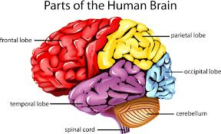
The role of the brain in language functioning has been a central concern in psycholinguistic inquiry.
So, it is only natural that we take a brief look at the brain and the areas that have been identified for language.
THE BRAIN:
Your brain is your most powerful organ, yet weighs only about three pounds. It has a texture similar to firm jelly. The brain is composed of the cerebrum , cerebellum , and brainstem .
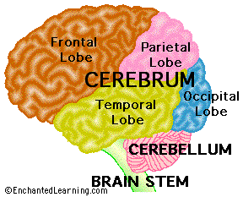
- -The cerebrum fills up most of your skull. It is involved in remembering, problem solving, thinking, and feeling. It also controls movement.
- -The cerebellum sits at the back of your head, under the cerebrum. It controls coordination and balance.
- -The brain stem sits beneath your cerebrum in front of your cerebellum. It connects the brain to the spinal cord and controls automatic functions such as breathing, digestion, heart rate and blood pressure
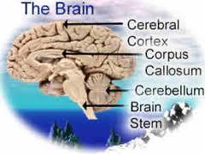
THE CEREBRUM
The cerebrum is the largest part of the brain and is composed of right and left cerebral hemispheres . It performs higher functions like interpreting touch, vision and hearing, as well as speech, reasoning, emotions, learning, and fine control of movement.
THE CEREBRAL CORTEX
The cerebral cortex is the outermost sheet of neural tissue of the cerebrum of the brain. It covers the cerebrum and is divided into left and right hemispheres. The cerebral cortex plays a key role in memory, attention, perceptual awareness, thought, language, and consciousness. It consists of up to six horizontal layers, each with a different composition in terms of neurons and connectivity. The human cerebral cortex is 2 to 4 millimeters thick.
THE CEREBRAL CORTEX
The cerebral cortex is the gray wrinkled outermost covering of the brain. It sits over the rest of the brain and accounts for language representation and processing.
The cerebrum contains about 70 - 75% of the 100 billion neurons of the brain. The gray matter has a folded structure.
The cerebral cortex, is composed of six thin layers of neurons, which sit on top of a large collection of white matter pathways. The cortex is heavily convoluted, so that if you were to spread it out, it would actually take up about 2 1/2 square feet (2500 sq cm). It includes about 10 billion neurons, with about 50 trillion synapses.
The folding of the cortex increases the brain’s surface area allowing more neurons to fit inside the skull and enabling higher functions. Each fold is called a convolution or gyrus , and each groove between folds is called a sulcus .
- The longitudinal fissure separates the left and right hemispheres of the brain.
- The corpus callosum is the bundle of nerve fibers that connects the two hemispheres.
- -Specific regions of the cortex:
- -Interpret sensations from your body, and sights, sounds and smells from the outside world.
- Generate thoughts, solve problems and make plans.-
- Form and store memories.-
- Control voluntary movement.-
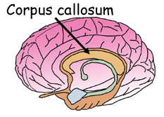
The two cerebral hemispheres are connected by a thick, tough band of neural fibers (axons) called the corpus callosum. The corpus callosum allows the left and right hemispheres to communicate with each other”.
It has been a widely accepted fact that the right and left hemispheres of the brain have control over different bodily functions and tasks, referred to as hemispheric specialization or brain lateralization. However, despite their differences, both hemispheres do share the common understanding of language and are physically connected by the corpus callosum.
The corpus callosum connects the left and right cerebral hemispheres and facilitates communication between the hemispheres. It is the largest white matter structure in the brain, consisting of 200–250 million myelinated axons.
LOBES OF THE CEREBRUM
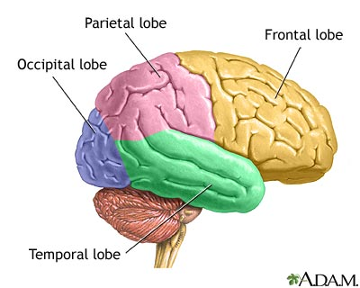
Each of the two cerebral hemispheres has four major areas or lobes.
- The Occipital lobe is involved in processing and creating visual information.-

- -The Temporal lobe is involved in hearing, memory, emotion, language comprehension(Wernicke’s area) , Sequencing and organization and it further processes visual information.
- -The Frontal lobe is involved in thought, imagination, planning (including planning and execution of movements), language, acting, learning, personality, behavior, emotions, judgment, problem solving, and speech: speaking and writing (Broca’s area) body movement (motor strip) Intelligence, concentration, and self awareness.

-The Parietal lobe is involved in further processing of visual information, it also receives motor and sensory information (Sense of touch, pain, temperature) from the rest of the body.
THE BRAIN STEM
located at the base of the brain, the brain stem includes the midbrain , pons , and medulla oblongata. It acts as a relay center connecting the cerebrum and cerebellum to the spinal cord and performs many of the body’s automatic functions. e.g. it keeps our heart pumping, our lungs breathing. It controls our digestion, blood pressure and other autonomic functions. It also controls the information that goes into and out the brain through the spinal cord. Many neurotransmitters are produced in the brainstem. Including those involved in keeping us awake or asleep.
CEREBELLUM
Second largest portion of the brain located beneath the posterior part of the cerebrum; aids in coordinating voluntary body movements and maintaining balance and equilibrium.
NEURONS:
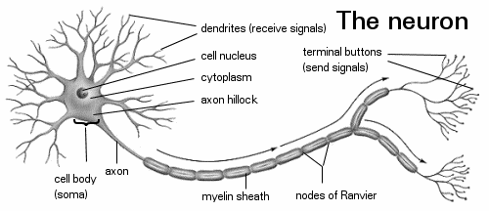
- The brain is composed of neurons, nerve cells that are the basic information processing units of the nervous system. The neuron is the nervous system cell. It is the working unit of our nervous system. It carries, processes and transmits electrical signals at incredible speeds. Neurons connect with thousands of other neurons. Their connections are called synapses.
- LATERALIZATION
- Through lateralization, the left hemisphere has been identified as the language brain due to the presence of language processing areas there.
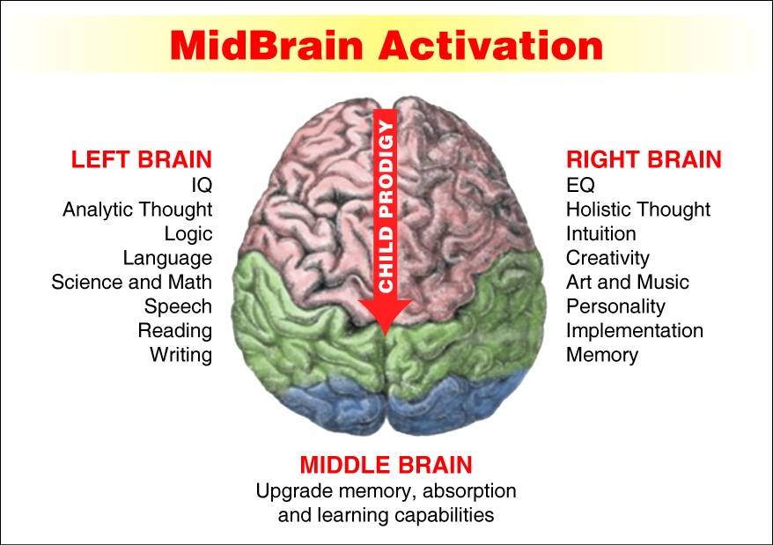
FUNCTIONS OF THE BRAIN HEMISPHERES

In terms of muscle movement, each hemisphere is responsible for half of the body – contralateral responsibilities.
Right hemisphere -> left side of body
Left hemisphere -> right side of the body
In terms of higher cognitive functions, the hemispheres are lateralized –
Left hemisphere -> analytic tasks
Math, Language
Right hemisphere -> recognition of complex patterns
Faces, Melodies
LATERALIZATION OF THE BRAIN FUNCTIONS
Left-hemisphere:
  - Sequential analysis
    - Analytical
    - Problem solving
  - Language
Right-hemisphere:
  - Simultaneous analysis
    - Synthetic
  - Visual-Spatial skills
    - Cognitive maps
    - Personal space
    - Facial recognition
    - Drawing
  - Emotional functions
    - Recognizing emotions
    - Expressing emotions
  - Music
  - THE LANGUAGE HEMISPHERE
- 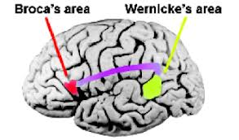 -The center for speech is in the left
hemisphere of the cerebral cortex.
- Two areas known as the Broca’s area -
and the Wernicke’s area are involved
in storing information related to speech.
BROCA’S AREA
-Located at the base of the motor cortex.
-Broca’s area stores information needed for speech production. It is responsible for programming the motor cortex to move the tongue, lips and speech muscles to articulate words.
-In simple terms, once a linguistic stimulus is processed and understood, impulses will be sent out from Broca’s area to order the speech mechanism to form the right response.
WERNICKE’S AREA
- -Wernicke’s area stores information needed for arranging the words of a learned vocabulary into meaningful speech.
- -This is part of the left hemisphere that has been identified as the comprehension center. Linguistic stimuli, either visual or auditory, are turned into electrical impulses and processed in this area.
- We could say that it is this area that does the actual listening and seeing. -
- ARCUATE FASCICULUS
- A white matter tract that connects Broca’s area and Wernicke’s area through the Temporal, Parietal and Frontal lobes. Allows for coordinated comprehensible speech.
- MOTOR CORTEX
- Motor cortex is an area that generally controls movement of the muscles( hands, feet, arms..etc) it sits close to Broca’s area. This area is involved in the physical articulation of speech.
APHASIA
Also known as language disorders, are caused by damage to the language processing areas of the brain, namely Broca’s and Wernicke’s areas. Damage or lesions to these areas could cause serious language impairment.
Aphasia causes problems in the ability to perceive, process, or produce language. Aphasia occurs in various forms and degrees, depending upon the situation, extent, and severity of the cerebral lesions which is responsible.
The cause of the brain injury may be a stroke, a severe blow to the head, a brain tumor, or brain infection.
BROCA’S APHASIA
Broca’s aphasia would affect speech production. Speech that is produced becomes short, almost telegraphic in nature. The language is however meaningful. In simple terms, although the input is understood, the response is impaired because impulses cannot get through from Broca’s area.

Example:
“Cookie jar…fall over…chair…water…empty…ov…ov…[Examiner: “overflow?”] Yeah.”
(Heny 637)
- Lesions in the left inferior frontal region (Broca’s area)-
- Nonfluent, labored, and hesitant speech-
- Most also lost the ability to name persons or subjects (anomia)-
- Can utter automatic speech (“hello”)-
- -Comprehension relatively intact
- Most also have partial paralysis of one side of the body (hemiplegia)-
- If extensive, not much recovery over time
- WERNICKE’S APHASIA
- Werniche’s aphasia is characterized by speech that is nonsense or meaningless, though it is phonologically and grammatically accurate. In simple terms, input that is received cannot be deciphered. As a result it is not understood. Hence, this amounts to nonsensical response.
- Well, this is…mother is away here working out o’here to get her better, but when she’s working, the two boys looking in the other part. One their small tile into her time here. She’s working another time because she’s getting, too.”
- (Heny 638)
- In girls we see many happy days.
- I’ll challenge a new bike.
- I surprise no new glamour.
- Is there three chairs in this room?
- Mike and Peter is happy.
- Bill and John likes hot dogs.
- CENTRAL APHASIA
- Central aphasia or Goldstein, syntactical aphasia
- This results from damage to the arcuate fasciculus which results in severing the connection between the Broca's and Wernicke's areas. Patients understand speech and correctly interpret words from the mental lexicon but will not be able to transmit information to Broca's area so that words can be articulated.

- BROCA’S APHASIA
- -Pierre Paul Broca made the first diagnosis of the condition resulting from damage to the Broca’s area. That condition has since been named Broca’s aphasia, and it involves a lack of ability to produce coherent language, including spoken, written or signed forms.
- -Patients suffering from Broca’s aphasia are able to use the organs of speech, the articulators, to produce sounds and even single words, but they cannot produce sentences or express thoughts.
WERNICKE’S APHASIA
- -Lesions in posterior of the left superior temporal gyrus, extending to adjacent parietal cortex
- Fluent speech-
- But contains many paraphasias -
“girl”-“curl”, “bread”-“cake”
- Syntactical but empty sentences-
- Cannot repeat words or sentences-
- Unable to understand what they read or hear-
- -Usually no partial paralysis
- -Often, patients will find one word or a short string of words, and repeat them over and over in an attempt to communicate thoughts and may sometimes be successful in communicating but they will not be able to grammatically express themselves. Similarly, they can draw, but are not capable of writing coherent speech.
- -The key is that they can understand speech and often can form ideas to communicate, but they cannot put words together to communicate those ideas.
LEFT BRAINS
- -It has been suggested over the years that problems with Broca’s area may be able to be compensated for by other areas of the brain, including the corresponding area of the non-dominant hemisphere. This suggestion is due to the somewhat transient nature of Broca’s aphasia symptoms as stroke and injury victims can regain use of their speech mechanisms.
- -Stuttering has also been linked to areas encompassed by Broca’s area, though this disorder is not well understood or explained.

- RIGHT BRAINS
- Patients suffering from damage to Wernicke’s area have difficulty in understanding language in any form. They can speak fluently, forming long and complex sentences, but their strings of words often lack coherent meaning. They frequently use vague terms and roundabout descriptions that never coalesce into complete thoughts.
- From the prolific speech production of patients, it is easy to see that this is not a difficulty with speech production but with language production. It has also been shown that damage to Wernicke’s area is not as transient as that done to Broca’s area.
Split-brain
- Split-brain patients are good examples of lateralization of language functions.-
- -Epileptic activity spreads from one hemisphere to the other through corpus callosum
- Since 1930, such epileptic treated by severing the interhemispheric pathways.-
- THE ANATOMY AND PHYSIOLOGY OF SPEECH-
- -The source for acoustic energy for speech sound production comes from modulation in the air flowing from the lungs to the lips called “air stream”.
- -We breathe in air into our lungs to serve as the power supply for the production of speech.
- -During regular quiet breathing, the vocal tract is open and the air flows freely either through the nose or mouth.
- -Some sounds are produced by modeling the air stream by the periodic opening and closing of the vocal folds of the glottis.
- -The voiced or phonated sounds have a buzz-like quality. You can actually feel the vibration of your vocal folds by placing your fingers on your throat when you produce the sustained [z].
- -Sounds produced without the regular glottal pulsing are called voiceless sounds. You can feel the absence of vibration when you produce the sustained [s].
- SUMMARY
- In this topic we have identified the brain and the areas that have been identified for language are:
- the language hemisphere of the brain ,,The Broca's area and the Wernicke's area ,,Aphasia,, The Physiology of Speech

Lecture 4
Language and the Brain (Part 2)

THE BRAIN
- -For most people the areas of the brain involved in language processing are the frontal and the temporal areas of the left hemisphere. This is true whether a language is spoken or whether it is a signed language.
- How the brain processes language -
- Is the brain hard wired for language ? -
- Language is primarily a left hemisphere operation. When there is damage in specific areas in the left hemisphere, we see language impairment
- Aphasia is an impairment of language, usually caused by left hemisphere damage either to :
  - Broca's area (impaired speaking) or to
  - Wernicke's area (impaired understanding).
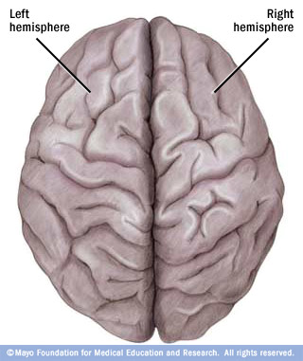

LANGUAGE CENTRES IN THE BRAIN
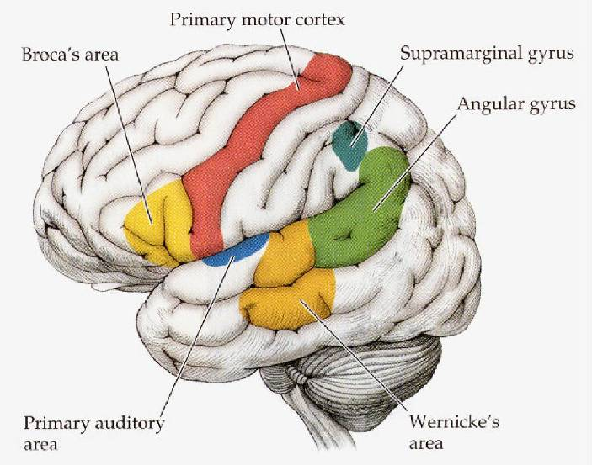
1-The visual cortex: receives written words as visual stimulation.
it is needed to process anything we see including words in reading.
2-angular gyrus: transforms visual representations into an auditory code.
In the Angular Gyrus you transforming the visual representations into a voice in your head ( like when you read to yourself) auditory code.
3-Wernicke's area: interprets auditory code.
4-Broca's area: controls speech muscles via the motor cortex (the frontal lobe Broca's area tells the motor cortex what to say) ( language production)
5-Motor cortex: word is pronounced
Brain activity when hearing, seeing, and speaking words
A-Hearing words
Auditory cortex & Wernicke's area
B-Seeing words (reading)
Visual cortex & angular gyrus
C-Speaking words
Broca's area and the motor cortex
Specialization and Integration
Neuroscientists now agree that running around the lateral sulcus in the left hemisphere of the brain, there is a sort of neural loop that is involved both in understanding and in producing spoken language. At the frontal end of this loop lies Broca's area, which is usually associated with the production of language, or language outputs . At the other end (more specifically, in the superior posterior temporal lobe), lies Wernicke's area, which is associated with the processing of words that we hear being spoken, or language inputs. Broca's area and Wernicke's area are connected by a large bundle of nerve fibers called the arcuate fasciculus.
WERNICKE-GESCHWIND MODEL OF SPOKEN AND WRITTEN LANGUAGE FUNCTIONS IN THE BRAIN
A first model of the general organization of language functions in the brain was proposed by American neurologist Norman Geschwind in the 1960s and 1970s. This “connectionist” model drew on the lesion studies done by Wernicke and his successors and is now known as the Geschwind-Wernicke model.
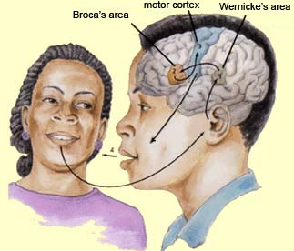
WERNICKE-GESCHWIND MODEL OF SPOKEN AND WRITTEN LANGUAGE FUNCTIONS IN THE BRAIN
According to this model, each of the various characteristics of language (perception, comprehension, production, etc.) is managed by a distinct functional module in the brain, and each of these modules is linked to the others by a very specific set of serial connections. The central hypothesis of this model is that language disorders arise from breakdowns in this network of connections between these modules.
WERNICKE-GESCHWIND MODEL OF SPOKEN AND WRITTEN LANGUAGE FUNCTIONS IN THE BRAIN
1. REPEATING A SPOKEN WORD
According to this model, when you hear a word spoken, this auditory signal is processed first in your brain’s primary auditory cortex, which then sends it on to the neighboring Wernicke’s area . Wernicke’s area associates the structure of this signal with the representation of a word stored in your memory, thus enabling you to retrieve the meaning of the particular word.
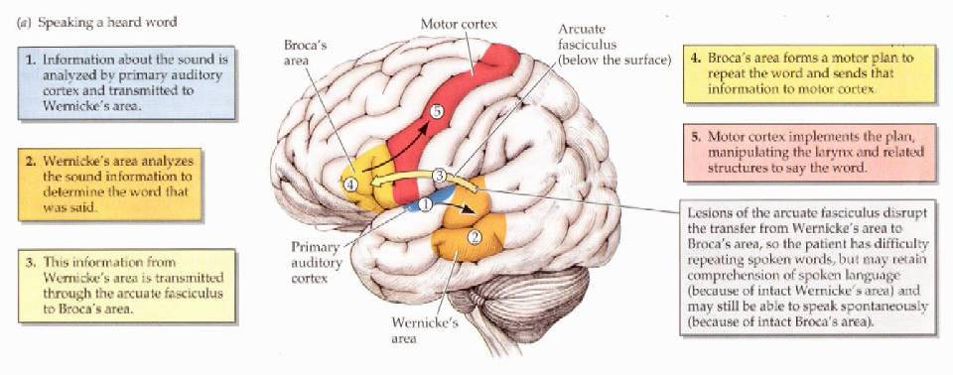
In contrast, when you read a word aloud, the information is perceived first by your visual cortex, which then transfers it to the angular gyrus , from which it is sent on to Wernicke’s area.
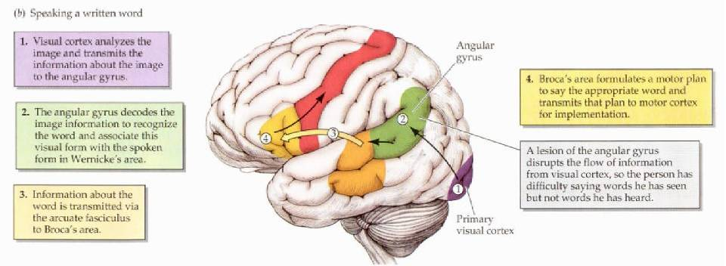
SPEAKING THE HEARD WORD
To speak a word that is heard, information must first get to the primary auditory cortex. From the primary auditory cortex, information is transmitted to the posterior speech area, including Wernicke’s area. From Wernicke’s area, information travels to Broca’s area, then to the Primary Motor Cortex.
SPEAKING THE WRITTEN WORD

To speak a word that is read, information must first get to the primary visual cortex. From the primary visual cortex, information is transmitted to the posterior speech area, including Wernicke’s area. From Wernicke’s area, information travels to Broca’s area, then to the Primary Motor Cortex.

