The Acropolis of Athens is an ancient citadel located on a high rocky outcrop above the city of Athens and containing the remains of several ancient buildings of great architectural and historic significance, the most famous being the Parthenon. The word acropolis comes from the Greek words, by the standard of the gods, stately, proportionate sculptures of whom had been adorning the Athenian Acropolis since about the time Socrates reached the age of thirty . Good looks and proper bearing were important to a man's political prospects, for beauty and goodness were linked in the popular imagination.

Map of the Acropolis of Athens in Socrates and Plato
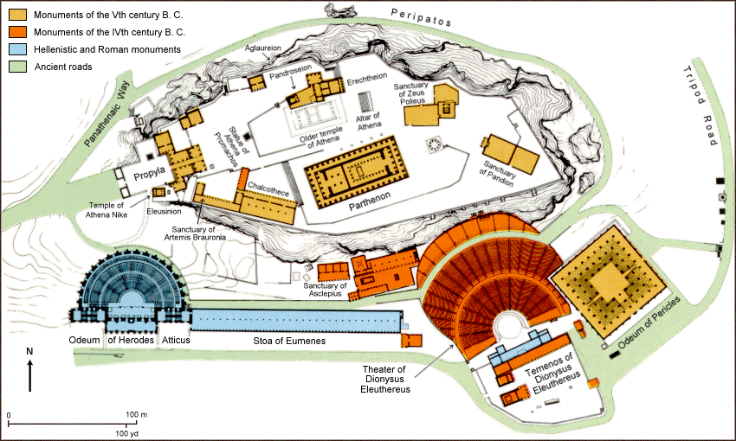

There is a lot of evidence showing that the area was inhabited as far as in the 4th millennium BC. However, studies reveal that the Pericles who existed between 495-429BC are the ones that coordinated its construction. The Pericles are attributed with the construction of the major buildings in this area. According to research, the Pericles constructed the Propylaia, Parthenon and Erechtheion. At the same time, they are also believed to have constructed the Athena Nike temple.
There is a cultural significance behind this building that every four years the Athenians held a festival called the Panathenaea that rivaled the Olympic Games in popularity. During the festival, a procession(believed to be depicted on the Parthenon frieze) traveled through the city via the Panathenaic Way and culminated on the Acropolis. There a new robe of woven wool(peplos) was placed on either the status of Athena Polios in the Erechtheum ( during the Panathenaca ) or on the status of Athena Parthenos in the Parthenon (during the Great Panathenaea , held every four years), within the later tradition of Western Civilization and classical revival the Acropolis , from at least the mid-18 century on, has often been invoked as a key symbol of the Greek legacy and of the glories of the Classical Greece.
There are several reasons why Acropolis was constructed. The first reason for the construction of this rock was for defense purpose. The rock was located a strategic location which made any looming danger easily visible. This provided the inhabitants of this area to launch attacks on the incoming enemy effectively. At the same time, this rock had many springs which provided enough water to the residents. Using this water, people living in this area were able to engage in agricultural activities through irrigations. At the same time, the flat top of this rock provided an effective topography for human settlements as it eased movement of people from one region to another.

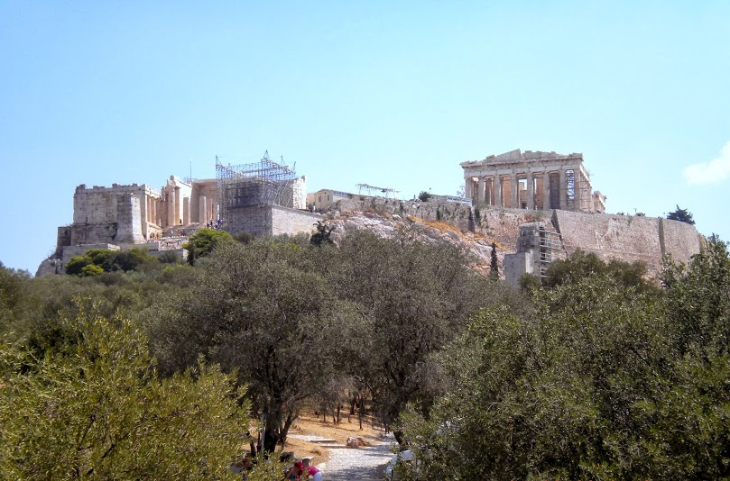

Rawan Faisal Alahmadi
Thursday group

