Linguistics
1st lecture
What is linguistics?
It is the scientific study of human natural language.
What is scientific?
When we say that a linguist aims to be scientific, we mean that he attempts to study language in much the same way as a scientist studies physics or chemistry. That is systematically, and as far as possible without prejudice.
It means observing language use, forming hypotheses about it, testing these hypotheses and then refining them on their bases of the evidence collected.
Linguistics shares with other sciences a concern to be objective, systematic, consistent, and explicit in its account of language. Like other sciences, it aims to collect data, test hypothesis, devise models, and construct theories. Its subject matter however is unique: at one extreme it overlaps with such ‘hard’ sciences as physics and anatomy; at the other, it involves such traditional ‘arts ‘subjects as philosophy and literary criticism. The field of linguistics includes both science and humanities, and offers a breadth of coverage that, for many aspiring students of the subject, is the primary source of its appeal.
David Cistal
What is language?
When we study human language, we are approaching what some might call the “human essence” the distinctive qualities of mind that are, so far as we know unique to man
Noam Chomsky
Language and mind
Why unique?
The possession of language, perhaps more than any other attribute, distinguishes humans from other animals. To understand our humanity, one must understand the nature of language that makes us human.
What is language?
A language is a set of signals by which we communicate. Human beings are not only species to have an elaborate communication system. Even if human languages do not differ in essence from animal communication, they certainly differ in degree. Nothing in the animal kingdom can be compared to human language for flexibility, complexity, … etc
Remember
Whenever man exists……………………. Language exist
Language is a systematic means of communicating ideas and feelings by the use of a set conventional symbols.
What is a linguist?
A scientist who investigates language in all its facets: structure, history, use and place in society.
A Polygot
Someone who speak several languages
Linguist # polygot
The linguist is concerned with natural languages. The question what is language deals with each of the several thousand distinct natural languages spoken throughout the world.
What is the linguist wants to know is whether all natural languages have something in common not shared by other systems of communication, human or non human( like Esperanto, or bee’s language)

Esperanto
It is a language created by humans. Its creators were people interested in world government who believed that having a worldwide common language was a prerequisite for such a government. Since its creation, Esperanto has not fulfilled the dreams of its creators.
Although Esperanto societies exist to promote its proliferation, it lacks the vitality of natural language. Here, however, Esperanto will serve nicely as an example of a word ending syntax language.
Look at the pictures and text below , and see if you can figure out the meanings.

Branches of linguistics
Different branches may be distinguished according to linguist’s focus and range of interest.
- General linguistics
- Applied linguistics
- Historical linguistics
- Descriptive linguistics
- Computational linguistics.
General Linguistics:
General linguistics is commonly used when one wants to emphasize the universal applicability of linguistic theory and method in the study of languages. It thus includes the theoretical, descriptive and comparative biases of the subject. It is sometimes seen in contrast with those branches of linguistics where there is an interdisciplinary or applied orientation (as in sociolinguistics and applied linguistics)
Applied Linguistics
The application of methods and results of linguistics to such areas as language teaching; national language policies; translation; language in politics; advertising; classrooms and courts( forensic linguistics)
Historical linguistics
A branch of linguistics which studies the development of language and languages over times; also known as diachronic linguistics. Historical linguistics uses the methods of the various branches of linguistics( including sociolinguistics, especially in considering the reasons for language change) one thus encounters such subfields as “ historical phonology/ morphology/ syntax” etc…
Descriptive Linguistics:
The aim of descriptive linguistics is to describe the facts of linguistics usage as they are, and not how they ought to be, with reference to some imagined ideal state.
Computational Lingustics:
Computational linguistics study natural languages, such as English and Japanese, rather than computer languages, such as Fortran, Snobol, or Java. The field of computational linguistics has two aims:
- The technological aim to enable computers to be used as aids to in analyzing and processing natural language
- The psychological aim to understand, by analogy with computers, more about how3 people process natural languages. It also includes research on automatic translation, electronic production of artificial speech and the automatic recognition of human speech.
What is linguistics?
Fundamentally, the field of linguistics is concerned with the nature of language and (linguistics) communication.
It is an attempt to break down the board questions about the nature of language and communication into smaller, more manageable questions that we can hope to answer, and in so doing establishing reasonable results that we can build on in moving closer to answers to the large questions.
As you will see, the field covers a surprisingly board range of topics related to language and communication.

Levels of Linguistics pragmatics
Semantics
Syntax
Morphology
Phonology
Phonetics
- Phonetics and phonemic transcription: introduces the physiology involved in the production of speech sounds as well as phonemic and phonetic transcription systems that are used to represent the sounds of English.
- Phonology: surveys the organizational principles that determine the patterns of the speech sounds are subject to.
- Morphology: is concerned with the properties of words and word-building rules.
- Syntax: presents a study of the structure of sentences and phrases.
- Semantics: surveys the properties of linguistic meaning.
- Pragmatics: explores some of the issues involved in describing human communication and proposes certain communication strategies that people use when they talk to each other.
- Language Acquisition in children: studies the stages involved in language acquisition by humans and reviews the evidence for positing a genetically endowed “ language Acquisition Device”
- Language Variation: deals with the ways speakers and groups of speakers can differ from each other in terms of the various forms of language that they use.

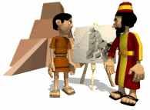
2nd Lecture
The Origin of Speech
What is language?
A language is a set of signals by which we communicate. Human beings are not only species to have an elaborate communication system. Even if human languages do not differ in essence from animal communication, they certainly differ in degree. Nothing in the animal kingdom can be compared to human language for flexibility, complexity, … etc
Language is a means of communication, a tool of thought, a medium of expression, a social institution, a source of ethnic pride and political controversy.
The centrality of language to every aspect of human life gives each of us a reason to want to understand more about its nature and use.
All normal human beings have at least one language, and it is difficult to imagine such significant social, intellectual, or artistic activity taking place in the absence of language.
The Origin of Speech
Spoken language developed well before written language.
Spoken: Linguistic history suggests that languages of the kind that exist today have been around for tens of thousands of years at the very least.
Written: but the earliest deciphered written records are barely six thousand years old. These records appear so late in the history of the development of language that they provide no clue to its origin.
Yet, when we uncover traces of human life on earth dating back half a million years, we never find any direct evidence relating to the speech of our distant ancestors.
There are no dusty cassette-tape fragments among the ancient bones, for example, to tell us how language was back in the early stages.
Perhaps because of this absence of direct physical evidence, there has been no shortage of speculation about the origins of human speech.
For these reasons, scholars in the latter part of the 19th century, who were only interested in “ hard science” ridiculed, ignored, and even banned discussions of language origin. In 1889 the Linguistic Society of Paris passed a resolution to ignore papers concerned with the subject.
The Theories of Language Origins
- the divine source
- the natural sounds source
- the oral-gesture source
- Physiological adaptation
The divine source
- In most religions, there appears to be a divine source Who provides humans with language. In an attempt to rediscover this original, divine language, a few experiments have been carried out.
God’s Gift to Mankind:
And out of the ground the Lord God formed every beast of the field, and every fowl of the air, and brought them unto Adam to see what he would call them; and whatsoever Adam called every living creature, that was the name thereof.

The basic hypothesis is:
If infants were allowed to grow up without hearing any language, then they would spontaneously begin using the original God-given language.
The monogenetic theory of language origin is also found not only in the Tower of babel story in genesis
Some experiments have reportedly been devised to verify particular theories of first language
For example
- an Egyptian pharaoh named Psammetichus 600 B.C.
- the holy Emperor Frederick II
- James IV of Scotland 1500 A.D.
- Noah Webster
However it seems that children with no access to human speech simply grow up with no language at all.

REMEMBER
No speech = No language

The Natural-Sound Source
Another speculation on the origin of language is that the primitive language was an imitations of natural sounds which early men and women heard around them.
They are divided into three theories:
- The BOW-WOW THEORY
- The POOH-POOH THEORY
- The YO-HEAVE-HO THEORY

The BOW-WOW THEORY
This theory proposes that people imitated the sounds that they heard in the natural world.
Examples
- Onomatopoetic words

- Words that echo natural sounds.
- CUCKOO, SPLASH, BANG, RATTLE, BUZZ.

The POOH-POOH THEORY
This theory suggests that language arose from instinctive emotional cries expressing pain, joy etc.
- Original sounds of language came from cries of emotions, such as pain, anger and joy.
- OUCH!
- One other natural sound proposal has come to be known as the “yo-heave-ho” theory.

The Yo-Heave-Ho Theory
The sounds of a person involved in physical effort could be the source of our language. It places the development of human language in a social context and states that language originated in the need to coordinate physical effort.
Remember
This theory suggests that the involuntary sounds that people make during physical labor evolved into language
The oral-gesture source

Many of our physical gestures, using body hands and face, are means of nonverbal communication. They are used by modern humans with their developed linguistic skills.
it proposes an extremely specific connection between physical and oral gesture involving a “specialized pantomime of tongue and lips.”
It is divded into:
- The gesture theory
- The oral theory
The Gesture Theory
This theory argues that gestures were accompanied by sounds that eventually came to mean what the gesture meant.
The Oral Theory
(DING-DONG THEORY)
This theory states that primitive people instinctively reacted to every sensory experience with a specific vocal expression.

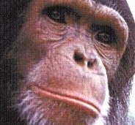
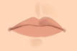
(MUSICAL THEORY)
This theory proposes that language arose from song or that speech and music developed together.
(Physiological adaptation)
Some of the physical aspects of humans that make the production of speech possible or easier are not shared with other creatures. Human teeth are upright and roughly even in height.
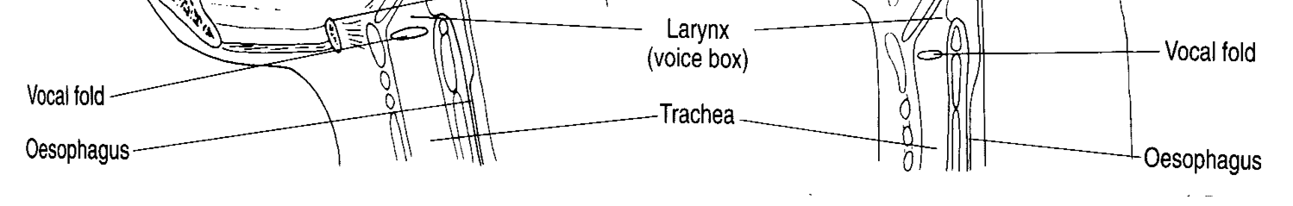

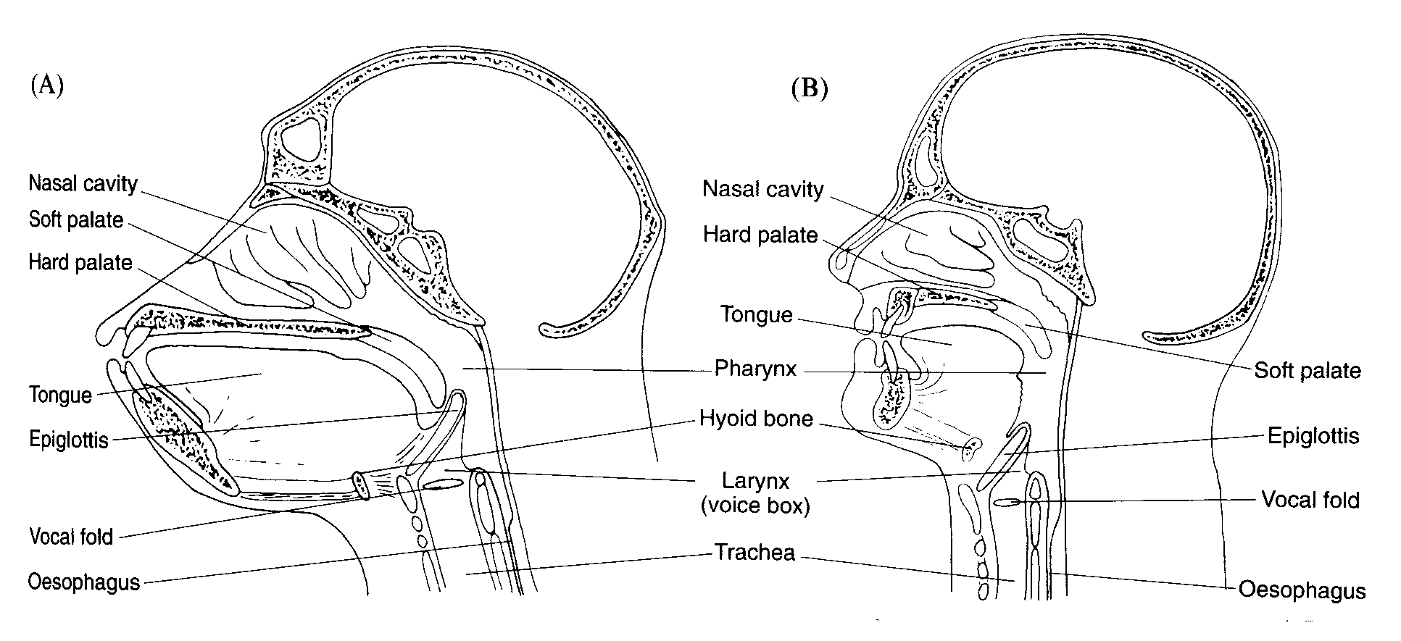

- Human lips have an intricate muscle interlacing.
- The human mouth is relatively small, can be opened and closed rapidly and contains a very flexible tongue.

The human larynx, or the “voice box” is special as well as the pharynx above the vocal cords can act as a resonator for any sounds produced.
The human brain is lateralized and has specialized function in each of the two hemispheres. The functions that are analytic, such as tool-using and language, are largely confined to the left of the brain for most humans. All languages require the organizing and combining of sounds or signs in specific constructions.
The development of language in the species:
There much interest today among biologists as well as linguists in the relationship between the development of language and the evolutionary development of the human spices.
There are those who view the language ability as a difference in degree between humans and other primates- a continuity view- and those who see the onset of language ability as a qualitative leap- the discontinuity view- there are those on both sides of the discontinuity view who believe that language is species specific.

3rd Lecture
The Origin of Writing

Introduction

Linguists are usually more interested in speech than in writing, and writing has often been viewed as a reflection of speech. Although we have no proof, we assume that speech preceded writing.
This assumption is supported by the observation that children can learn to speak before they learn to write and that many of the world’s peoples do not possess written forms of their language.
Writing (def.)
Writing is derived from speech, and is in fact an imperfect visual representation of it, for such purposes as communication at a distance and the keeping of records. Not all visual communications and records are writing in this sense.
Petroglyphs
In fact, the seeds of which writing developed were probably the early drawings made by ancient humans. Cave drawings, called petroglyphs, such as those found in the Altamira cave in northern Spain, drawn by humans living over twenty thousand years ago, can “read” today.
Petroglyphs are literal portrayals of life at that time. We don’t know why they were produced; they may be aesthetic expressions rather than pictorial communications..

The purpose of such works was probably magical to enable the hunter to master the beast depicted or acquire its strength, to promote fertility, and so on.
Cave drawings may serve to record some event, but they are not usually thought of as any type of specifically linguistic message. They are normally considered as part of a tradition of pictorial art.
The same is true of primitive peoples who often use systems of knots tied in ropes, or of notches cut in sticks, and later on clay tokens as aids to the memory.
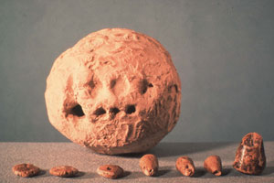
Clay Token →→→

The Development of Writing

We may trace human attempts to represent information visually back to cave drawings which were made at least 20,000 years ago, or to clay tokens from about 10,000 years ago. Writing which is based on some type of alphabetic script can only be traced back to inscriptions dated around 3,000 years ago.
A large number of the languages found in the world today are used only in the spoken form. They do not have a written form. For those languages which do have writing systems, the development of writing, as we know it, is a relatively recent phenomenon.
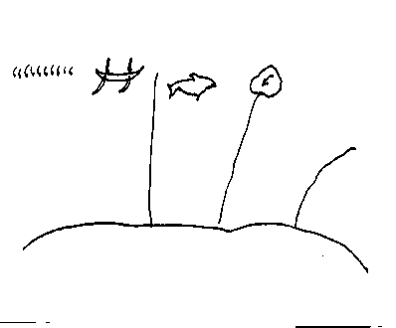
Later drawings, however, are clearly ” picture writing,” or pictograms. Pictures were used for keeping records and for sending messages, and both these uses are known among primitive peoples in historical times.

Pictograms
Unlike modern writing systems, each picture or pictogram is a direct image of the object it represents. There is a nonarbitrary relationship between the form and meaning of the symbol.
Whether these pictures were telling a ‘story’ or represented some type of “spirit house” or ritual exercise is not known.
Pictograms
This early form of writing represented objects in the world directly rather than through the linguistic names given to these objects. Thus, they do not represent the words and the sounds of the spoken language.
Thus, a form such as ☼ might come to be used for the sun. An essential part of this use of a representative symbol is that everyone should use similar forms to convey similar meaning.
Pictogram or picture-writing is pictures came to represent particular images in a consistent way.
Ideogram
Once a pictogram was accepted as a representation of an object, its meaning was extended to attributes of that object, or concepts associated with it.
In times, the picture of the sun ☼ might take on a more symbolic form, such as , and come to be used for ‘heat’ and ‘daytime’, as well as for ‘sun’. This type of symbol is considered to be part of a system of idea-writing, or ideograms.
Remember
A key property of both pictogram and ideogram is that they do not represent words or sounds in a particular language.
For Ex.
Pictograms are used today in international road signs where the native language of the region might not be understood by all travellers. Such symbols can be understood by anyone because they do not depend on the words of any language.
The distinction between pictogram and ideogram is essentially a difference in the relationship between the symbol and the entity it represents.
The more ‘picture-like’ forms are pictograms, the more abstract, derived forms are ideograms.
It is generally thought that there are pictographic or ideographic origins for a large number of symbols which turn up in later writing systems.
For example, in Egyptian hieroglyphics, the symbol is used to refer to a house and derives from the diagrammatic representation of the floor-plan of a house.
When the relationship between the symbol and the entity or idea becomes sufficiently abstract, the symbol is then used to represent words in a language.
In Egyptian writing, the ideogram for water was . Much later, the derived symbol came to be used for the actual word meaning ‘water’.
Logogram
When the symbols come to be used to represent words in a language, they are described as examples of word-writing, or ‘logograms’.
A good example of logographic writing is that used by the Sumerians, in the southern part of Iraq.
A modern writing system which is based on the use of logogram can be found in China. Many Chinese written symbols, or characters, are used as representation of the meaning of words and not of the sound of the spoken language.
One of the advantages of such a system is that two speakers of very different dialects of Chinese can both read the same written text.
One major disadvantage is that a large number of different written symbols exist within this writing system. Remembering such large number of different word-symbols does seem to represent a serious memory load.
The Rebus Principle
One way of using existing symbols to represent the sounds of language is via a process known as the rebus principle.
When a graphic sign no longer has a visual relationship to the word it represents, it becomes a phonographic symbol, standing for the sounds– the homophones of the language.
If, for example, the symbol Ω stood for son in English, it could then be used in a sentence like
My Ω is a doctor.
This sentence is an example of the rebus principle.
Modern Writing Systems
The various types of writing systems used in the world are: word or logographic writing, syllabic writing, consonantal alphabet writing, and alphabet writing.
Most of the world’s written language use alphabetic writing.
Modern Writing Systems
Even Chinese and Japanese, whose writing systems are not alphabetic, have adopted alphabetic transcription systems for special purposes such as communicating with foreigners, computers, and over the internet.
Word Writing
In a word -writing, or logographic writing system, a written character represents both the meaning and pronunciation of each morpheme.
Syllabic Writing
Syllabic writing systems are more efficient than word-writing systems, and they are less taxing on the memory.
Syllabic writing
When a writing system employs a set of symbols which represent the ronunciation of syllables, it is described as syllabic writing. There are no purely syllabic writing systems in use today, but modern Japanese is often described as having a (partially) syllabic writing system.
Both the Egyptian and the Sumerian writing systems evolved to the point where some of the earlier logographic symbols were used to represent spoken syllables.
However, the full use of a syllabic writing system does not appear until that used by the Phoenicians, inhabiting Lebanon. It is clear that many of the symbols which they used were taken from earlier Egyptian writing.
Consonantal Alphabet Writing
Semitic languages, such as Hebrew and Arabic, are written with alphabets that consist only of consonants. Such an alphabet works for these languages because consonants form the root of the word.
For example, the consonants ktb in Arabic form the root of words associated with “write”. Thus kataba means “to write”, aktib means “ I write” kitab means“ a book,” and so on.
Inflectional and derivational processes can be expressed by different vowels inserted into triconsonantal roots.
Because of this structure, vowels can sometimes be figured out by a person who knows the spoken language.
Semitic alphabets provide a way to use diacritic marks to express vowels. This is partly out of desire to preserve the true pronunciation of religious writings, and partly out of deference to children and foreigners learning to read and write.
These systems are consonantal alphabets because only the consonants are fully developed symbols. Sometimes they are considered syllabaries because once the reader or writer perceives the vowel, the consonantal letter seems to stand for a syllable.
Alphabetic Writing
Alphabetic writing systems are easy to learn, convenient to use, and maximally efficient for transcribing any human language.
The term sound writing is sometimes used in place of alphabetic writing, but it does not truly represent the principle involved in the use of alphabets.
Alphabetic Writing
In alphabetic writing, the symbols can be used to represent single sound types in a language. An alphabet is essentially a set of written symbols which each represent a single type sound.
The alphabetic writing system seems to have occurred in the origins of the writing systems of Semitic languages such as Arabic and Hebrew. The alphabet of these languages, even in their modern versions, consist of consonant symbols.
The early form of alphabetic script, originating in the writing systems of the Phoenicians, is the general source of most other alphabets to be found in the world.
A modified version can be traced to the East into Indian and South-East Asian writing systems and to the West through Greek.
The early Greek took the alphabetizing process a stage further by also using separate symbols to represent the vowel sounds as distinct entities, and so a remodelled alphabet was created to include these.
This change produced a distinct symbol for the vowel a (alpha) to go with the existing symbols for consonants such as b (beta).

4th Lecture
The Origin of Writing II
From Hieroglyphics to Alphabets
The Story of Writing
In the development of writing out of pictures, two main processes took place:
(1) the pictures were simplified and conventionalized, until they were not recognizable as pictures at all;
And (2) they were made to stand directly for linguistic items (first words, then syllables, and finally sounds or phonemes) and arranged in the same order as the linguistic items.
The Conventionalization Process
The process of simplification and conventionalization depended to some extent on the material used for writing.
If symbols are scratched on clay, or incised on wood or stone, there is a tendency to avoid curves, and the writing becomes angular.
Perhaps the earliest true writing was developed by the Sumerians in southern Mesopotamia some time between 4000 and 3000 BC
The Sumerian scribes wrote on clay with a stylus made from a reed. At first they drew little pictures by pulling the tip of the stylus through the clay.
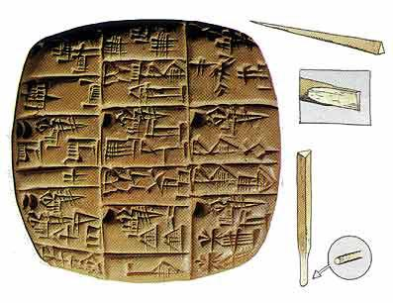
But this is not very efficient, for the clay heaps up in front of the stylus and blurs the picture.
So later they simply pressed the head of the stylus into the clay as if it were a stamp, thus producing a little wedge shaped mark. For this reason the writing is called cuneiform, which simply means ‘wedge shaped’.
Wedges pointing from right to left were avoided, because they involved turning the stylus right round. So gradually the marks used became more limited in number, and the signs became increasingly conventionalized and remote from the original pictures.

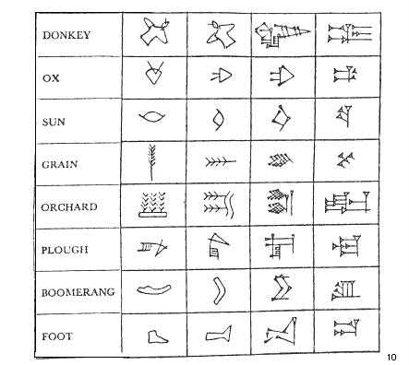
You will notice that the ultimate signs are at right angles to the original pictures.
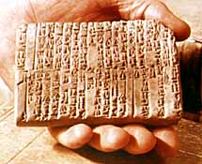
This is due to the way in which the clay tablet was held.
At one period, the tablets were small and were held in the palm of the left hand, with the fingertips gripping the top of the tablet.
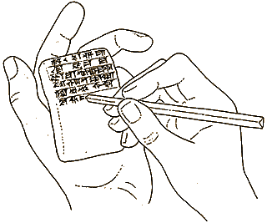
So that pictures were drawn with their ‘tops’ pointing towards the left hand edge of the tablet instead of towards its top edge
. 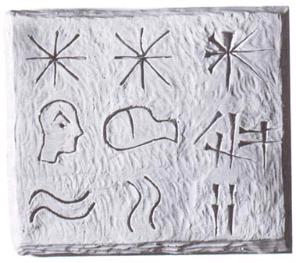
Later, when tablets became larger and were rested on a table, the scribes continued to draw the symbols facing this way.
The Sumerians were early replaced as the greatest power of the Mesopotamian region by various Semitic peoples, such as the Babylonians and the Assyrians, but the Semites took over the Sumerian writing and improved it, and for many centuries cuneiform was the almost universal script of the Near East.
But when the scribes write with a pen or a brush on leather or papyrus, a different development takes place: curves, far from being difficult, offer the easiest and most rapid forms, and a cursive style of writing may arise. This is seen in ancient Egyptian writing.

Ancient Egyptian Scribe
The original Egyptian script was pictorial, and is called hieroglyphic writing, from a Greek word meaning ‘holy carved (letters)’, because the Greeks believed that the Egyptians used this script mainly for religious inscriptions.
Hieroglyphic Writing 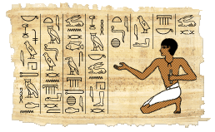
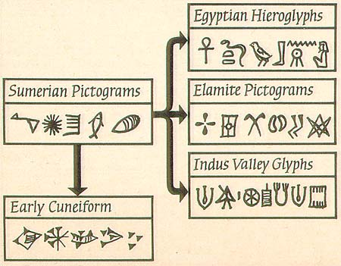
In fact it could be painted as well as carved, and it was also used for documents written on papyrus, a paper-like writing material made from a sedge plant.
Papyrus

But for everyday use a more conventionalized form of writing very soon developed from it, less complicated and much quicker to write, which is known as hieratic, or priestly writing; from this, in turn, developed a script called demotic, or ‘popular’ writing.

What about English Alphabet?
English alphabet like all those of Western Europe, is derived from the Latin alphabet. This in turn is derived from the Greek alphabet. The Greeks in turn got their alphabet from West Semitic people, almost certainly the Phoenicians
From the Greek, this revised alphabet passed to the rest of Western Europe via the Romans. Another line of the development took the same Greek writing system into Eastern Europe where Slavic languages were spoken.
The modified version, called Cyrillic alphabet, is the basis of the writing system used in Russia today.

5th lecture
Language and Medium
- Orality
- Literacy
Language is an abstraction based on the linguistic behavior of its users
Language (abstraction

Speech writing
Speech is primary to writing:
- Writing is a relatively recent development in human societies.
- Thousands of speech communities rely solely on speech
- All of us speak a great deal more than we write.
- Learning to read and write is less spontaneous and less automatic.
Speech | Writing
Speech is composed of sounds | Writing is composed of letters
- make use of intonation, pitch, rhythm, tempo | - make use of pronunciation and other graph logical devices like italics-
-composed of effortlessly- ( no tools are required)- | -produced with efforts(tools required-
- transitory ) | -relatively permanent-
-perceived by ears(listen)- | -perceived by eyes(reading-
-addressee present- | -addresses absent-
-immediate feedback- | -delayed feedback-
-meaning is helped by context, body language& gestures | -meaning must be clear within the context-
- spontaneous- | -non spontaneous-
-associative | -logical
Speech is EPHERMAL
Most of additional differences can ultimately be derived from ephermality of the speech signals and the rapidity of speech production.
Speech is planned over units of less than a sentence in length.
Speech relies heavily on the context of utterance for interpretation.
The context of utterances includes knowledge already known to be shared by speaker and hearer. Also, part of the context, are the objects in the surroundings, which are typically referred to by pronouns rather than descriptive expressions. Less complex syntactic structures are used in speech less than in writing.
REMEMBER
Such a list is sufficient to indicate that speech and writing are very DIFFERENT mediums. But they can function INDEPENDENTLY of each other. We do not have to speak a language in order to read and write it. Nor does an ability to speak a language give a person automatic access to writing. Yet, there are links between the mediums. Most writing systems are based on speech.

6th lecture
Animal Communication
Linguists interest in animal communication system has been largely fueled by a desire to compare such systems with human language3 in order to show the differences between the two, and often, by implication, to show the superiority of human language over the communication system of animals.
Can animals understand human language?
As far as animal behavior is concerned, the standard explanation is that the animal produces a particular behavior in response to a particular sound- stimulus, but does not actually” understand” the meanings of the words uttered.
What is communication?
Communication is a process in which information is transmitted from a source- the sender- to a goal- the receiver .
The process involves five steps:
- Encoding the information into a symbolic system.
- Selecting a mode of communication
- Delivering the symbols through a medium.
- Perceptual processing of the symbols by the receiver.
- Decoding of the symbols to obtain the information.
NOTE:
Nothing is communicated unless the receiver is able to decode the message.

How do we know when communication has taken place?
A specific animal’s behavior may be considered a communication if another’s animal behavior apparently changes as a result. Communication does not take place unless there is a response between the animals.
SWANS
If swan A ruffles its tail feathers and swan B promptly dives, then it seems reasonable to consider the question of what the ruffling of feathers by a swan “says” to another swan. The first observation cannot be conclusive.
If we observe time after time and the response is always the same, then the hypothesis that the ruffling of the feathers by a swan is a communicative behavior.
BEES
The scientist Karl von Frisch spent decades of his life observing the behavior of bees. To study this behavior, he organized the environment of his bees to elicit the same behavior repeatedly and to evaluate the response of other bees. He established a new source of nectar and waited for a bee to discover it. After finding the nectar, the bee would return to the hive and go into a “dance”
As an apparent result, other bees would fly directly to the new source of nectar. Frisch came to the conclusion that there was something about the bee’s dance that communicated the location of the source of the nectar.
The more general significance of Frisch’s studies is that showed that bees have a spontaneous nonhuman communication system that can be reliably translated.
Frisch found that the dance performed by many kinds of bees after they have found a rich source of food can convey a great deal of information.
THE ROUND DANCE
If the food source is very near, a bee returning back to the hive performs a round dance. The dance tells other bees that there is a good source of food nearby.
THE WAGGLE DANCE
If the food is far away from the hive, the bee returning from a rich source of food goes into a waggle dance.
Back at the hives, it flies round in a little dance which tells the other bees where the flowers are.
The dance which proceeds as a repetitive figure eight includes a straight portion. The angle that this straight portion makes with respect to the vertical is the same as the angle lying between the direction to the food source and a horizontal line in the direction of the sun.
Thus, if the straight portion of the dance is exactly vertical, the food source lies in exactly the direction of the sun.
The straight portion of the dance is related to the distance of the food source; the faster the dance, the closer the food.
The dance even contains information about the quality of the food source. The higher the sugar concentration of the food, the longer and livelier the dance.

DOLPHINS AND WHALES
Dolphins and whales have the ability to make variety of sounds. They use whistles to locate objects and to navigate. But their sounds cannot be explained.
CHIMPANZEES
recent work with chimpanzees, which are the animals most closely related to humans, has brought perhaps the most significant advance in the study of animal communication and has raised new questions about the uniqueness of our ability to use language.
METHODS OF TEACHING APES:
Several researchers invented codes to teach apes:
- Using plastic shapes as “words”
- Using a kind of typewriter console keypad to signs
- Using American Sign Language.
CAN APES LEARN LANGUAGE?
In all these cases, the results have been similar. Within a couple of years , the apes could communicate in a fairly restricted manner with their human colleagues by using vocabularies that ranged from about a hundred to three hundred symbols and beyond.
According to the researches, the apes were not just communicating as other animals communicate, they were using language. This, this work seemed to challenge the belief that using language is uniquely human ability.
Some researchers point to several surprising achievements of apes:
- They can handle not only declarative statements but also interrogative forms, negation, comparison, and ever conditional statements.
- The apes not only respond to the researchers but also routinely initiate” conversations” and they formulate new statements that they have not learned through training.
The communication of these apes seems to be creative; they may be using language.
Even if it is proved that human beings are not unique in possessing language, humans do represent the first species to possess a highly developed, creative form of language.
CHARCTERISTICS OF ANIMAL COMMUINCATION:
A vast array of creatures has been observed- bees, whales, chimpanzees and baboons- and many types of communication have been found.
In analyzing these varied systems and comparing them to with human communication, two questions are especially interested:
- What kinds of messages can particular animals convey, and
- Are their systems of communication genetically set or learned.
THE MESSAGES OF ANIMALS:
Many animals vocalize in response to stress. Some cries and actions have more specific meanings that are conveyed to other members of the species.
The words of the various anima; languages are merely interjections. Some animal calls or signals indicate a readiness to mate, others, ownership of a territory; others that danger is near.
Often the animal cannot vary the message or can vary it only slightly and can convey only a very limited range of signals. Animal communication seems to be stereotyped and limited.
But some animals can communicate sophisticated messages, as the behavior of bees indicates. But, the bees vocabulary is quite limited, and its communications are stereotyped compared with human communication.
LEARNED AND INNATE COMMUINCATION
Some animals have their communicative behavior handed to them on a genetic platter, and it develops as they mature; other animals must learn their communicative system.
The bulk of bee communication, for example, has been shown to be genetically built in, or innate. A bee knows from the start how to dance and how to interpret a dance.
However, there is a crucial step that must be learned: a young bee is a poor follower and must practice following dancers before it can accurately perceiver another bee’s dance.
Many birds have calls or songs that are completely innate. Such birds, if raised from the chick stage to adulthood totally separated from their species, will nevertheless develop the characteristics call of their kind.
With other birds, there is an innate component and a learned component to their song. For example, even if the chaffinches are isolated from other chaffinches at birth, their songs show the characteristics of the chaffinch song.
CHAFFINCH
Other aspects of the song, however are learned as the young develop by hearing adult chaffinches sing.
If a chaffinch is raised in isolation from normal adult chaffinches, it develops a song that does not include the final flourish characteristic of normal chaffinch song.
Some birds, such as the skylark, must learn their entire song from others of their species.
HUMAN COMMUINCATION
Human communication seems to be almost totally learned. However, most linguists and psychologists assume that human language has an innate component that causes us to learn language, provided we have contact with.
Many linguists believe that there is a more important innate aspect of language that results in a basic similarity among all the world’s language

