القطع مع الحلول .....وبملف بي دي اف وورد ..بس ..لعيونكم
أول قطعة ركز عليها ص17 ..يلي هي ص18 بالملزمة ...
محدث اليوم الصباح للقطعة الأولى ...
Choose the best answer to complete the paragraph

There are several reasons that undergraduate students should not study away from home living away from home is much more expensive than liv*ing at home. Families can save money by not paying room and board, teen*agers are not mature enough to live far away from their families. Therefore, they often get into trouble. Some students even fail courses because they are not disciplined enough to study in addition they never go to class. Fi*nally many students feel lonely and homesick So they are not able to study. All undergraduate students who stay home with their families get a good education and also a good price.
مالقيتلها اسئلة ......
ولئن الاسئلة صارت50 سؤال احتمال كبير يجيبها لانعا قطعة صغيرة وفيها حروف جر كثير ..وايضا تحتوي على also ,in addation أيضا انتباه شديد عالفواصل والنقط ...
حددت اهم الكلمات بالاحمر ....من وجهة نظري طبعا ....

القطعة الثانية المهمة ص31 يلي هي ص28 بالملزمة ..
بصراحة مالقيت عليها أسئلة لكن لا..بمفهومي العام للمادة ..لونت أهم الكلمات يلي ممكن تجي ..
Muscat, the ancient cap*ital of Oman, is on a spectacular site. The city lies on a narrow strip of land between the sparkling blue waters of the Arabian Gulf and the rocky brown moun*tains behind it. Muscat is a wonderful combination of historic sites and modern buildings. Tourists inter*ested in history will marvel at the splendid forts with their watchtowers and walled gateways. Those with an interest in contemporary architecture will appreciate the simple lines of the Sultan's lovely but unpretentious palace. Directly adjacent to Muscat is the harbor of Muttrah with its beautiful corniche and busy market full of the sights and sounds of this ancient bridge between the Middle East and Asia.
القطعة الثالثة ص35 يلي هي ص29 بالملزمة
تنبييييه مهم ..هالقطعة جابها المحبوب بالاختبار لما كان مستلم المادة زمان ...
We live in an ordinary house and I think it is terrific! Our house is
now 30 years old, but it looks newer. My house is like hundreds of
other houses in the suburbs, one story with an attached garage.
There isnothing special about the house, and it won’t win any
prizes for architecture, but it’s perfect for our family. The kitchen is
big and has new appliances, including a beautiful new dishwasher
and a microwave oven. I don’t like the heat, but we have air
conditioning in the living room and bedrooms, so it is always cool.
For the kids there’s a nice yard where they can play. It’s very safe,
so my wife and I don’t have to worry. I am very thankful that we can
afford this house and live our ordinary lives there.
في ورقة وحده وجدها أحد الأخوة ..
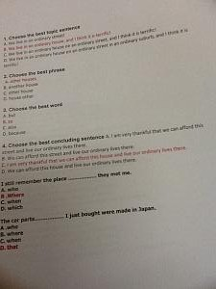
بكل حال راح ألون أهم الاشياء بنظري ....يقولوا جاهم أماكن الفواصل والنقط كمان ..يعني انتبهوا وركزوا عليها ..اتمنى انها ماتجي ...
باقي قطعتين ندخلها من ضمن المهمه يلي هي نزلت بالافتراضي ..
أول قطعة ماذكرها ولاجاب طاريها لا بالمحاضرات ولا بالمحتوى ..مدري احس في سر بالموضوع
القطعة الثانية نعرفها وذكرها ..يلي هي ص21 بالملزمة ..
I have many qualities that have made me a successas a bike messenger. First of all, I have the ability to persevere when there are difficulties. Andbike messengers run into many difficulties. Ihave hadproblems with drivers who almost run me over, constant rain for weeks at a time, unreadable addresses, and rude customers. Inaddition, mydedication to the job hasalsoserved me well. I believe that you shoulddo your best at even the most routine jobs. For example, I work hard atfinding short cuts around the city. And I'm proud to say that when a packageneeds to be deliveredreally quickly, my boss always calls on me. Finally, my success as a bike messenger is partly due tomy sense of humor.Manytimes I have wanted to quit, but I just try to laugh at thesituation
-Choose the best topicsentence

a-I have many qualitiesthat have made me a success as a bike messenger.

هذي هي الاجابه الصحيحه وماعليكم من الباقي ..[IMG]file:///C:/Users/user/AppData/Local/Temp/msohtmlclip1/01/clip_image001.gif[/IMG]

2-Usetransitionwords and phrases:لازم نفرق بين أدوات النقل

a- First ofall

b-- First of

c-- First off
Choose the best verb :

a-has had

b-havehad

c-had had

Choose thebestConnectingwordوأدوات الربط

a-Therefor

b-. Inaddition

c- so

Choose the bestphrase:

a-really quick

b-real quick

c-really quickly

-Choose the best concludingsentence:

a-. Many times Ihave wanted to quit.

b-but I just try to laugh at the situation.

c-. Many times I have wanted to quit, but I just try to laugh at thesituation

- 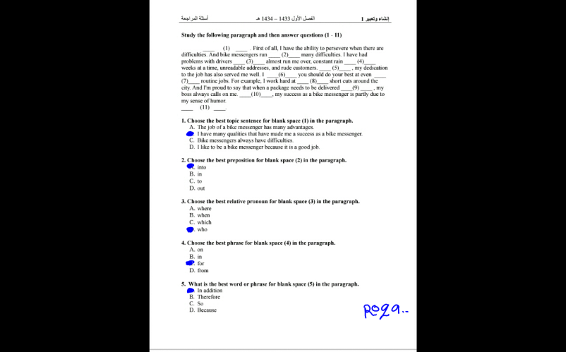
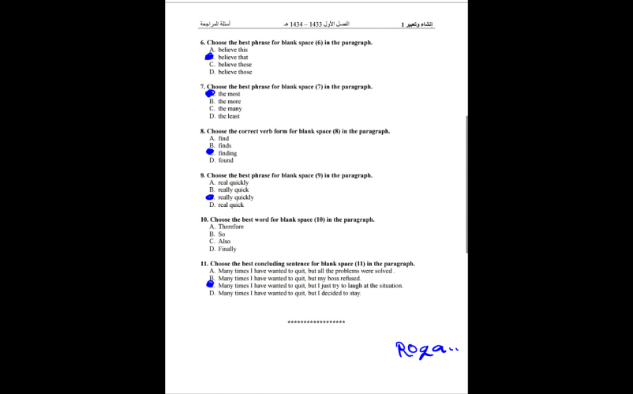
تنبيه مهم ..الاجابة رقم 10 Fainally نسيت احلها ...
الاجابة رقم 15 from ....انتبهوا بليز ...
وهذه الثانية يلي قلتلكم عليها بصفحة 21 بالملزمة
Read paragraphs and complete sentence
My neighborhood is …(1)…because people from all over the world live in it. When I walk down the main street of my neighborhood, I can hear the … (2)…sounds of languages from all over the world. Each ethnic group has its own …( 3)..shop or…(4)… restaurant. On a …(5)…evening, I can smell the …6… melons from the Korean produce store and the …7…curries from the Indian restaurant. These smells are…8…, but for a small price, I can also buy any of 50 kinds of cheeses with …9…names from one store, or …10…Asian vegetables and the spices to cook them in from another. The people of the neighborhood take pride in their surroundings. On almost every street , they plant trees and flowers from their …11…countries to remind them of home and to brighten up the …12…cement and run-down apartment buildings. One of my neighbors plants …13…Scottish flowers every year in memory of her mother’s garden in Scotland. Another neighbor has a Chinese vegetable garden in window boxes. I don’t need to buy an airplane ticket to experience the world, a walk around my neighborhood can be just as…14....
1:which is the best word …?
A: warm B: Colorful C: Unfamiliar D:Fascinating
2:which is the best word …?
A: free B: Fascinating C: Colorful D:Unfamiliar
3:which is the best word …?
A:Colorful B: Fascinating C: StrangeD:exotic
4 : which is the best word …
A: free B: Fascinating C: Colorful D:Unfamiliar
5:which is the best word …
A:WarmB: Colorful C: Unfamiliar D:exotic
6; which is the best word …
A: sweet B: good C:wonderfull D: native
7: which is the best word …?
A:spicy B:sweet B: good D:frees
8: which is the best word …?
A:spicy B:sweet B: good D:frees
9: which is the best word …?
A:Strange B: native C: dull gray D: exciting
10: which is the best word …?
A:Strange B: Colorful C: Exotic D:Unfamiliar
11: which is the best word …?
A: warm B: native C: Unfamiliar D:frees
12: which is the best word …?
A:dull gray B:sweetC: ExoticD:frees
13: which is the best word …?
A: free B: Fascinating C: ExoticD: exciting
Which sentences are correct?
A: Since many people have lived in my neighborhood for years, it is a very friendly place.
B: many people have lived in my neighborhood for years, Since it is a very friendly place.
C: Since Many people have lived in my neighborhood for years. it is a very friendly place.
D: Many people have lived in my neighborhood for years .Since it is a very friendly place.
Which sentences are correct?
A: Since my apartment is very small. I have to keep it very clean.
B: My apartment is very small, since I have to keep it very clean.
C: Since my apartment is very small, I have to keep it very clean.
D: my apartment is very small. Since I have to keep it very clean.
Which sentences are correct?
A: my cousin needed a roommate and is easy to get along with. Since I decided to move
B: my cousin needed a roommate and is easy to get along with, Since I decided to move
C: Since my cousin needed a roommate and is easy to get along with. I decided to move
D: Since my cousin needed a roommate and is easy to get along with, I decided to move
Which sentences are correct?
A: It is easy to get to know everyone in my dormitory since only 40 people live in it.
B: It is easy to get to know everyone in my dormitory, since only 40 people live in it.
C: It is easy to get to know everyone in my dormitory .since only 40 people live in it.
D:Since It is easy to get to know everyone in my dormitory . only 40 people live in it.
Which sentences are correct?
A: Since I have many relatives in the city, I decided not to live in a dormitory.
B: I have many relatives in the city, Since I decided not to live in a dormitory.
C: I have many relatives in the city .Since I decided not to live in a dormitory.
D: Since I have many relatives in the city I decided not to live in a dormitory.
Which sentences are comma splices?
A: My suburban apartment is big and sunny it has a living room with large windows filled with plants.
B: My suburban apartment is big and sunny; it has a living room with large windows filled with plants.
C: My suburban apartment is big and sunny. it has a living room with large windows filled with plants.
D: My suburban apartment is big and sunny. and it has a living room with large windows filled with plants.
Which sentences are comma splices?
A:I have a roommate who is very sloppy .she never washes the dishes, and she leaves her clothes all over the apartment.
B:I have a roommate who is very sloppy. She never washes the dishes, and she leaves her clothes all over the apartment.
C:I have a roommate who is very sloppy ,She never washes the dishes, and she leaves her clothes all over the apartment.
D:I have a roommate who is very sloppy. But She never washes the dishes, and she leaves her clothes all over the apartment.
….
A: I like my street because my neighbors are wonderful .they will help anybody who is having problems.
B: I like my street because my neighbors are wonderful, they will help anybody who is having problems.
C: I like my street because my neighbors are wonderful. Sothey will help anybody who is having problems.
D: I like my street because my neighbors are wonderful. They will help anybody who is having problems.
…
A: First I painted my room, and later I made new curtains.
B: First I painted my room, And later I made new curtains.
C: First I painted my room. later I made new curtains.
D: First I painted my room. and later I made new curtains.
…
A: My favorite place to relax is the park ,is up the hill from my apartment.
B: My favorite place to relax is the park. that is up the hill from my apartment.
C: My favorite place to relax is the park ,that is up the hill from my apartment.
D: My favorite place to relax is the park that is up the hill from my apartment.
…
A: My Street is dirty and noisy.however it has many good restaurants and my neighbors are friendly.
B: My Street is dirty and noisy, and it has many good restaurants and my neighbors are friendly.
C: My Street is dirty and noisy, it has many good restaurants and my neighbors are friendly.
D: My Street is dirty and noisy. And it has many good restaurants and my neighbors are friendly.
1.What is the word that means the same as"protected from loss
A: armored
C: spew
B: split
D: insured
2.What is the word that means the same as"very happy"
A: recover
C: scoop up
B: gleeful
D: bonanza
3.What is the word that means the same as". pick up"
A:prosecute
C: split
B: recover
D: prosecute
4.What is the word that means the same as" charge with a crime"
A:prosecute
C: armored
B: scoop up
D:prosecute
5.What is the word that means the same as" . tear open"
A:prosecute
C: insured
B: split
D: armored
6.What is the word that means the same as"find"
A: armored
C: recover
B: bonanza
D: prosecute
7.What is the word that means the same as"spill"
A: prosecute
C: bonanza
B: spew
D: armored
8.What is the word that means the same as" "sudden riches
A: bonanza
C: bonanza
B: prosecute
D: armored
9.What is the word that means the same as" "protected with strong metal
A: scoop up
C: armored
B: prosecute
D: bonanza
10.What is the word that means the same as" find guilty of a crime"
A: prosecute
C: prosecute
B: convict
D: armored
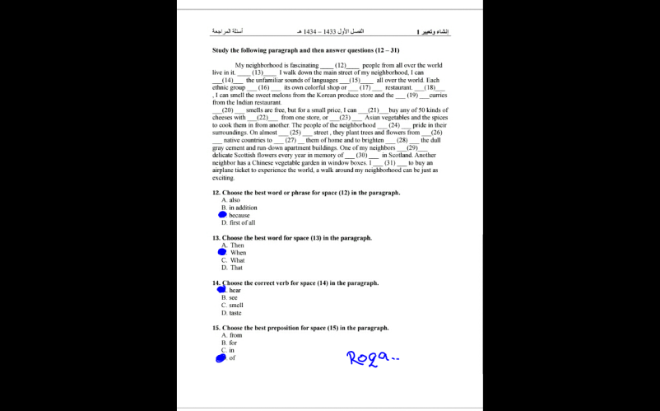
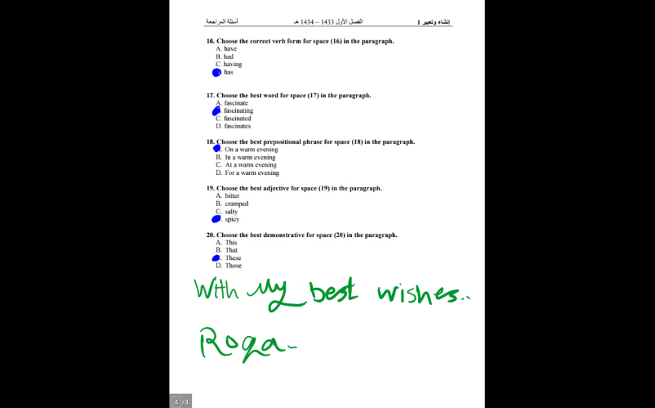
ملاحظة هذه فقط القطع المهمة والتي وردت بالافتراضي ..هذا مو دليل نهمل باقي القطع ..
موجوده طبعا كاملة بملف بالورشة ..وأيضا بالملزمة ....
roqa

