1_ راح يجي بالاختبار [قطعتين] وحدة منهم في (المحاضرة الخامسة) والدكتور راجع عليها في (المحاضرة 14)
2- قطعة عليها 20 سؤال
3- قطعة عليها 10 أسئلة
4- راح يجي بالاختبار Vocabulary تقريبًا 6 أسئلة
5- أسئلة [هل الجملة صحيحة من حيث الكتابة] راح يجينا عليها سؤالين (المحاضرة السابعة)
6- أسئلة عن الكلمات الوصفية [أشياء نشوفها - ولا نحسها - نسمعها] عليها 3 أسئلة (المحاضرة الرابعة)
7- الـSuffixes والـPrefixes مو ان شالله ما راح يجي منها شي
8- سؤالين أو ثلاثة عن الصفات الإيجابية والسلبية (المحاضرة الثامنة)
9- راح يجينا أسئلة على نوع الكلمة [فعل - اسم - صفة..] (في مثال عليه بالمحاضرة السادسة)
10- التمارين اللي كل بمحاضرة <--
11- بالنسبة لأسئلة [therefore. so / who which that..] طمننا إن ما راح ييجي أسئلة تلخبط
12- الاختبار راح يكون سهل بإذن الواحد الأحد
Vocabulary
الكلمات في المحاضرات:
الأولى - الرابعة - السادسة
المحاضرة الأولى:
1- a good thing = advantage
2- the cost of college classes = tuition
3- very large = huge
4- a good reputation = prestige
5- teachers = faculty
6- a building, laboratory, a library = facility
7- go to = attend
8-having many different kinds = diverse
9- not friendly = impersonal
10- a bad thing = disadvantage
المحاضرة الرابعة:
1- Strange and unusual = exotic
2- small and pretty = delicate
3- very interesting = fascinating
4- to make pretty = brighten up
5- sad-looking = dull gray
6- to be proud of = take pride in
المحاضرة السادسة:
1- Armored = protected with strong metal
2- Split = tear open
3- Spew = spill
4- Recover = find
5- Scoop up = pick up
6- Gleeful = very happy
7- Bonanza = sudden riches
8- Prosecute = charge with a crime
9- Convict = find guilty of a crime
10- Insured = protected from loss
الـVocabulary
+
الصفات السلبية والإيجابية
+
تقسيم الكلمات هل: اسم - فعل - حال...~
القطعة
هاذي القطعة بالمحاضرة الخامسة + بالمحاضرة الـ14
لكن عشان تاخذون فكرة..~ بحط هنا اللي جت بالمحاضرة 14 + الأسئلة اللي كانت عليها..~
ها هي ذا:
Choose the best answer to complete the paragraph:
( 1 )………………………………………………………………………………. !Our house is now 30 years old, but it looks newer. My house is like hundreds of ( 2 )…………………… in the suburbs, one story with an attached garage. There is nothing special about the house, and it won’t win any prizes for architecture, but it’s perfect for our family. The kitchen is big and has new appliances, including a beautiful new dishwasher and a microwave oven. I don’t like the heat, but we have air conditioning in the living room and bedrooms, so it is always cool. For the kids there’s a nice yard where they can play. It’s very safe, ( 3 ) …………….. my wife and I don’t have to worry. ( 4 ) …………...................................
1. Choose the best topic sentence
A. We live in an ordinary street!
B. We live in an ordinary house, and I think it is terrific!
C. We live in an ordinary house on an ordinary street, and I think it is terrific!
D. We live in an ordinary house on an ordinary street in an ordinary suburb, and I think it is terrific!
2. Choose the best phrase
A. other houses
B. another house
C. other house
D. house other
3. Choose the best word
A. but
B. so
C. also
D. because
4. Choose the best concluding sentence
A. I am very thankful that we can afford this street and live our ordinary lives there.
B. We can afford this street and live our ordinary lives there.
C. I am very thankful that we can afford this house and live our ordinary lives there.
D. We can afford this house and live our ordinary lives there.
تلقون هذا التمرين في المحاضرة الرابعة
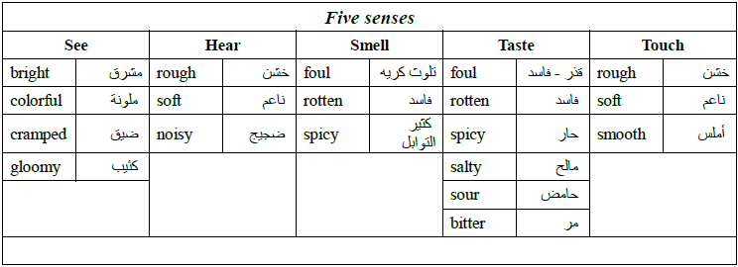
كان هذا في بالمحاضرة السادسة.. وبالمحاضرة العاشرة..~
موجود بملف Great Heart بعد..~
وهاذي صورته..~
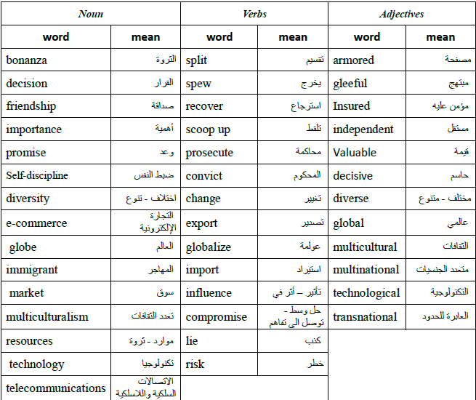
الصفات الإيجابية والصفات السلبية
كانت في المحاضرة الثامنة..~
الصفات الإيجابية:
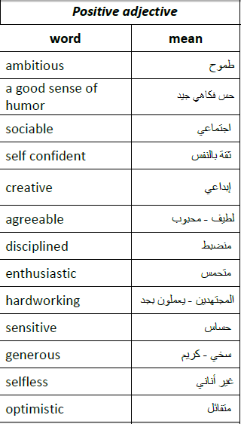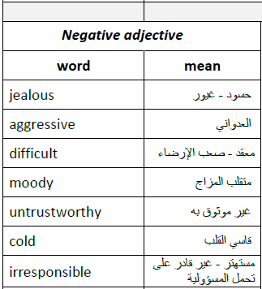
الصفات السلبية:

Correcting Spelling Error
تعديل الأخطاء الكتابية..~
هذا التمرين في المحاضرة السابعة:
هذا اللي قلنا بيجي عليه سؤالين..~
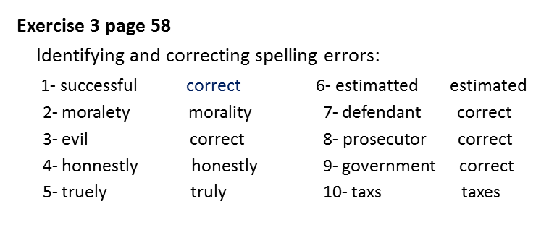
القطعة الثانية..~
القطعة تلقونها بالمحاضرة الثالثة
هاذي هي:
Studying abroad offers students many advantages. First of all, students have the opportunity to learn a new language by interacting with native speakers every day. In addition, the students live in a new culture, so they can learn both in and out of the classroom. Studying abroad also teaches students that there are other ways of looking at the world. This is a very important part of education. In addition, students learn to be flexible because they have to adapt to different ways of living. They experience another culture in a much more significant way than if they simply took a vacation to another country. Also, Foreign students are far from home. Therefore, they have to become responsible and self-reliant. When they study abroad, students have an experience they will remember all their lives.
Studying abroad ___2__ students many advantages .__7_, students have the opportunity to learn _4__ by interacting with native speakers every day. The students live in a new culture_3__ they can learn both in and __6__ the classroom. Studying abroad teaches students that there are _11_of looking at the world. This is a very important part of education. Students learn to be flexible ____8____ they have to adapt to different _16__ of living. They experience another culture in a_5__ significant way than if they simply __14__ a vacation to another country. Foreign students are far from home. __12__, they _15__ become responsible and self-reliant. When they study abroad, students have an experience they will remember all their lives.
1-Choose the best topic sentence
a- Studying abroad offers students many advantages
b- many advantages
c- Studying abroad
2- Choose the best phrase
a- students offers
b- offers students
c- offer students
3-Choose the best word
A. but
B. so
C. also
4- Choose the best phrase
a- news language
b- a new language
c- language new
5- Choose the best phrase
a- a many more
b- a more much
c- a much more
6- Choose the best phrase
a- out of
b- out off
c- of out
7- Use transition words and phrases:
a- First of all
b-- First of
c-- First off
8-Use transition words and phrases:
a- therefore
b- because
c—Therefore
connect similar ideas9-
a- Also Studying abroad teaches
b- Studying abroad also teaches -
c - In addition Studying abroad teaches –

connect similar ideas10-
a- - In addition ,the students live in a new culture
b- The students also live in a new culture
c-in addition The students live in a new culture
Choose the best phrase- 11
a-other way
b-another ways
c- other ways
12-Choose the best word
a-Therefor
c- so
b-also
13-Choose the best concluding sentence
a. When they study abroad, students have an experience they will remember all their lives
b- students have an experience they will remember all their lives
c-. When they study abroad, students have an experience
Choose the best word14-
a- took a vacation
b- take a vacation
c- taken a vacation
Choose the best word 15-
a-must become
b- have become
c- have to become
Choose the best word16-
a- different way
b- different ways
c- differents ways

