بسم الله الرحمن الرحيم
lecture 5
في هالمحاظره ان شالله مازلنا في معرفه الكلمات الجديده بدون استخدام الدكشنري
today also we’re going to take new 7 ways :
- Definition
give the meaning of words by using some keywords
المقصود فيه تعريف الكلمه من خلال بعض المفاتيح والي هم

is/are means/mean
is/are called what this means is
is/are known as consist of
is/are defined as refer to
is/are described as may be seen as
Exercise 1
Use signal words as your clues to find the meaning of the underlined words. Circle signal words and write their meaning in the space provided.
- The encyclopedia defines astrology as “the ancient art or science of divining the fate and future of human beings from indications given by the positions of stars and other heavenly bodies.”
الجواب الي بالهايلايت طبعا هنا بهالمثال الي راح يخلينا متاكدين من الحل مره الي هو علامه الترقيم " وطبعا الكلمه الي بالاسود هي من الـ keywords
- Sales literature means printed matters that contain information on the goods.
الجواب الي بالهايلايت والكلمه الي بالاسود هي من الـ keywords
- The part at the back of the car used for holding luggage is called the car boot in United Kingdom, whereas Americans would refer to this as the car’s trunk.
هنا فيه جوابين بهالسؤال .. الجواب الاول الي بالهايلايت الرصاصي والجواب الثاني الي بالهايلايت الاصفر ونفس الشي الكلمتين الي بالاسود من الـ keywords وكلهم صح سواءا اخترتوا الجواب الاول او الثاني
- Restatement
describe the same words in a different way
والمقصود فيه شرح الكلمه بنفس الجمله بس يعطيكم اياه بمعنى اخر وفيه بعد مفاتيح للطريقة
or – that is to say – in other words – i.e. or that is
Exercise 2
Use signal words as your clues to find the meaning of the underlined words. Circle signal words and write the meaning in the space provided.
- According to Indian custom, a great dowry of money and objects is given to the bridegroom, in other words, it is a dot.
الجواب الي بالهايلايت ونفس الشي الي راح يخلينا متاكدين من الحل مره الي هو علامه الترقيم , وطبعا الكلمه الي بالاسود هي من الـ keywords
2. There are several types of aerosol cans. Simple ones contain a liquefied gas, called the propellant, in which material is dissolved, i.e., melt.
الجواب الي بالهايلايت ونفس الشي الي راح يخلينا متاكدين من الحل مره الي هو علامه الترقيم , وطبعا الكلمه الي بالاسود هي من الـ keywords
3. Our youth nowadays should not engage in intoxicating things such as alcohol, cigarettes, and tranquilizers, that is to say, they should not ingest them.
الجواب الي بالهايلايت ونفس الشي الي يخلينا متاكدين من الحل مره الي هي علامه الترقيم , وطبعا الكلمه الي بالاسود هي من الـ keywords
- Punctuation
تكلمنا عنها بالمحاظرات السابقه ومافي جديد فيها غير علامتين ترقيم جديدة
dashes // appositive , ,

Exercise 4
Use signal words as your clues to find the meaning of the underlined words. Circle signal words and write the meaning in the space provided.
- Both facsimile (known as fax) and electronic mail (email) are ways of sending documents.
2. An FM radio DJ (disk jockey) broadcasts over the airwaves.
3. Infection / becoming ill through contact with bacteria / of the respiratory system such as the nose, the throat, and the chest is among the most common of all diseases.
- Examples
وهنا عندنا طريقه اخرى والي هي بذكر امثله في الجمله حتى يسهل علينا معرفه الكلمه الجديدة
such as – for examples – for instance – is / are
معلومه خارجيه اخذتها بالمعهد بلفل 5 وحبيت اقولها لكم وان شالله تفيدكم خصوصا بالكتابه
for examples and for instance دايما يجي بعدها comma وتجي بمكانين اما بدايه الجمله او بالوسط
اما بالنسبه لـ such as دايما تجي بوسط الجمله ما تجي بعدها comma ابد لكن يجي بعدها noun

Exercise 5
Use signal words as your clues to find the meaning of the underlined words by choosing the best answer for each question. Circle signal words.
1. Some people in the North of Thailand do wickerwork, for example, they make elephants, turtles, plates, beds, and chairs, from teak trees for earning money.
a) silver handicraft
عرفنا الجواب من الشجر عشان كذا قلنا
wood handicraft
b) bronze handicraft
c) nylon handicraft
d) wood handicraft
2. The Savanna grasslands are the home of grazing animals such as elephants, giraffes, antelopes and zebras. Lions, leopards and hyenas also live there.
a) non-backbone animals
b) meat-eating animals
c) invertebrate animals
d) grass-eating animals
- Contrast
show the opposite meaning of the new words
معرفه الكلمه من عكسها او النقيض لها وايضا لها keywords حتى يسهل علينا البحث
but instead of – even though – in contrast to – yet – in spite of although – as opposed to – unlike – despite – however – on the other hand – whereas – fond of still – provided that .
Exercise 6
Use signal words as your clues to find the meaning of the underlined words by choosing the best answer for each question. Circle signal words.
1. Ladda was promoted to be the chief secretary of the manager of the company, whereas her colleague, Somechai, was penalized.
a) promoted
b) punished
c) exiled
d) Rewarded
- Similarity
it will display the same meaning of the new words .
معناته ان بالجمله راح يكون عندنا كلمتين بنفس المعنى بس كلمات مختلفه وايضا راح يكون عندنا مفاتيح لمعرفه هالكلمات
like – similarly – in the same way – as the same as – just as

Exercise 7
Use signal words as your clue to find the meaning of the underlined words. Circle signal words and write the meaning in the space provided.
- Learning should not be limited to the classroom or with teachers. We can learn by ourselves about things that are not taught by teachers. Similarly, “self-learning” is encouraged for our education system.
الجواب الي عليه الهايلايت

- Pictures
اخر شي عندنا الي هو من خلال الصور وتعتبر من اسهل الطرق الي مرت علينا
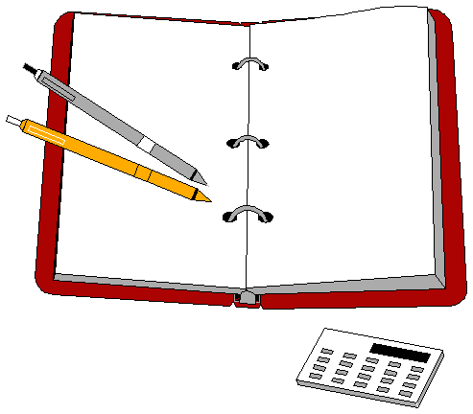
Which is the best description for the above picture?

- For Sale
- Equipment used in an office
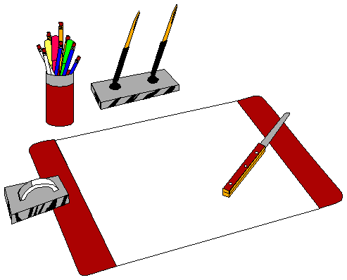
- Instruments for you
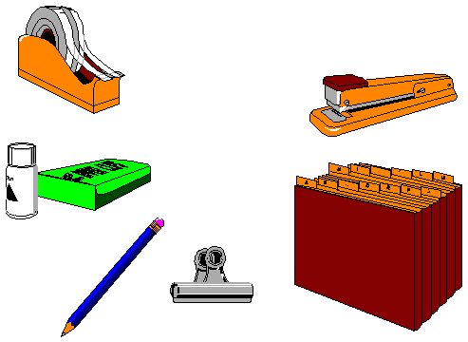
وبكذا خلصنا المحاظره الخامسه ولله الحمد واي سؤال راح اكون بالخدمه باذن الله
اختكم
English student

