بسم الله الرحمن الرحيم
lecture 9
راح نبدا بصفحه 81
ونكمل مع skimming for the topic and the main idea
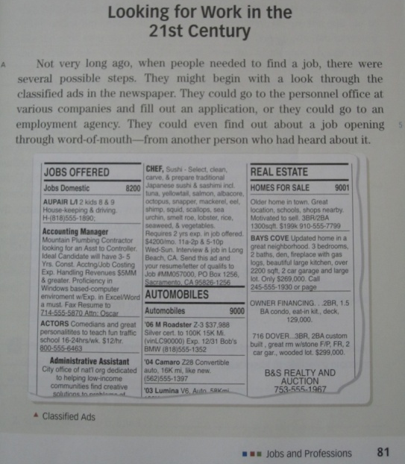
Topic: Steps of finding a job
Main Topic: There were several possible steps to find jobs Not very long ago.
They (Paragraph A, Line 2)
people who need a job

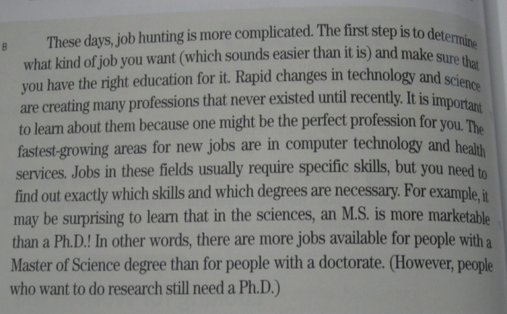
Topic: Job Hunting Steps nowadays
Main Idea: Job hunting has become more complicated these days
Them (Paragraph B, Line 11)
many professional

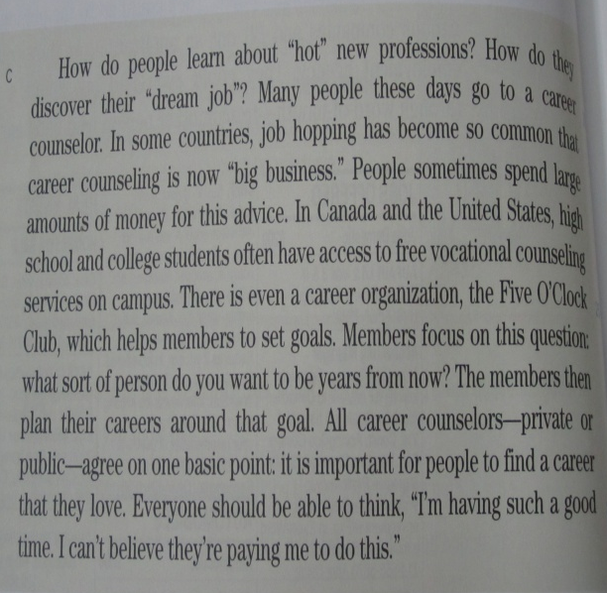
Topic:
Career Counseling
Main idea:
Job hopping has become so common that career counseling is now big business

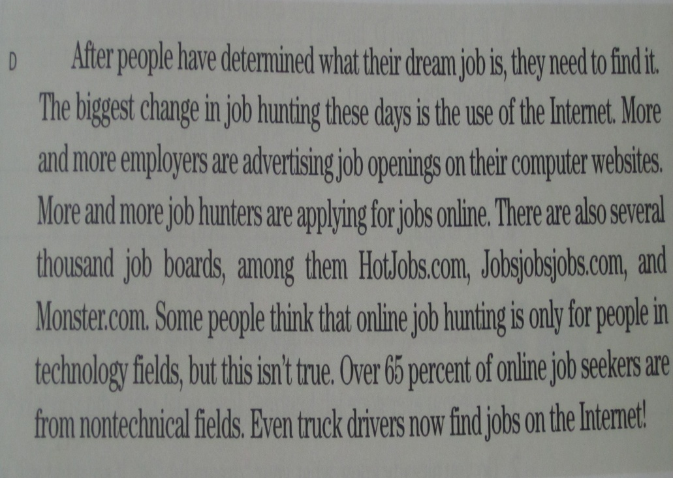
Topic: Internet and Job Hunting
Main Idea: More and more job hunters
are applying for jobs online.
It (Paragraph D, Line 33)
dream jobs
Them (Paragraph D, Line 36)
jobs

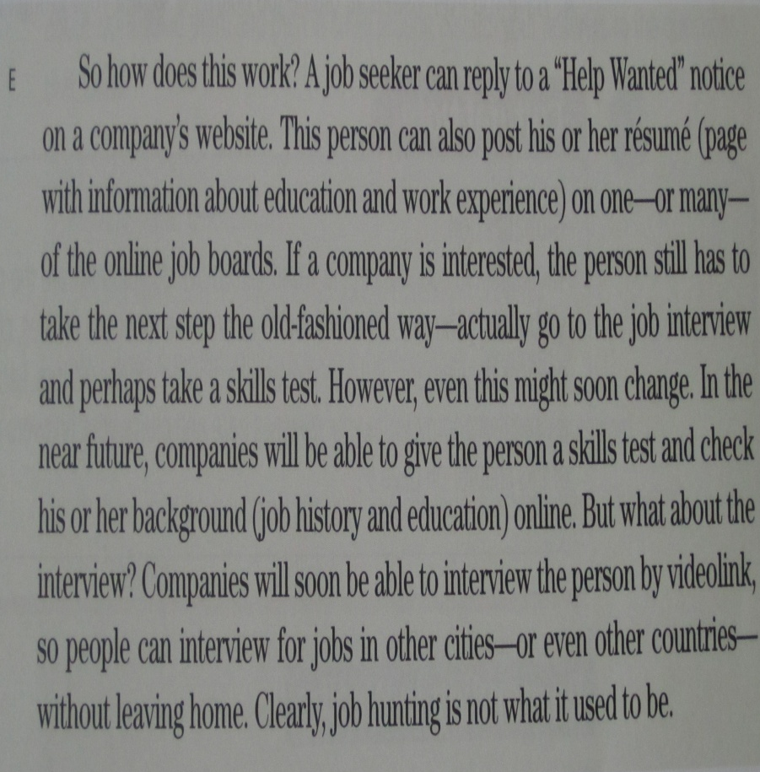

Topic:
Online Job Hunting Steps
Main Idea:
Job hunting nowadays is not
what it used to be

بعده عندنا previewing vocabulary مأخوذه من كذا صفحه من الكتاب ( 123- 131 – 135 )
n / noun
v / verb
pv / phrasal verb

Meaning | Words | Meaning | Words
Need or want | require ( v ) | A place by sea for ships and boats | harbor ( N )
surprise | astonish ( v ) | A space between two things / a difference | gap ( N )
Make happy | Excite ( v ) | Very useful food | nutrients ( N )
to rest | Relax ( v ) | hindrances | obstacles ( N )
Concern / benefit | interest ( N ) | advantages | benefits ( N )
Stand against | Challenge ( v ) | places | Areas ( N )
Horrify / terrify / make others feel afraid | Frighten ( v ) | An inspector who looks for criminals | detective ( N )
Stop or prevent | Hold back (PV) | search | Look for ( v )
Away from others/ nobody with him/ her | Alone (Adj) | Make less | reduce ( v )

exercise:
1.The word “_____________” is closest in meaning to the word “ surprise “.
a. terrify b. challenge
c. laugh d. astonish
2. If you go to the______________ you will many boats and ships.
a. harbor b. office
c. hospital d. restaurant
3. The word “need” is closest in meaning to the word
a. question b. visit
c. require d. invest
4. The phrase “ a space/ distance between two things or persons” is a ـــ
a. building b. street
c. wall d. gap
5.The word “_______” is closest in meaning to the phrase “ make less “.
a. reduce b. widen
c. require d. worsen
6. most people prefer to ______________ by the sea coast.
a. relax b. test
c. work d. type
7. The word “hindrances” is closest in meaning to the word _______
a. questions b. obstacles
c. facilities d. stories
8. The phrase “ an inspector who looks for criminals” is called a/n _____
a. detective b. astronaut
c. teacher d. servant
ننتقل الحين لصفحه 130 المطلوب مننا نقرا القطعه الموجوده ونجاوب ع الاسئله
Questions
1. What do the travelers who come from a vacation say about their trip?
a. We were sick? b. It was a long trip
c. Oh, it was out of the world d. Oh, Nice trip
2. The underlined pronoun “ it” line 2 refers to __________ .
a. the answer b. the question
c. the trip d. this world
3. which of the following is closest in meaning to special ?
a. strong b. enjoyable
c. public d. private

4. literally means: _______________:
a. word by word b. stay alive
c. unreal d. wonderful
5. How long does it take to give you the feeling of weightlessness?
a. Two weeks b. Three minutes
c. One hour d. Several minutes
6. The underlined pronoun “ their” line 3 refers to ______________ .
a. amazing trips b. people
c. travelers d. the vacations
7. It is clear that a trip to space is ______________
a. expensive b. tiring
c. public d. dangerous
8. How much did the two individuals who stayed a week at I S S pay?
a. $20,000,000 b. $40,000,000
c. it was free d. $10,000,000
9. The most appropriate TOPIC of the reading passage is _____
a. California Company b. Travelling Into Space
c. Amazing Expression D. Galactica
10. The MAIN IDEA of the passage is _____________
a. A trip to the sea is wonderful b. It is very cheap to go to space
c. Space travelling is now possible d. No one like to travel into space

وبكذا نكون خلصنا محاظرتنا واي سؤال انا بالخدمه
اختكم / English student

