Lecture 3
The Sonnet
A sonnet:
is a fourteen-line poem in iambic pentameter with a carefully patterned rhyme scheme.

- Other strict, short poetic forms occur in English poetry (the sestina, the villanelle, and the haiku, for example), but none has been used so successfully by so many different poets.
- There are two types of sonata: Italian(Petrarchan) and English (Shakespearean)

The Italian sonnet:
- First by the Italian poet Francesco Petrarch (1304-1374), who ascribed to him a Petrarchan sonnet.
- the Italian poet, was introduced into English poetry in the early 16th century by Sir Thomas Wyatt (1503-1542).

Sonnet consists of: Its fourteen lines break into:

octave (or octet): ⬅ 8 الأبيات الأولى which usually rhymes abbaabba, but which may sometimes be abbacddc or even (rarely) abababab

sestet: ⬅ 6 الأبيات الأخيرة which may rhyme xyzxyz or xyxyxy,
or any of the multiple variations possible using only two or three rhyme-sounds.

Example: “Farewell Love and all thy laws for ever”

Farewell Love and all thy laws for ever, a
Thy baited hooks shall tangle me no more; b become confused
Senec and Plato call me from thy lore b Senec . Plato stands for knowledge
To perfect wealth my wit for to endeavour. a attempt
In blind error when I did persever, a
Thy sharp repulse, that pricketh aye so sore, b your. Rejection. Causes pain, stings
Hath taught me to set in trifles no store b
And scape forth, since liberty is lever. a escape.
Therefore farewell; go trouble younger hearts c
And in me claim no more authority; d
With idle youth go use thy property d
And thereon spend thy many brittle darts. c hard but easily broken
For hitherto though I have lost all my time, e
Me lusteth no longer rotten boughs to climb. e

- Wyatt Devonshire (1557)

The English (Shakespearean) sonnet:

- developed first by Henry Howard, Earl of Surrey (1517-1547)

Sonnet consists of: three quatrains and a couplet--that is, it rhymes abab cdcd efef gg.

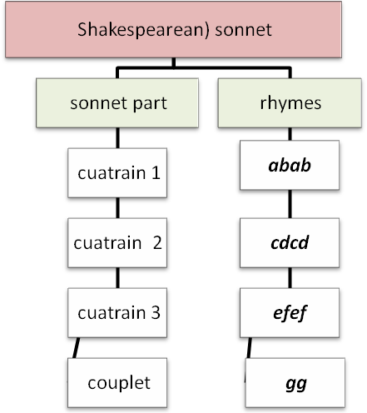

- The form into which a poet puts his or her words is always something of which the reader ought to take conscious note. And when poets have chosen to work within such a strict form, that form and its strictures make up part of what they want to say. In other words, the poet is using the structure of the poem as part of the language act: we will find the "meaning" not only in the words, but partly in their pattern as well.

The sonnet can be thematically divided into two sections:
- The first presents the theme, raises an issue or doubt.
- The second part answers the question, resolves the problem, or drives home the poem's point.
- This change in the poem is called the turn and helps move forward the emotional action of the poem quickly.

- The Italian form, in some ways the simpler of the two, usually projects and develops a subject in the octet, then executes a turn at the beginning of the sestet, so that the sestet can in some way release the tension built up in the octave.

- The Shakespearean sonnet has a wider range of possibilities.
One pattern introduces an idea in the first quatrain,
complicates it in the second,
complicates it still further in the third,
and resolves the whole thing in the final couplet.

Example:
“Sonnet 138” or “When My Love Swears that She is Made of Truth”

When my love swears that she is made of truth a
I do believe her, though I know she lies, b
That she might think me some untutor'd youth, a
Unlearned in the world's false subtleties. b
Thus vainly thinking that she thinks me young, c ⬅
Although she knows my days are past the best, d ⬅
Simply I credit her false speaking tongue: c ⬅هنا لاحظوا انها نفس الصوت
On both sides thus is simple truth suppress'd. d ⬅
But wherefore says she not she is unjust? e
And wherefore say not I that I am old? f
O, love's best habit is in seeming trust, e
And age in love loves not to have years told: f
Therefore I lie with her and she with me, g
And in our faults by lies we flatter'd be. g

- William Shakespeare

الدكتور وهو يقرأ القصيدة قام بشرح لها أتمنى الأستماع لها

- Shakespeare at the end of the poem repeats the word lie
Tells us that he likes to become detrimental to his love and flirting with his sweetheart ((and he knows they are many ..!!)) and demonstrating in front of each other that their relationship and not to accept the bitterness has accepted each other .. and here Shakespeare describes his feelings for years, courting her youth while she accept his confidence on its promises.
- First quatrain; note the puns and the intellectual games: [I know she lies, so I believe her so that she will believe me to be young and untutored]

- Second quatrain: [Well of course I know that she doesn't really think I'm young, but I have to pretend to believe her so that she will pretend that I'm young]

- Third quatrain: [so why don't we both fess up? because love depends upon trust and upon youth]

- Final couplet, and resolution:
[we lie to ourselves and to each other, so that we may flatter ourselves that we are young, honest, and in love]. Note especially the puns].

شريحتي review يلخص فيها الدكتور في نهاية المحاضره النقاط الرئيسيه التي شرحها بالتفصيل سابقا ..
وهي مهمه جداااا <<<< منقووووول من أختي لاتحزني ☺

بدويه

© 2011 ملتقى جامعة الملك فيصل- اللغة الإنجليزية
المستوى الرابع

