Lecture 8
THE SHAKESPEAREAN THEATER
William Shakespearean
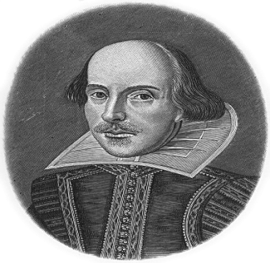
The Shakespearean Theater
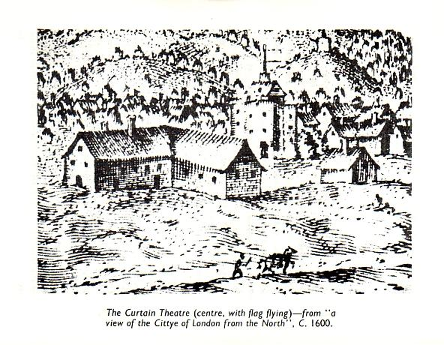
The (Elizabethan) Shakespearean Theater
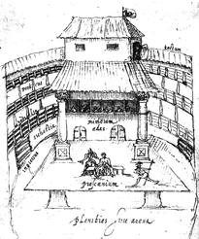
The Shakespearean Theater
Before Shakespeare's time and during his boyhood, groups of actors performed wherever they could—in halls, courts, courtyards, and any other available open spaces. In 1574, however, when Shakespeare was ten years old, the Common Council passed a law requiring plays and theaters in London to be licensed. In 1576, actor and future Lord Chamberlain's Man, James Burbage, built the first permanent theater called simply The Theatre outside London’s city walls. Thereafter, many more theaters were established around the city of London, including the Globe Theatre in which most of Shakespeare's plays were performed.
(The image shows an illustration of the Curtain Theater, which was built some 200 yards away from London. The Curtain Theater and also housed many Shakespearean plays.)
The Shakespearean Theater
Elizabethan theaters were generally built after the design of the original Theatre. Built of wood, these theaters comprised three rows of seats in a circular shape, with a stage area on one side of the circle. The audience's seats and part of the stage were roofed, but much of the main stage and the area in front of the stage was open to the elements sun as rain. About 1,500 audience members could pay an extra fee to sit in the covered seating areas, while about 800 "groundlings" (standing spectators) paid less to stand in the open area before the stage.
The Shakespearean Theater
The stage itself was divided into three levels: a main stage area with doors at the rear and a curtained area in the back for "discovery scenes"; an upper, canopied (decorated cover with clothes) area called "heaven" for balcony scenes; and an area under the stage called "hell," accessed by a trap door in the stage. There were dressing rooms located behind the stage, but no curtain in the front of the stage, which meant that scenes had to flow into each other and "dead bodies" had to be dragged off.
The Shakespearean Theater
Performances took place during the day, using natural light from the open center of the theater. Since there could be no dramatic lighting and there was very little scenery or props (The objects and furniture used in the play), audiences relied on the actors' lines and stage directions to supply the time of day and year, as well as the weather, location, and mood. Shakespeare's plays convey such information masterfully. In Hamlet, for example, the audience learns within the first ten lines of dialogue where the scene takes place ("Have you had quiet guard?"), what time of day it is ("'Tis now struck twelve"), what the weather is like ("'Tis bitter cold"), and what mood the characters are in ("and I am sick at heart").
The Shakespearean Theater
One important difference between plays written in Shakespeare's time and those written today is that Elizabethan plays were published after their performances and sometimes even after their authors' deaths. The scripts were in many ways a record of what happened on stage during performances, rather than directions for what should happen. Actors were allowed to suggest changes to scenes and dialogue and had much more freedom with their parts than contemporary actors. A scene illustrative of such freedom occurs in Hamlet: a crucial passage revolves around Hamlet writing his own scene to be added to a play in order to ensnare (gain power over somebody by using dishonest means) his murderous uncle.
The Shakespearean Theater
Shakespeare's plays were published in various forms and with a wide range of accuracy during his time. The discrepancies between versions of his plays from one publication to the next make it difficult for editors to put together authoritative editions of his works. Plays could be published in large anthologies in folio format (the First Folio of Shakespeare's plays contains 36 plays) or smaller quartos. Folios were so named because of the way their paper was folded in half to make a large volume. Quartos were smaller, cheaper books containing only one play. Their paper was folded twice, making four pages. In general, the First Folio is considered to be more reliable than the quartos.
The Shakespearean Theater

Although Shakespeare's language and classical references seem archaic (old) to many readers today, they were accessible to his contemporary audiences. His viewers came from all classes and his plays appealed to all kinds of sensibilities, from "highbrow" accounts of kings and queens to the "lowbrow" blunderings of clowns and servants. Even utterly tragic plays like King Lear or Macbeth contain a clown or fool to provide comic relief and to comment on the events of the play.
The Shakespearean Theater

Audiences would also have been familiar with his numerous references to classical mythology and literature, since these stories were staples (an essential part) of the Elizabethan knowledge base. And yet, despite such a universal appeal, Shakespeare’s plays also expanded on the audience’s vocabulary. Many phrases and words that we use today—such as "amazement," "in my mind's eye," and "the milk of human kindness," to name only a few—were coined by Shakespeare. His plays contain indeed a greater variety and number of words than almost any other work in the English language.
The Shakespearean Theater
About Macbeth :
Legend says that Macbeth was written in 1605 or 1606 and performed at Hampton Court in 1606 for King James I and his brother-in-law, King Christian of Denmark. Whether it was first performed at the royal court or was performed at the Globe theatre, there can be little doubt that the play was intended to please the King, who had recently become the patron of Shakespeare's theatrical company. We note, for example, that the character of Banquo—the legendary root of the Stuart family tree—is depicted very favorably. Like Banquo, King James was a Stuart. The play is also quite short, perhaps because Shakespeare knew that James preferred short plays. And the play contains many supernatural elements that James, who himself published a book on the detection and practices of witchcraft, would have appreciated. Even something as minor as the Scottish defeat of the Danes may have been omitted to avoid offending King Christian.
The Shakespearean Theater
The material for Macbeth was drawn from Raphael Holinshed's Chronicles of England, Scotland, and Ireland (1587). Despite the play’s historical source, however, the play is generally classified as tragedy rather than a history. This derives perhaps from the fact that the story contains many historical fabrications—including the entire character of Banquo, who was invented by a 16th-century Scottish historian in order to validate the Stuart family line. In addition to such fictionalization, Shakespeare took many liberties with the original story, manipulating the characters of Macbeth and Duncan to suit his purposes. In Holinshed's account, Macbeth is a ruthless and valiant leader who rules competently after killing Duncan, whereas Duncan is portrayed as a young and soft-willed man. Shakespeare draws out certain aspects of the two characters in order to create a stronger sense of polarity. Whereas Duncan is made out to be a venerable and kindly older king, Macbeth is transformed into an indecisive and troubled young man who cannot possibly rule well.
The Shakespearean Theater
Macbeth is certainly not the only play with historical themes that is full of fabrications. Indeed, there are other reasons why the play is considered a tragedy rather than a history. One reason lies in the play's universality. Rather than illustrating a specific historical moment, Macbeth presents a human drama of ambition, desire, and guilt. Like Hamlet, Macbeth speaks soliloquies that articulate the emotional and intellectual anxieties with which many audiences identify easily. For all his lack of values and "vaulting ambition," Macbeth is a character who often seems infinitely real to audiences. This powerful grip on the audience is perhaps what has made Macbeth such a popular play for centuries of viewers.
The Shakespearean Theater
Given that Macbeth is one of Shakespeare's shortest plays, some scholars have suggested that scenes were excised (removed) from the Folio version and subsequently lost. There are some loose ends and non-sequiturs* in the text of the play that would seem to support such a claim. If scenes were indeed cut out, however, these cuts were most masterfully done. After all, none of the story line is lost and the play remains incredibly powerful without them. In fact, the play's length gives it a compelling, almost brutal, force. The action flows from scene to scene, speech to speech, with a swiftness that draws the viewer into Macbeth's struggles. As Macbeth's world spins out of control, the play itself also begins to spiral towards to its violent end.
The Shakespearean Theater
- A non-sequitur : is a statement, remark, or conclusion that does not follow naturally or logically from what has been said.

