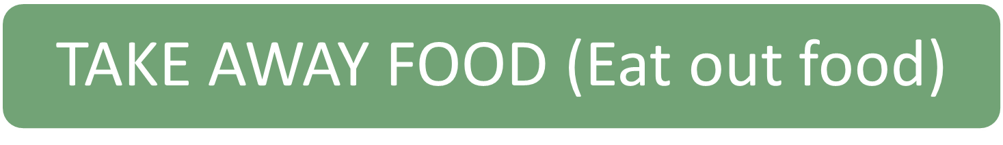
Take-away meals are very popular and most towns have a selection of Indian, Italian, Chinese and Greek Restaurants. You will also find Macdonalds, Burger King and Subway.
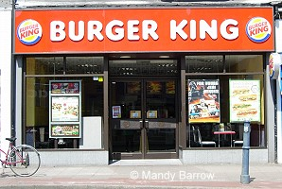
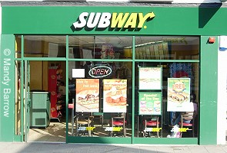

Fish and chips is the classic English take-away food and is the traditional national food of England. It became popular in the 1860's when railways began to bring fresh fish straight from the east coast to the our cities over night.
The fish (cod, haddock, huss, plaice) is deep fried in flour batter and is eaten with chips. Traditionally, the fish and chips are covered with salt and malt vinegar and, using your fingers, eaten straight out of the newspaper which they were wrapped in. Now-a-days small wooden forks are provided and the fish and chips are wrapped in more hygienic paper. In the north of England, fish and chips is often served with "mushy peas" (mashed processed peas).
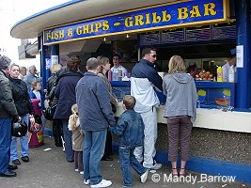

Where can you eat in Britain apart from at home and in a restaurant ?
Pubs are an important part of British life. People talk, eat, drink, meet their friends and relax there.
Do you really know what the English are like?
English Stereotypes (Not British)
Woodlands Junior School is in the south-east corner of England
Definition: A stereotype is "...a fixed, over generalised belief about a particular group or class of people.” (Cardwell, 1996). In other words stereotyping is believing that people of a certain group, race or religion all have the same characteristics when they don't.
Learning from the media and talking to older people, we pick up a lot of stereotypes about other nations. In every country there are plenty of stereotypes about residents, some maybe true but most of them are untrue and very wrongful. This page looks at stereotypes of the English and what people around the world see as the stereotypes of the English.

What are the first three things which come into your mind when you hear the words 'England' or 'the English?
Mine are fish and chips, rolling hills and sarcasm
The most common image people have of a typical Englishman is a man wearing a bowler hat and reading the Times newspaper. Is this your image?
"Men wearing bowler hats, a pin striped suit, a newspaper under the arm and carrying a long unopen umbrella."
Bowler hats are very rarely seen in England today. In fact, I don't think I have ever seen one being worn apart from in the movies!
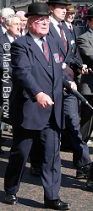

When I think of the English, I think of .........

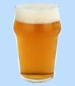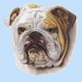
"Beer, honesty, Bulldog-type, Royal Family, Cricket, the Weather"
- Dickie Bird (Famous English cricket umpire)

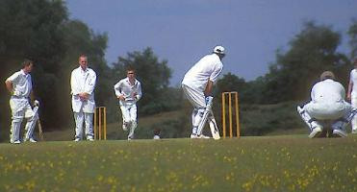

"Long shadows on county cricket grounds, warm beer, invincible green suburbs, dog lovers and old maids bicycling through the morning mist"
- John Major (Ex Prime Minister )

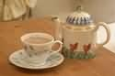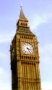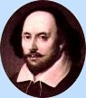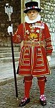
cream teas, Big Ben, Shakespeare, pubs, beefeaters
"I think that English people are quite reserved. I had to laugh when I went by tube and saw everyone sitting and reading their newspapers."

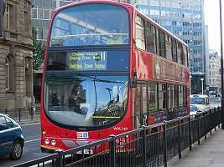"Gardening, warm beer, stiff upper lip, double-decker buses, Morris dancing “
"Saying the words 'splendid' and 'terribly' and old fashioned words/phrases like 'cheerio', 'spiffing' etc, '' (We don't say these words!)

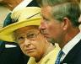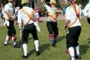

Morris Dancing, Royal family, Union Jack, God Save the Queen, Battle of Britain, Trooping the Colour'
"A lot of folks overseas think that the English are crazy about dogs and love them more than their kids!"
"The English eat a big breakfast in the morning with bacon, eggs, baked beans…”



"England is a land of beer, football and bad weather."
(Contrary to popular belief, it DOES NOT rain every day in England! :)
"My in-laws are from the Middle East - they think that we boil all our food. If the truth be told I would rather eat curry than boiled cabbage!"

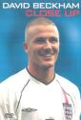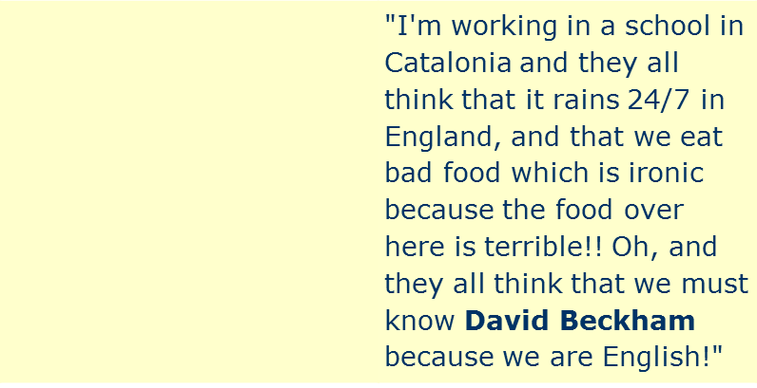
Patriotic people, some think we are snobs but we are just
proud of our country and Queen. We are very polite and patient although as in any country, there are the bad eggs. But on the whole we are a very pleasant nation."
Tom Eccles aged 13.
"People think the English are no good at learning foreign languages and have the attitude that if they yell loud enough in English the "foreigners" will evertually understand them... "
What are the first three things which come into your mind when you hear the words 'England' or 'the English?

