First Lecture

Warm-up
-Before we talk about the nature and characteristics of the novel in the 18th century, let us have a brief history of England at that time.
-It will help us to understand a lot about the emergence and development of the novel.

England in the Eighteenth Century

A Brief History of England in the Eighteenth Century

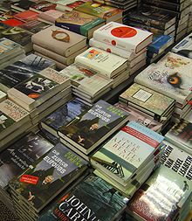

The Political Scene FAIR
During the eighteenth century, Britain, Continental Europe and North America were scenes of enormous changes. The French and American Revolutions were epochal events that have produced much historical fiction. There were also the Industrial Revolution and the Reformation or the religious revolution.
Question: What does FAIR stand for?

Question
Question: 1-What does FAIR stand for?
Answer:
FAIR stands for:
The French revolution
The American Revolution
The Industrial Revolution
The Religious Revolution

2-The four revolutions that affected the rise of the novel in the 18th century are:
1-... The French revolution......
2-... The American Revolution...
3-.... The Industrial Revolution...
4-....... The Religious Revolution.......

Political Scene: The French Revolution
*The French Revolution took place in France from 1789 to 1799
*It was a revolution against injustice and inequality and oppression
It called for three mottos (EFL ):*
Equality*
Fraternity*
Liberty*

Question
1- The three mottos of the FR are:... Equality....,.... Fraternity...., and... Liberty.....

2-The French Revolution took place in the (17th-18th -19th)century.

The French Revolution
The slogans of the French Revolution are:
-Equality
Fraternity-
Liberty-

Famous thinkers are:
Voltaire-
Rousseau-
Montesquieu-

Question

Some famous thinkers who motivated the French Revolution are
1-Voltaire 2-Rousseau 3-Montesquieu
Liberty, Equality, Fraternity

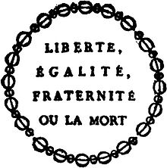

Political Scene: The French Revolution
-This revolution inspired many people around the world from the 18th century onwards. We will notice the effect of the three slogans in many of the works written afterwards.
-The French Revolution also affected many liberation movements all around the world like the American Revolution.

Question

The slogans of the FR gave rise to other revolutions like the (British- German- American) Revolution.

OR/ The French revolution inspired the
(Italian- Egyptian-American) Revolution.

Political Scene: The American Revolution
-The American Revolution 1775–1783

-The American Revolution was the political upheaval during the last half of the 18th century in which thirteen colonies in North America joined together to break free from the British Empire, combining to become the United States of America.

-It called for freedom, independence, human rights of equality and brotherhood. It was inspired by the Revolution in France.

Question
1-When did the American Revolution take place?
(the 17th-18th-19th) century.

2-Where did the American Revolution take place?
France- England - America

The American Revolution
-"We hold these truths to be self-evident, that all men are created equal, that they are endowed by their Creator with certain unalienable rights, that among these are life, liberty and the pursuit of happiness.“
-Quoted from The American Declaration of Independence

Political Scene: the System of Government
-The English Parliament and monarchs turned to political maneuvering rather than civil war to resolve their conflicts.

-There was an ongoing conflict between the two major parties in England: the Whigs and the Tories. There were also some wars between France and England, some of which were expressed in Dickens’s A Tale of Two Cities.

Question

The two famous parties that always were in conflict in England are (.........Whigs........and...... Tories..........)

Political Scene
The system of government was characterized by division and political problems. It was Monarchy still but people began to feel more freedom, more change. So they were able to criticize though in an indirect way.

Question

In the 18th century, England was
(1- a monarchy 2- a republic 3- a colony)

Second Lecture

Before the 18th Century:
-People’s lives before the 18th century were largely rural or primitive.-
No machines.-
No factories. -
No schools.-
Just the church and the farm. -
NO CHANGE AT ALL. -
-As one critic said, nothing came, nothing went, nothing happened. Stagnant.

Stagnation
Stagnant
No changes at all on any level
Education
Health (superstition)
Religion

Pope’s Idea about the Time Before the 18th Century
Pope says:
Happy the man whose wish and care,
a few paternal acres bound,
content to breathe his native air
in his own ground.

The Religious Scene
-In terms of religion, the dark ages in Europe in general saw the death of reason and the spread of darkness and superstition.
-There was no creativity as people were told everything they needed to know by the Church.
-The Church did not want people to think, simply because it needed them to remain devoted to it.

Question

1-Why did the Church not want people to think?

because it needed them to remain devoted to it.

2-In the 18th century, (the Church- the government-the University) told people what to do and how to think

The Religious Scene
- It made it easy for everyone to get rid of their sins by buying indulgences and having their sins forgiven.

- People therefore closed their minds and hearts and trusted so much in the authority of the Church.

-It interfered even in the way they looked at life itself .

- For example, the Church told them that the earth is the centre of the universe and that the sun revolves around the earth.

- For a long time, people believed this to be a scientifically proven fact. They never questioned its truthfulness.

- If the earth was the centre of the universe, the church was at the centre of the earth, and then the church is simply the centre of the whole universe and it was logical to believe everything it advised.

Question
1-According to the Church in the 18th century, (the earth-the sun-the moon) was the centre of the universe.

2-According to the Church in the 18th century,
(England-the sun-the Church) was the centre of the earth.

The Religious Scene
- But the modern ages gave scientists the chance to study this fact and to prove that the earth revolves round the sun. This means that the church is not the centre of the universe. That is to say, not everything the church said was true.

- People were encouraged to rely more on themselves for forgiveness. The path to real repentance was not the church but a direct relationship with the Creator.
Every individual person felt important.-

Question
Every individual in the 18th century felt
(important-unimportant-ugly)

Stop and Think
(Things you will always remember!)
- All the previous factors summed up in FAIR can be understood

to have led to the appearance of :

Individualism -
(to be explained later.)-
- In all fields of life, individual persons felt important and confident.

- They needed to achieve themselves by reading, travelling, exploring, and having lots of adventure.

Question
All revolutions in the 18th century led to the increased importance of
(parties- wars- individuals).

England Before and After the Industrial Revolution
England Before and After the Industrial Revolution
The Industrial Revolution
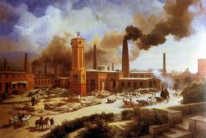

The most far-reaching, influential transformation of human culture since the advent of agriculture eight or ten thousand years ago, was the industrial revolution of eighteenth century Europe.
The consequences of this revolution would change irrevocably human labor, consumption, family structure, social structure, and even the very soul and thoughts of the individual.

- The industrial also changed the lives of people in the 18th century.
- England was a purely rural and agricultural society in the middle ages.
- People lived and worked at farms in what is called the age of feudalism.
- Their entire life was limited to farming the fields and serving the landlords. There was no other ambitions, no further interests.

Before The Industrial Revolution
No transportation-
No communication-
No hospitals-
No machines-
No universities or large-scale production-

Third Lecture

Names given to the period of time before 18th Century
So people felt calm, happy, and content.
They also felt stagnant as there was no movement, no change.
It was the age of stagnation
The age of negativity.
The age of reason.
The classical age.
The age of propriety (this is good, this is bad).

England in the eighteenth century
It is an age that witnessed a rebellion against the values that were prevalent in the age of Pope (1688-1744).
A new generation of writers reacted against the self-complacency, the chilliness, and the aridity of the preceding age.
They found themselves unhappy with the way in which their fathers looked at life, with their formalism, their narrowness of sympathy, and their controlling ideals.
They dreamed of becoming more natural and spontaneous in expressing themselves in literature.

The New Age
The new age was different
It was the age of change
The age of science
The age of the industrial revolution
Lots of machines, lots of production.
Factories, boats, trains, hospitals, telegrams, printing, transportation, communication, education, health, etc.

The Industrial Revolution
The industrial revolution and its impact on health (pollution, smoke);
family (women going to work, family disintegration work of children);
lack of interest in education and the false or dogmatic ideas spread in educational institutions; reason versus imagination;
clash between science and religion and the weakening of the influence of the church over people (secularism).
Materialism as people lost all trust in religion and began to seek fulfillment of their desires and needs.

What are some of the passive effects of the IR?
The industrial revolution also had its demerits:
Environmental Pollution
Poor health conditions at the start of the century
Materialism
Lack of interest in education
Work of women and children
The weakness of the family structure
Poverty of some classes of people
Hunger, diseases, deaths.

The Empire
On the international level, England became a huge super power.
It occupied many countries all over the world.
It became the Empire over which the sun never sets
There was huge expansion and geographical discoveries all the time.
People from England felt very important and very powerful.

Individualism
Every man and woman felt the desire to roam the globe, to travel everywhere and explore new lands.
Individuals preferred their own good. They wanted to satisfy their desires for more money, more knowledge, more pleasure.
Every individual wanted to achieve himself and lost interest gradually in every other individual.

Individualism is the moral stance, political philosophy, ideology, or social outlook that stresses "the moral worth of the individual". Individualists promote the exercise of one's goals and desires and so value independence and self-reliance while opposing most external interference upon one's own interests, whether by society, family or any other group or institution.

definition
A fictional prose narrative of considerable length, typically having a plot that is unfolded by the actions, speech, and thoughts of the characters.
It is about 250 pages in length.

More definitions
The novel is a worldwide cultural instrument which helped redefine:
The time and space where we live
The way we speak and talk
How we feel
What we do

Hybrid genre
The novel encompassed many different sub-genres
Is always in search of a definition
Battled with other genres from the very beginning

Another definition
A novel (from French nouvelle and Italian novella) is an extended, generally fictional narrative in prose. Untill the 18th century the novel referred specifically to short fictions of love and intrigue as opposed to romances, which were epic-length works about love and adventure. During the 18th century the novel adopted features of the old romance and became one of the major literary genres.

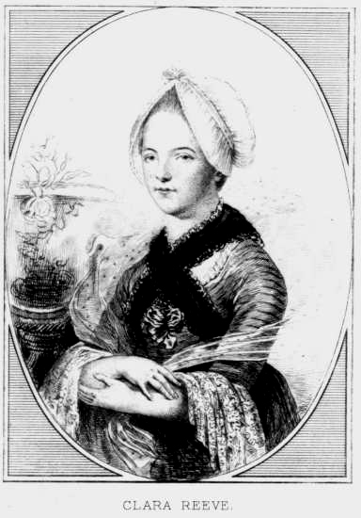

- The Novel is a picture of real life and manners, and of the time in which it is written.
The Romance, in lofty and elevated language, describes what never happened nor is likely to happen.”
Clara Reeve, The Progress of Romance, 1785

Goal of the Novel

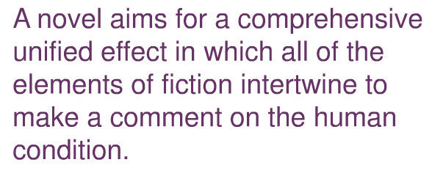

Novel: various Meanings of the Term
Novel = m(adj): new
Unfamiliar
Unacceptable
Novelty (a noun) = something that is not welcome

Why the “rise of the novel”
Restoration of monarchy (post-Puritan)
Appearance of periodicals
Rise of middle class
Leisure time for middle class
Growing audience of literate women

Title Count in the 18th Century
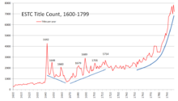

When and where?
1st half of the 18th century in England. Prototypes of the novel date back to the Elizabethan literature. Sir Philip Sidney’s arcadia, Aphra Behn’s Oronooko or the royal slave (1688), and John Bunyan’s the Pilgrims Progress (1678)

Fourth Lecture

In this lecture:
1-Passive effects of the industrial revolution
2-Positive effects of the industrial revolution
3-How the novel came into being
4-Reasons Behind the Emergence of the Novel
5-When and where the novel came into being
6-The Origins of the novel
7-The masters
8-Who is the father/ mother of the English Novel?

Some of the passive effects of the IR
The industrial revolution had its demerits:
- Environmental Pollution due to the spread of machines and factories
- Poor health conditions at the start of the century: no hospitals, no doctors, just superstition.
- Materialism: Only believing what is concrete, what is seen, not what is spiritual or ambigiuos
- Lack of interest in education as everyone went to work to gain money
- Work of women and children
- The weakness of the family structure
- Poverty of some classes of people
- Hunger, diseases, deaths.

Some Positive Effects of the
- It changed society from stagnation to turmoil (change)
Made it easier for people to get in touch-
- Made means of transportation easier
- Made travelling and exploration easier
- Created more resources of knowledge like books and magazines

Questions
The industrial revolution
(changed society – caused stagnation- didn’t change England)

Select True or false

1-The industrial revolution made Knowledge easier. √
2-The industrial revolution made transportation easier. √
3-The industrial revolution created more resources of knowledge like books and magazines. √

How the novel came into being
- Of all other literary genres like poetry and drama, the novel is the last major literary form to have developed in terms of history.
- (poetry- drama- the novel) is the last major literary form.
- There was plenty of fiction or of imaginary works like epics, ballads, anecdotes, myths, fables, folk-tales, legends, and the like. The epics written by Homer in the 6th century BC are an example of the existence of ‘fictional literature’ well before the novel proper.

Question
True or false

Before the novel arose, there was plenty of fiction like epics, ballads, anecdotes, and myths. √

Before the novel arose, there was plenty of fiction like history and geography. X

Reasons Behind the Emergence of the Novel
- The rise of the novel is due to:
- the rise of the middle classes in western Europe.
- Profound social and economic changes brought the novel into popular prominence.
- Advances into the technology of printing made written texts available to a growing population of readers.
- Changes in the modes of distribution and literacy rates brought books and pamphlets to populations excluded from education: working-class men and women.
- Authors became free agents in the literary market place dependent on popular sales for success and sustenance.

Question
The novel arose due to:
- the rise of the middle classes in western Europe. √
- Profound social and economic changes brought the novel into popular prominence. √
- Advances into the technology of printing made written texts available to a growing population of readers. √

-The spread of poetry X
-wars X

Reasons Behind the Emergence of the Novel
- Moreover, the decline of drama in the eighteenth century was also partly responsible for the rise and -ascendency of the novel. After the Licensing Act of 1737, the drama lay moribund.

- The poetry of the age too-- except for the brilliant example of Pope's work—was in a stage of decadence. It was then natural that from the ashes of the drama (and, to some extent, of poetry, too) should rise this new literary genre. This new genre was, of course, the novel.

When and Where?
- 1st half of the 18th century in England. Early works similar to the novel date back to the Elizabethan literature.
- There were also some effects by the Spanish novel.
- Sir Philip Sidney's arcadia, Aphra Behn’s Oronooko or the Royal Slave (1688), and John
Bunyan’s the Pilgrims Progress (1678)

Origins
- The dominant genre in world literature, the novel, is a relatively young form of imaginative writing.
- Only about 250 years old in England, its rise to pre-eminence has been striking. After sparse beginnings in 17th century England, novels grew rapidly in production by the 18th century and in the 19th century became the primary form of popular entertainment.

Question
How old is the English novel?
1-100 years
2-400 years
3-250 years

The Masters:
- Between 1740 and 1800 hundreds of novels of all kinds were written. However, the real "masters" of the novel in the eighteenth century were five – Defoe, Richardson, Fielding, Smollett, and Sterne.

- The rest of them are extremely inferior to them. Oliver Elton maintains: "The work of the four masters stands high, but the foothills are low.“

- Fielding was the greatest of the foursome. Sir Edmund Gosse calls Richardson "the first great English novelist" and Fielding, "the greatest of English novelists." Fielding may not be the greatest of all, but he was certainly one of the greatest English novelists and the greatest novelist of the eighteenth century.

Question
True or false:
The greatest masters of the English novel are Defoe, Richardson, Fielding, Smollett, and Sterne. √

The greatest masters of the English novel are Shaw and Shakespeare (they are famous dramatists) X

Who is the father/ mother of the English Novel?
- The first significant novel in English was Aphra Behn’s Oroonoko (1688). It is a novel of violence and cruelty and is ahead of its time in its defiance of the “noble savage” and its affirmation of an anticolonial stance.

- The novel also talks about man’s essential freedom and about women’s rights in a relatively very early age. In this way, it can be said that Aphra Behn antedated Daniel Defoe some 30 years before he began writing proper novels.

Question
Oroonoko was written in the (17th- 18th- 19th) century.

- Defoe’s Robinson Crusoe (1719) is often regarded as the foundation of the modern tradition. The novels of Daniel Defoe are generally fundamental to 18th century ways of thinking. They also reflect the merits and demerits of the 18th century novel, and that is why they are essential for any study of the novel of this period.

Fifth Lecture

In this lecture:
- Censorship
- How writers escaped from censorship
- Individualism
- Sentimentalism
- Demerits of the English novel in the 18th century
- Journalism
- Coincidence
- Elements of the novels
- Summary of weaknesses
- Merits of the English novel in the 18th century
- Censorship
- Patronage
- Serialisation

Characteristics of the 18th Century Novel: Censorship
- A Novelty means something that is strange, unfamiliar, unacceptable.
The novel was considered to be a novelty.-
- It could not be published easily.

- This had to do with the nature of the novel at that time as it was a new genre and was considered by many to be a novelty, something which not many people were proud of. Robinson Crusoe for example was not published as a novel but a s a history or journalistic repertoire.

- What did writers do to escape from censorship?
- Writing prefaces to justify the writing of novels

- Changing the setting like solitary islands or remote places and past times

- The setting is the (time- place- time and place) of the novel.

- Seeking patronage.

- Calling the novel history or tale or adventure or just giving it any other name in order to avoid censorship.

- Was this good for the rising novel?
- Of course not
- Unnecessary prefaces
- Exaggeration
- Not giving the novel its proper name

True or False?
Censorship was good for the rising novel X
- Of course not
- Unnecessary prefaces
- Exaggeration
- Not giving the novel its proper name

Individualism
Individualism means the interest in one's own problems, desires, hopes, ambitions, and dilemma.
It is a tendency that began in the modern ages especially the eighteenth century.

- Most works of art written in that age talked about individuals rather than about groups of people. Examples are Robinson Crusoe, Gulliver's Travels, Emma, Rasselas, Hamlet, King Lear, Macbeth, Othello, Romeo and Juliet, Silas Marner, and Oliver Twist.
- All features of the age (geographical expansion, scientific discoveries, the clash between science and religion) led to individualism.

In Robinson Crusoe, the writer focuses entirely on the character of Robinson as if no one else exists.
When Robinson deals with anyone even his parents and friends, we understand that his own good and desires come first.
That is why he does not listen to the advice of his parents or even know what happened to his friend.

sentimentalism
Tendency to shed tears over any occasion
It is affected and not sincere
It is a demerit

Verisimilitude
A French term
Verite
Smili
Tude
= realism= probable= possible= can happen
Things as they can be not things as they are

Features of the novel
- Title expressive (remote-exotic)
- Prefaces
- No dialogue
- Illustrations
- repetition
- All places very queer
- Setting
- Sharp but indirect criticism

Demerits
- Titles of novels and chapters
- Subtitles
- Coincidence
- Language
- Illustrations

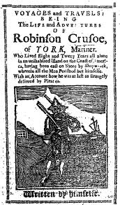

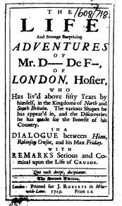

Robinson Crusoe by Daniel Defoe

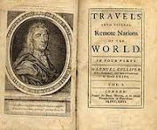

Gulliver’s Travels by J Swift

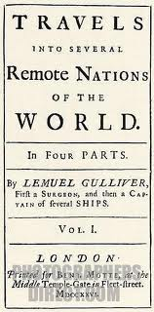

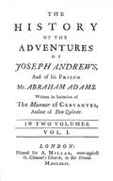

Elements of the Novel
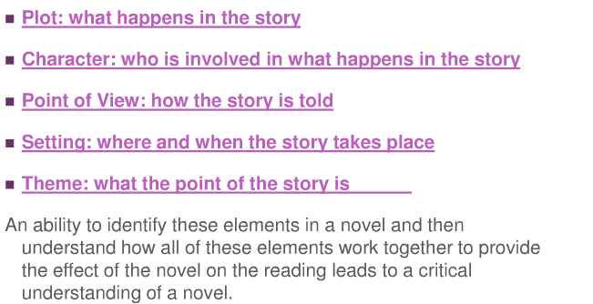

Summary of Weaknesses
Titles of novels and chapter headings:
- sentences
- Repetition
- Structure
- plots
- story-telling
- Coincidence
- Sentimentalism
- long and detailed
- Long and complex
- Repetition
- Weak
- Loose, multiple
- Crude and abrupt
- Overrated and revolting

Sixth Lecture

In this Lecture:
- Ian Watt’s view of Daniel Defoe
Individualism in Robinson Crusoe-
- A word about Daniel Defoe
- Defoe and the Reading Public
What Defoe wrote about -
Some disadvantages of Robinson Crusoe: serialization-
How writers avoided censorship-
- Some disadvantages of Robinson Crusoe: Patronage
- Some disadvantages of Robinson Crusoe: Prefaces.

Ian Watt’s Idea of Robinson Crusoe
The title of Watt’s chapter on Robinson Crusoe is this:
- “III Robinson Crusoe, individualism and the
novel”.
- Writing a whole section in this book on the rise of the novel under this title means that the most important feature the critic has noticed about the novel is individualism.
- As we said before, all developments that took place in the 18th century led to the enhancement of the individual.

Let us read what Watt says:
- “Robinson Crusoe, like Defoe's other main characters, Moll Flanders,Roxana,Colonel Jacque and Captain Singleton, is an embodiment of economic individualism. “

- “All Defoe's heroes pursue money, which he characteristically called 'the general denominating article in the world'; and they pursue it very methodically according to the profit and loss book-keeping which Max Weber considered to be the distinctive technical feature of modern capitalism. “
- Ian Watt, The Rise of the Novel.

“Defoe's heroes, we observe, have no need to learn this technique; whatever the circumstances of their birth and education, they have it in their blood, and keep us more fully informed of their present stocks of money and commodities than any other characters in fiction.”
From THE RISE
OF THE NOVEL
Studies in Defoe, Richardson
and Fielding
by
IAN WATT

Summary of Watt’s Point of View
- Defoe describes Robinson as the embodiment of the age in which he lived.
- Robinson is interested in himself an individual.
- He is so keen on collecting money and on becoming rich.
- This financial issue is the most obvious trait of his character.
- It is even more important than any other values in his life, even more important than his parents and friends.

Individualism in Robinson Crusoe
- In Robinson Crusoe, the writer focuses entirely on the character of Robinson as if no one else exists.

- When Robinson deals with anyone even his parents and friends, we understand that his own good and desires come first.

- That is why, as we will see, he does not listen to the advice of his parents or even know what happened to his friends.

Question
1-The most important thing Defoe’s characters are
interested in is (love- marriage- money).

2-As an 18th century writer, Defoe was interested
most in (sports- the individual- schools).

3-The most important feature the critic has noticed about Robinson Crusoe is (spiritualism- individualism- culture).

A Word about Daniel Defoe
- He worked a s a journalist most of the time.
- This made his style and language easier than those of other writers who did not work as journalists.
- He got interested in stories full of action and adventure
- He knew how to create suspense and excitement in readers.
- He liked to refer to facts and data in all he wrote.
He came to novel- writing at the age of 59.-
- This means that the novels he wrote suffered from certain technical problems.

Question
1-How old was Defoe when he wrote Robinson Crusoe?
(45- 55- 59)

2-Defoe worked as a (teacher-preacher- journalist) before writing Robinson Crusoe.

3-Defoe’s language is (easy- hard- ambiguous) because he worked as a journalist.

4-One thing Daniel Defoe liked to refer to in his novels is
(facts- women- children)

Defoe and the Reading Public
- Daniel Defoe made it clear that he exploited the prevalent tendencies in his time in order to write for people what attracted their attention.

- That is to say, he only wrote when he felt that what he wrote could be appreciated and liked by readers.

- Defoe declared that he was a very good observer of the prevalent attitudes and tendencies of people and that he made use of this in order to win the favour of publishers and readers alike.

What did Defoe write about?
- Individuals in search of fortune, dreaming of wealth
Adventures of all sorts-
- Remote places like islands and African nations.
- Stories of exotic people (different from the British)
- The clash between science and religion

Some more Disadvantages of Robinson Crusoe
Serialization
- Like all other novels in this age, our novel was published in journals, in serials.

- It was not published in book form until later.

- Writing serialized novels for papers or magazines involved some sort of novelistic or fictional lack of cohesion. That is to say, the final product which is the novel, had to suffer from disintegration and structural disorganization.

- Every chapter or episode for instance had to be interesting in itself as if it were the end product and as if it would not be followed by other installments.

- Structural cohesion in this sense was sacrificed for the sake of arousing the immediate attention of readers.

- At this point, it can be said that Poe endorses an established tradition in world literature and aesthetics in general- that of organic unity. From Aristotle through Philip Sidney and Matthew Arnold to T. S. Eliot and present- day critics, organic unity has always been an issue to grapple with.

- Organic unity simply means that all pieces and elements of the work of art combine together to produce a single effect or meaning.

- In one word: Robinson Crusoe does not have this organic unity.

- There are chapters and elements in the novel that can be removed without harming the overall structure.

Questions: Mark as True of False

1-Robinson Crusoe does not have organic unity. √
2-The structure of Robinson Crusoe is weak. √
3-Defoe preferred the excitement of readers to the cohesion of the novel. √
4-Robinson Crusoe was published in serials. √
5-Serialisation means a type of food. X



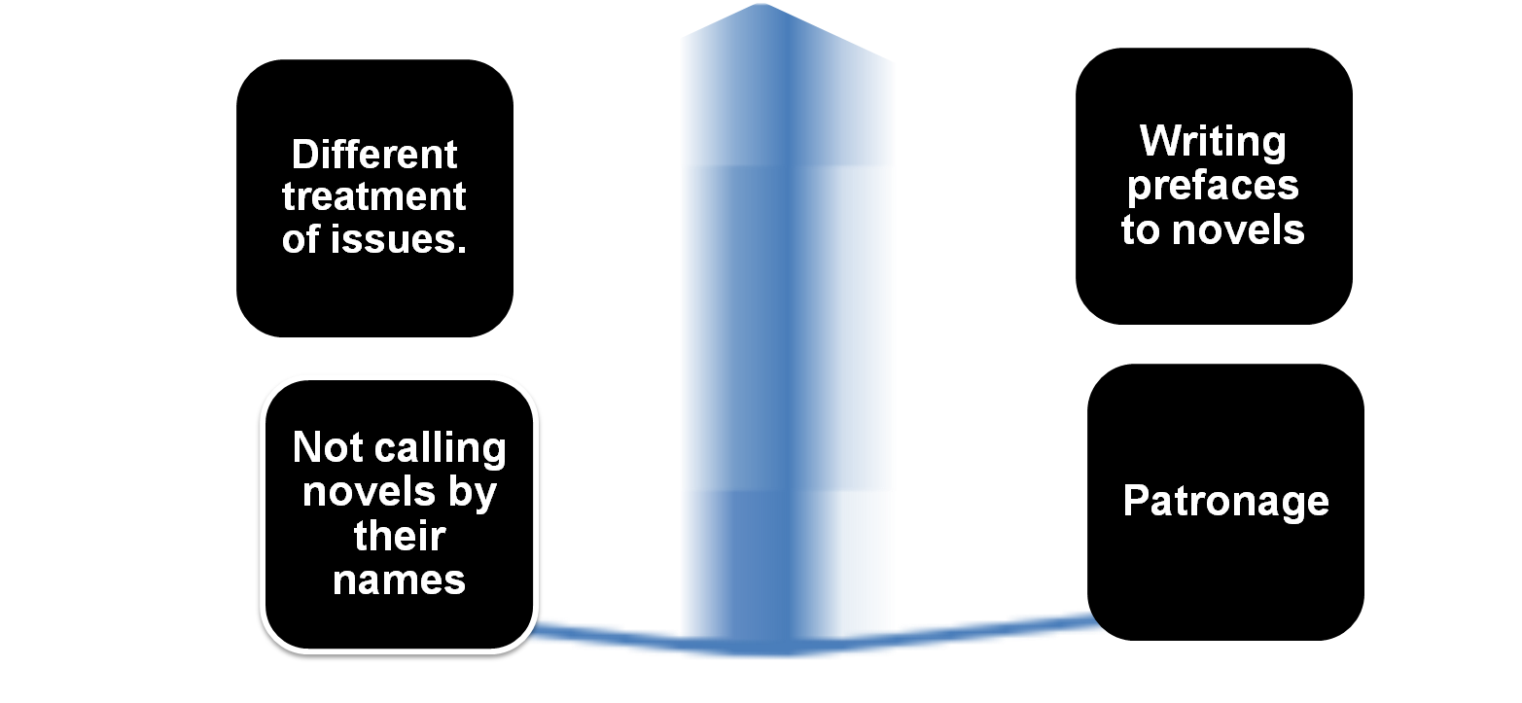
Questions Decide True or False
1-To avoid censorship, 18th century novelists resorted to patronage. √
2-To avoid censorship, 18th century novelists refused to write prefaces to their novels. X
3-To avoid censorship, 18th century novelists insisted on calling their new books “novels”. X
4-To avoid censorship, 18th century novelists discussed current topics in the same way. X

Some more Disadvantages of Robinson Crusoe
Patronage

- We have to remember that the novel started as an unfamiliar literary kind.
- Readers did not welcome it because it used to open the eyes of society to its problems. It was hard to publish.
- A lot of novelists had to seek ‘patronage’ among politicians, businessmen, and even the court itself. This promised to be the last resort for writers who wanted to escape the anger of the reading public and the censorship of authorities.

- The opening pages of so many eighteenth century novels are almost always dedicated to praise of the author’s patron or ‘patroness’.
- This is unnecessary as it has nothing to do with the novel itself.
- Such pages can easily be removed.
- Robinson Crusoe also has this disadvantage.

Some more Disadvantages of Robinson Crusoe
Prefaces

- If ever the Story of any private Man’s Adventures in the World were worth making Publick, and were acceptable when Publish’d, the Editor of this Account thinks this will be so.

- The Wonders of this Man’s Life exceed all that (he thinks) is to be found extant; the Life of one Man being scarce capable of a greater Variety.

- The Story is told with Modesty, with Seriousness, and with a religious Application of Events to the Uses to which wise Men always apply them (viz.) to the Instruction of others by this Example, and to justify and honor the Wisdom of Providence in all the Variety of our Circumstances, let them happen how they will.

- The Editor believes the thing to be a just History of Fact; neither is there any Appearance of Fiction in it: And however thinks, because all such things are dispatch’d, that the Improvement of it, as well as the Diversion, as to the Instruction of the Reader, will be the same; and as such he thinks, without farther Compliment to the World, he does them a great Service in the Publication.

Seventh Lecture

Where we Stand
In the Previous Lecture
Individualism
Materialism
Serialisation
Patronage
Prefaces

In this lecture
Long titles
Sentimentalism
Repetition
Colonialism
Contradiction
The omniscient narrator

Some more Disadvantages of Robinson Crusoe: Long Titles and Chapter Headings

Full title:
- Like all other novels in the 18th century, the title page is so long.

- It is long because the writer wants to

1-Make the novel interesting to readers.
2-Prove that it is not “a novel” but just a history or some adventures.
3-Make sure thee reader will buy the book using illustrations and explanations.

Full Title
The Life and Strange Surprising Adventures of Robinson Crusoe of York. Mariner; who lived Eight and Twenty Years, all alone in an uninhabited Island on the coast of America, near the Mouth of the Great River of Oroonoque; Having been cast on Shore by Shipwreck, wherein all the Men perished but himself. With An Account how he was at last as strangely deliver'd by Pirates. Written by Himself.

Titles of Chapters are Also Lengthy
That of course is a demerit in the 18th century novel
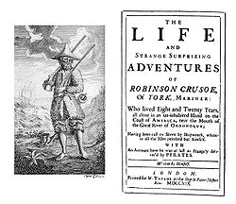

Titles and Subtitles

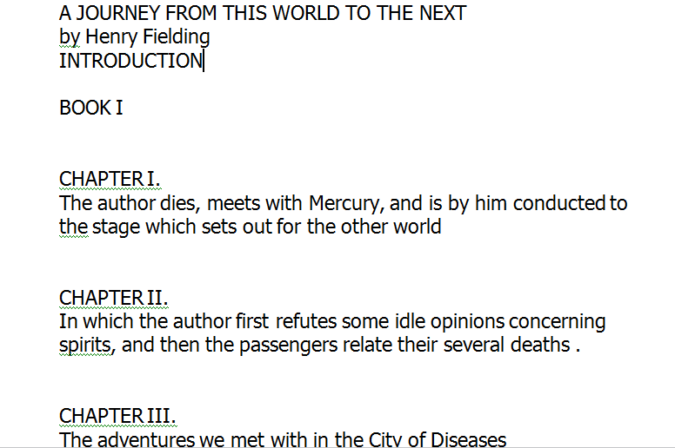

Sentimentalism
- It means a lot of crying and tears on any occasion. It is affected, not real. Men and women are described as shedding tears.
- It is against verisimilitude.
- It is one of the common features of the novel in the 18th century.
- This is not touching all the time. It could be insincere.
An example is Robinson's parents early in the novel

Repetition
The reasons behind repetition are:
-the novel was published in journals and the writer had to remind readers every time of what has been said before.
-The writer had no experience of novel-writing before and that is why he could not avoid repetition.

-Robinson Crusoe is full of redundancy:
-It is full of fun
It is full of irony-
-It is full of repetition
-Redundancy is…… in Robinson Crusoe .
-An advantage
-A disadvantage
Vague -

Colonialism
-The colonizer and the colonized.
-The ruler and the ruled.
-England XX Africa (vulgar) .
-Robinson feels very important as a British citizen.
For him Africans and Arabs and even Muslims are lower classes of people. He is the superior one.
For him they are inferior.

-Robinson is a representative of powerful rich individuals from England the Empire over which the sun never set.

- It would be meaningless and contradictory of course if the writer portrayed him as a slave. That is why in the novel we do not read at all about this period in his life.

Master (England) | Servant (Africa)
Colonizer | Colonized
Ruler | Ruled
Superior | Inferior
Upper | Lower
Noble, western  (Christians) | Savage Eastern  (Arabs, Muslims, Moors
White | Black, colored
Good | Bad
Has a lot of learning | Ignorant
Has a lot of experience | Innocent
Has a lot of cleverness | Good-for-nothing

Contradiction
- No experience in novel-writing led writers to contradict themselves without noticing it.

- The novel is full of contradiction which is understandable in the light of the things explained above

Examples:
- promising to obey God and parents then obeying only himself,
- saying that he has close friends then getting rid of them so soon,
- visiting Africa to know more about it but considering it to be inferior and referring to it in a vulgar way.
- Describing the voyage as the most successful one while we know that it is not.

The Omniscient Narrator
Why is Defoe called an omniscient narrator?
- First of all, the word omniscient means a narrator who knows everything about characters and events.
- He is the one through whose eyes the whole novel is narrated.

- In the novel, no character speaks for himself or herself. All are given to us from the point of view of that narrator. We are just told about them.

- The same thing with events which are narrated only from the point of view of the narrator.

- This is of course a demerit in novel writing as it detracts from the reader’s right to free judgement.

Question
True or false:
The word omniscient means a narrator who knows everything about characters and events √

Best Answer?
Using the omniscient narrator is (an advantage-
a disadvantage- needed) in the 18th century novel.

Eighth Lecture

In this Lecture
Preface to the novel
Chapter One of the novel
Chapter Two
Chapter Three

A Summary of Robinson Crusoe

Summary: Preface
-An unnamed editor explains his reasons for offering us the narrative we are about to read. He does not mention the name or story of Robinson Crusoe explicitly but, rather, describes the narrative as a “private man's adventures in the world” and focuses on its realism when he calls it a “just history of fact.” He claims it is modest and serious, and that it has an instructive value, teaching us to honor “the wisdom of Providence.” Thus, the editor asserts he is doing a great service to the world in publishing Crusoe's tale.

Comment on the Preface
-If Daniel Defoe published it as a novel in 1719, it would not be published at all.
-He does not call the novel a novel.
-He gives it the name of a history and a narrative of fact or a book of adventures.
-He insists it is realistic, not fictional
-He says he is just the editor not the writer of the story.
-We learn from this that he avoids censorship through these steps.

Chapter One
A man named Robinson Crusoe records his own life story, beginning with his birth in 1632 in the English city of York. Crusoe's father was a German, originally named Kreutznaer. Crusoe is the youngest of three brothers, the eldest being a soldier and the second one having vanished mysteriously. As the youngest son in the family, Crusoe is expected to inherit little, and, as a result, his father encourages him to take up the law. But Crusoe's inclination is to go to sea. His family strongly opposes this idea, and his father gives him a stern lecture on the value of accepting a middle station in life.

Questions
1-When does the novel start?
The (16th- the 19th- the 17th- the 18th) century.

What happens to Robinson’s second brother?
1-He dies
2-He vanishes
3-He works as a lawyer
4-He is a sailor.

Chapter One
Crusoe resolves to follow his father's advice. But when one of his friends embarks for London, Crusoe succumbs to temptation and boards the ship on September 1, 1651. A storm develops. Near Yarmouth the weather is so bad that Crusoe fears for his life and prays to God for deliverance. The ship nearly founders, but all are saved. Crusoe sees this ordeal as a sign of fate that he should give up sea travel, and his friend's father warns him against setting foot on a ship again, echoing his own father's warning.

Question
What is the most obvious thing about Robinson’s character?

1-Hesitation
2-Honesty
3-Liveliness
4-Kindness

Robinson fears for his life and prays to God for deliverance when

1-He is in trouble
2-He gets married
3-Goes home
4-Starts sailing.

Robinson’s parents advise him to

1-Stay at home
2-Go to the sea
3-Search for money
4-Search for adventure.

Chapter Two
Crusoe parts with his friend and proceeds to London by land, where he meets a sea captain who proposes that Crusoe accompany him on an upcoming merchant voyage. Writing to his family for investment money, Crusoe sets off with forty pounds worth of trinkets and toys to sell abroad. Crusoe makes a net income of 300 pounds from this trip, and considers it a great success. Taking one hundred pounds with him, and leaving the remaining 200 pounds with a widow whom he trusts, Crusoe sets off on another merchant expedition.

Question
On his very first voyage, what does Robinson do to achieve himself as an individual?

1-He tries to make more money
2-He works as a surgeon
3-He works as a farmer
4-He studies medicine.

Chapter Two
This time he is pursued by Moorish pirates off the coast of Sallee in North Africa. His ship is overtaken, and Crusoe is enslaved, the only Briton among his Moorish master's slaves. Crusoe is assigned the task of fishing because of his natural skill. One day the slaves' fishing vessel gets lost in fog, and the master installs a compass on board. The master also stores some gunpowder on board in preparation for a shooting party, but the guests do not come. Crusoe waits.

Brainstorming
What is a narrative gap?
It is a section in the story that is not covered in detail by the author.

Why is Robinson not described in detail as a prisoner?
A.Because he is British and readers in Britain would not welcome such a story
B.Because he did not want to
C.Because prisoners were good readers of novels
D.Because he intended to escape.
E.Robinson is not described in detail as a prisoner.
This is called:
(a- narrative gap - b- a plot c- a story d- a theme)

Chapter Three
Robinson sets off on a fishing expedition with two other slaves, a man named Ismael and a boy named Xury. Sneaking up behind Ismael, Robinson pushes him into the
water. Ismael swims alongside the boat and begs to be taken in. Crusoe pulls a gun on him and tells him to return to shore or else be killed. Crusoe then asks Xury whether he will accompany him and serve him faithfully, and Xury agrees. By evening, Crusoe calculates they have sailed 150 miles south of Sallee. They see wild creatures onshore that Crusoe recognizes as lions. Crusoe shoots one dead, and he and Xury skin it.

They proceed southward toward what Crusoe believes are the Cape Verde or Canary Islands. They see naked black people onshore, and they fear them until the natives offer them food. When the Africans witness Crusoe shooting a leopard, they are impressed, and they offer the skin to Crusoe. Unsure where to head, Crusoe is surprised by a European ship in the distance. The ship picks up Xury and Crusoe, and its kind Portuguese captain offers to take them to Brazil. The captain buys Crusoe's boat as well as Xury.

Questions
As a prisoner, Robinson manages to escape because:

A.He is regarded by the author as powerful and skilful
B.He arranges this with the Moors
C.He wants to go back home
D.He is powerful

Is Defoe a colonialist writer?

A.Yes he is
B.No he is not
C.Maybe
D.It is not clear from the novel.

Ninth Lecture

In this Lecture
Chapter Four of the novel
Chapter Five
Chapter Six
Chapter Seven

Chapter Four
After a voyage of twenty-two days, Crusoe lands in Brazil, accepting many farewell gifts from the Portuguese captain. After meeting his Anglo-Brazilian neighbor, he conceives a plan to become a tobacco planter. For two years Crusoe earns only enough on which to subsist, but in the third year he begins to do well and, in retrospect, misses the labor potential of the slave boy Xury whom he sold.

Questions
Why does he decide to become a tobacco planter?

1-It is a chance for him to earn more money.
2-He is a heavy smoker.
3-He has lots of time.
4-His father wanted him to do so.

Chapter Four
Having told the Portuguese captain of his 200 pounds left in England, the captain arranges to have one hundred pounds sent to Crusoe in Brazil, along with many gifts besides. After receiving what the captain sent, Crusoe feels quite well off. Eager for slave labor to extend his business further, he agrees to an acquaintance's plan to sail to Guinea for black slaves, in exchange for his own share of the slaves.

Chapter Five
After writing a will leaving half his possessions to the Portuguese captain, Crusoe sets sail for Guinea on September 1, 1659 with a cargo of trinkets with which to buy slaves. Sailing up the South American coast, the ship encounters a storm, and two men are lost. Crusoe fears for his life. Reaching the Caribbean, the ship is shaken by yet another storm that drives the ship onto the sand, breaking the rudder. The ship is clearly doomed, and the crew climbs into boats to make for shore.

Crusoe loses sight of his mates when all are swept away by an immense wave. Finally Crusoe makes it to shore, where he immediately prays to God in gratitude. He never sees a sign of another living crewmember. After drinking some fresh water and finding a tree in which to sleep, Crusoe spends his first night on the island.

Chapter Six
Awakening the next morning refreshed, Crusoe goes down to the shore to explore the remains of the ship. Swimming around it, he finds it impossible to climb aboard until he finds a chain hanging, by which he pulls himself up. Crusoe conceives the idea of building a raft out of broken lumber, on which he loads provisions of bread, rice, goat meat, cheese, and other foods. He also finds clothes, arms, and fresh water. He sails his cargo-laden raft into a small cove, where he unloads it.

Questions
What are the basic things that Robinson looks for once he is on the island?

1-Food and shelter
2-Friends
3-Neighbours
4-parents

Chapter Six
He notices that the land has wildfowl but no other humans. Crusoe returns to the ship twelve times over the following thirteen days. On one of the latter trips he finds thirty-six pounds, and he sadly meditates on how worthless the money is to him. After a strong wind that night, he awakens to find the ship's remains gone the next morning.

Questions
Though Robinson finds money on the ship, he is sad. Why?

1-He has to pay it back to others
2-He cannot make more money by trading with people
3-The money is not British
4-The money is little

Chapter Seven
Wary of savages, Crusoe decides he must build a dwelling or “fortress,” as he calls it. He chooses a spot with a view of the sea, protected from animals and the heat of the sun and near fresh water. He drives wooden stakes into the ground, using them as a frame for walls. Crusoe sleeps securely in the shelter that night. The next day he hauls all of his provisions and supplies inside, and hangs a hammock on which to sleep. He also builds a cellar. During a thunderstorm he suddenly worries about his gunpowder supply, which he separates from the other supplies and stores in the cellar.

Crusoe discovers wild goats on the island. He kills one and then sees that it had a kid, which he then kills too. On about his twelfth day on the island, he erects a large cross that he inscribes with the date of his arrival, September 30, 1659. He resolves to cut a notch on the cross to mark every passing day. He also begins a journal in which he records the good and evil aspects of his experience, until he runs out of ink. He keeps watch for passing ships, always disappointed.

Questions

Why does the writer use the journal in the novel?

1-He worked as a journalist
2-To keep record of the time
3-To achieve verisimilitude
4-To start the real action

بالتوفيـــــــق للجميـــــــع

أختكم
السالفة مليـــون

