-11-

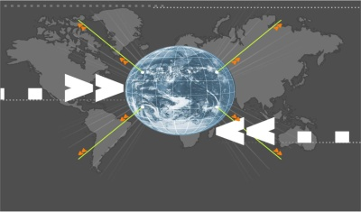
Reaching Out

Effective Communication Skills & Creative methods and approaches
on presenting Islam and its beauty to others nicely and wisely!
www.etawasol.org

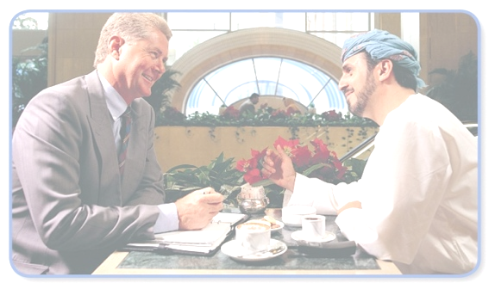
Effective dialogue & Communication Skills. (Part 1)
Creative methods and approaches on presenting Islam and its civilization & culture to others nicely and wisely!
 | From Where  Should We  Start?

 | 


Breaking the Ice :First
(Building Bridges)
 | 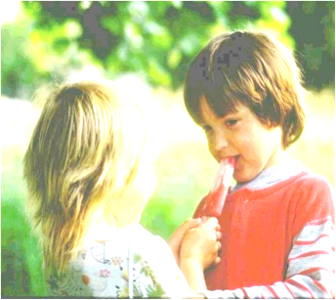
Good First Impression

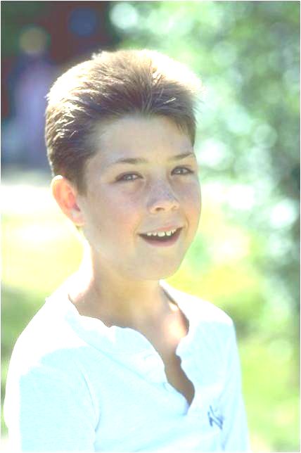 | 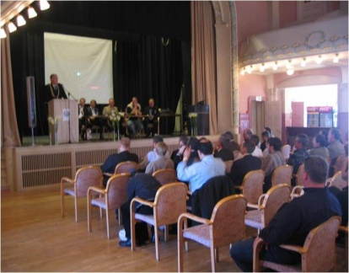
Sincere Smile | Good Speech

Mention Benefits

Knowledge
Is Power!

Seek
the Truth!

  Love and Respect | 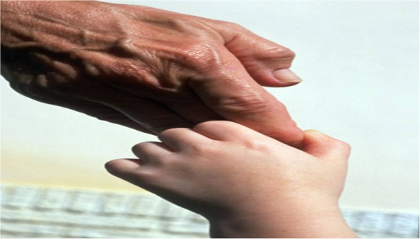  Love and Respect

  Good  Conduct and Treatment |   Names and Backgrounds

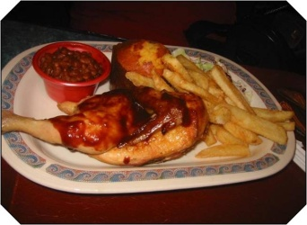 | 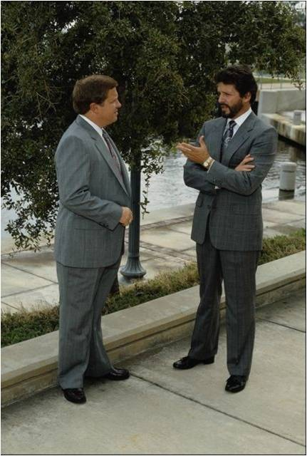
Helping, Serving, and Visiting others


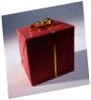    Gift | 

 | Can you suggest  other keys for  winning hearts  &  building bridges?

Notes:_______________________________________________________________________________________________________________________________________________________________________________________________________________________________________________________________________________________________________________________________________________________________________________________________________________________________________________________________________________________________________________________________________________________________________________________________________________________________________________________________________________________________________________________________________________________________________________________________________________________________________________________________________________________________________________________________

