-13-
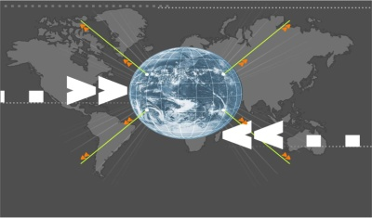
Reaching Out

Effective Communication Skills & Creative methods and approaches
on presenting Islam and its beauty to others nicely and wisely!
www.etawasol.org

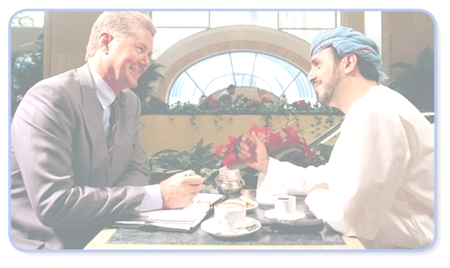
Effective dialogue & Communication Skills. (Part 3)
Creative methods and approaches on presenting Islam and its civilization & culture to others nicely and wisely!

Fifth:
Special keys

Dealing with

‘the People of the Book’
Common Ground
Just One Message!

Just One Message!
Evidence

The Bible

The Qur’an

Sixth:
Secrets of Success


Prepare and Plan
“If you fail to plan, you plan to fail”

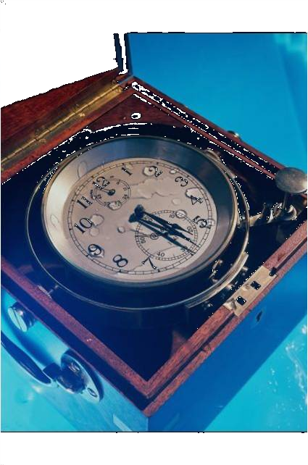
Time
“If you are not early, you are late!”


Good appearance

 |   Using  Creative,  Interesting  Materials  & visual aids
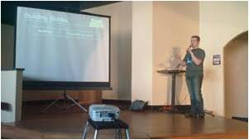

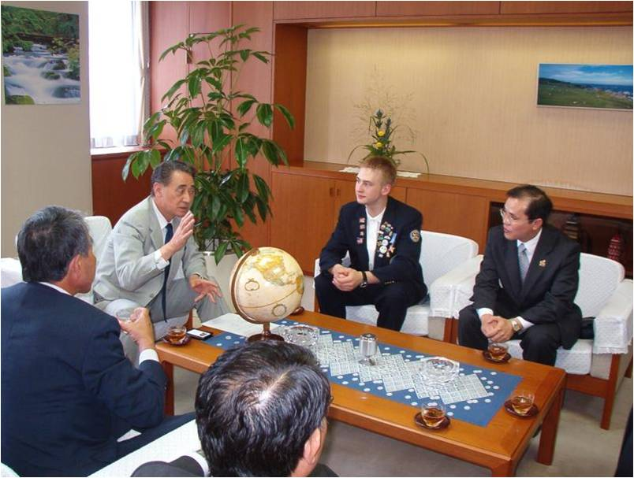
Be Brief

- Let them Ask questions
- The Art of Choosing Attractive Topics

God is One
Use PCs / LCDs
Get Feedback
  Via Evaluation Form |   Via Recording

What is your role?
What is your role?
What is your role?
What is your role?
What is your role?
? ? ? ? ?
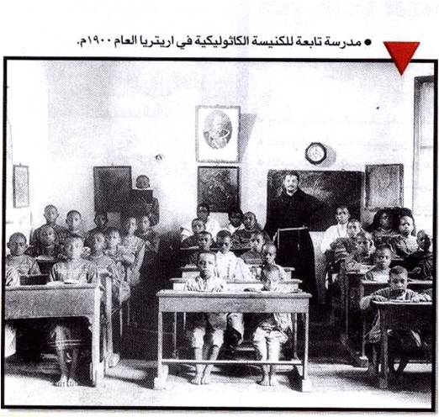
How do others work?
A school belonging to a Catholic church in Eretria 1900

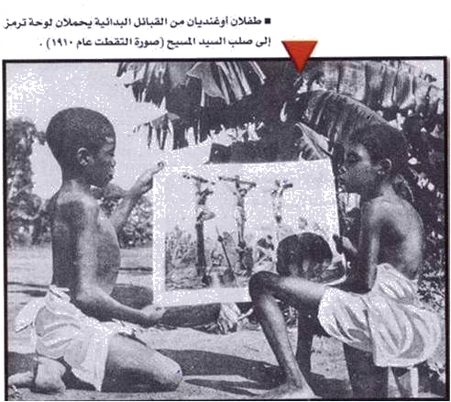
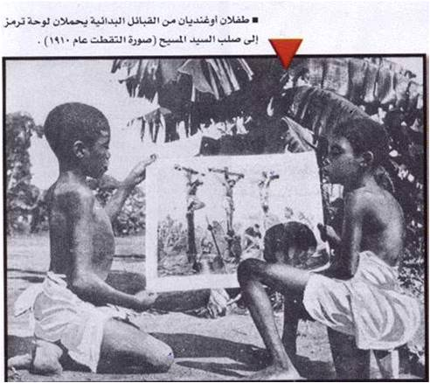
How do others work?

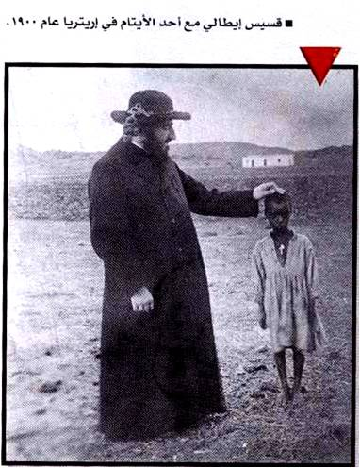 | 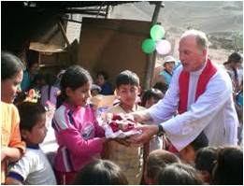
How do others work?
An Italian priest with an orphan in Eretria.

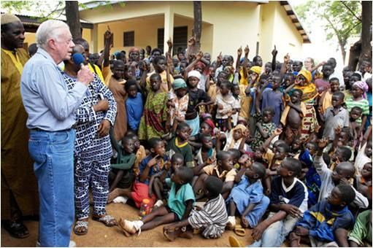  How do others work?  President Jimmy Carter | 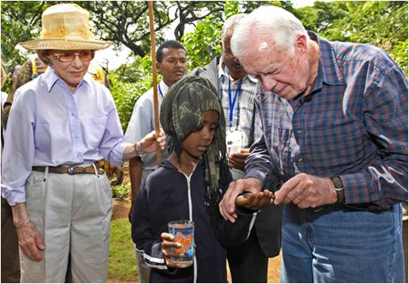How do others work?  President Jimmy Carter & wife
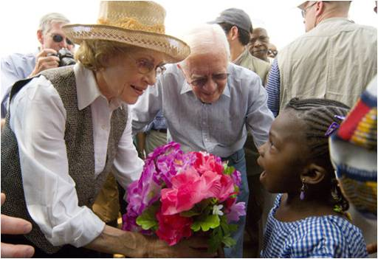 How do others work?  President Jimmy Carter & wife | 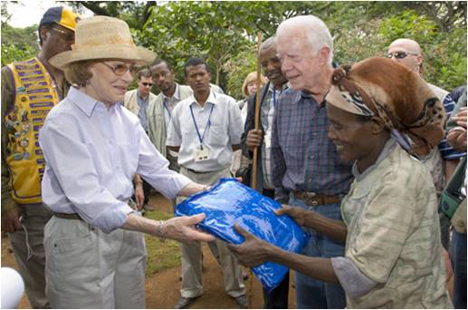How do others work?  President Jimmy Carter & wife
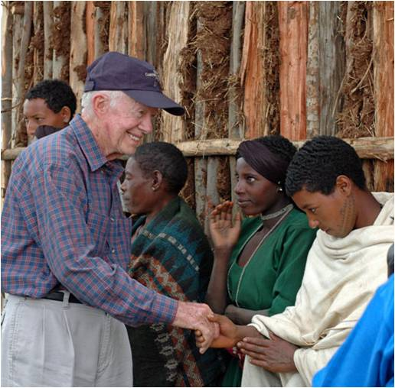 How do others work?  President Jimmy Carter | 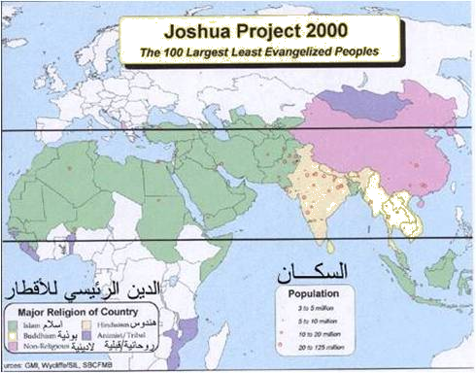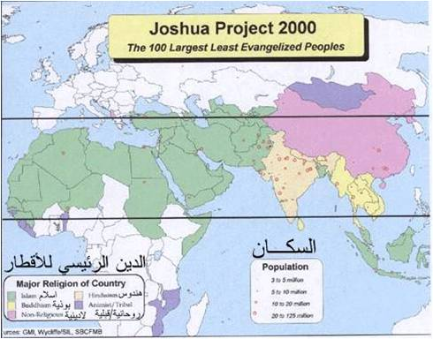How do others work?

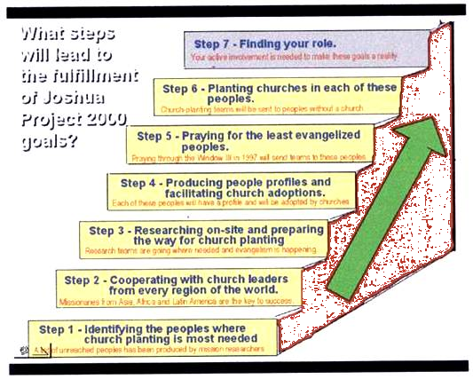

How do others work?

 |  | 
Books prepared by Dr. Naji Al-Arfaj are available on:
http://www.etawasol.org/downloads.php?show_all_sec=60

Notes:_________________________________________________________________________________________________________________________________________________________________________________________________________________________________________________________________________________________________________________________________________________________________________________________________________________________________________________________________________________________________________________________________________________________________________________________________________________________________________________________________________________________________________________________________________________________________________

