Lecture 8:
Modernism and the Novel
The Modern Novel
Modernism: Background
- By the end of the 19th century, artists and novelists were already becoming unsatisfied with realism.
- Rejection of Realism and Naturalism became common
- a wide range of experimental and avant-garde trends (all the –isms: dadaism, surrealism, expressionism, futurism, etc.)
- A reaction to the modern, urban experience
- A rejection of bourgeois values
- Discontinuity and Fragmentation
- Realism stressed the role of art as a mirror of social reality, the values of bourgeois society, and notions of progress.
- Modernism questioned art’s capability to reflect reality, questioned the coherence of that reality, the bourgeois values of society and the notions of progress and happiness.
- Life and reality are not coherent or simple and it is an illusion to think that the novel or art in general can simply depict them like a mirror.
- Bourgeois values and morality are fake and superficial
What modernism stressed instead was:
- Discontinuity and fragmentation
- Juxtaposition and multiple points of view
- Lack of a unitary self
- “Self” is seen as artificial, a social fiction
- The individual is stripped of the traditional defining categories of personhood
- Modernist fiction
Stressed:
- Crisis rather than coherent reality
- Attempts to represent multiple truths as reflected in consciousness and the psyche
- Rejection of external, unitary, coherent appearance of realist conventions
- Stresses a lack of causality (chaos)
- Insufficiency of language (incapability to represent)
Stressed:
- Oppositional relations between the individual and the social, (the alienation of the individual in his/her social environment)
- Antibourgeois (because bourgeois values and lifestyle are fake and superficial)
- Uses first person narrator, and he/she is often unreliable, reflecting the difficulty to represent reality
- Reflects a sense of urban dislocation and alienation
- Works by male writers tend to be misogynistic
- Compare: Édouard Manet, “Breakfast in the Studio”
- (Realist Art)
- 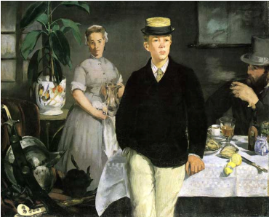 With: Picasso “Weeping Woman” (Modernist Art)
- Discontinuity and fragmentation
Juxtaposition and multiple points of view 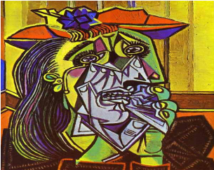
- Lack of a unitary self
- “Self” is seen as artificial, a social fiction of undetermined status
- Individual is stripped of the traditional defining categories of personhood
- Or Picasso’s famous Guernica 1937
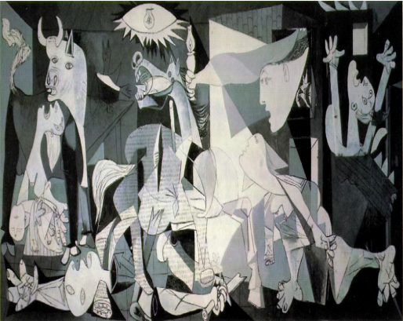
Or any of Salvador Dali’s work
