Semantics and Pragmatics
Instructor: Abdulrahman A. Alsayed
First lecture
By: Abu Bakr
تدقيق : نوني و سلطان
http://www.classmarker.com/online-test/start/?quiz=deh50e9cd6107216

- Semantics is the technical term used to refer to:
  - The reason behind meaning
  - The study of meaning.
  - The study of formation
  - The reason behind formation
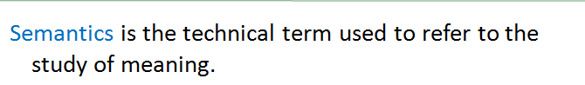
المحاضره1 شريحه4

- The term "Semantics" was used to refer not to meaning only but to:
  - Its development
  - Its formation
  - Its category
  - All true

المحاضره1 شريحه4

- “Historical semantics” is a term that is being used now:
  - When we look at the meaning only.
  - When we look at the development of meaning only.
  - When we look at the formation only.
  - When we look at both the meaning and the development.
المحاضره1 شريحه4

- The term "Semantic" earliest use was in:
  - 1794
  - 1894
  - 1925
  - All false
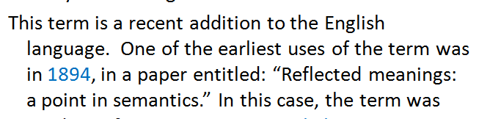
المحاضره1 شريحه4

- In 1900, a book called “Semantics: studies in the science of meaning” was published. The term Semantics was treated in this book:
  - The way people at that time understood semantics.
  - The way we use it today.
  - The wrong way which had to be abandoned.
  - A and C
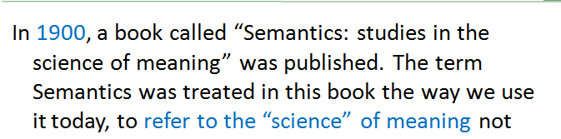
المحاضره1 شريحه5

- The way we use the term "Semantics" today is when it refers to:
  - The “science” of meaning.
  - The changes of meaning from a historical point of view.
  - Both true
  - All false
المحاضره1شريحه5

- When the word “semantics” is used to refer to the manipulation تلاعبof language, this happens in:
  - Formal language
  - Aggressive language
  - Popular language
  - Political language
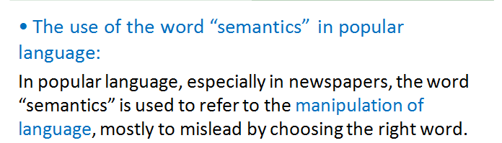
المحاضره1شريحه6

- Manipulation of language mostly occurs in:
  - Newspapers
  - History books
  - Encyclopedias
  - All false
المحاضره1شريحه6

- The reason behind manipulation is to:
  - Make things more appealing to public.
  - Mislead the public
  - Inform the public.
  - All true
المحاضره1شريحه6

- To understand what meaning is, one has to keep in mind whether we are talking about what speakers mean or:
  - What the listener might understand.
  - What words (or sentences)mean.
  - What the speaker wants to say.
  - A and C
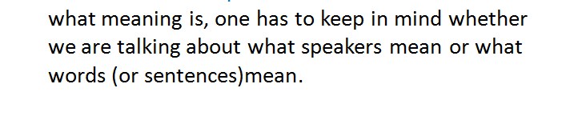
محاضره 1 شريحه 9

- In utterance Meaning (Speaker Meaning), a word meaning includes the secondary aspects of meaning, especially those related to:
  - Context.
  - Weather
  - Emotions
  - All false
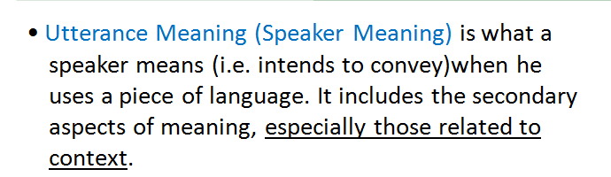
المحاضره 1 شريحه 10

- There is a distinction between what would seem to be the usual meaning of a word or a sentence, and the meaning it has in certain specific circumstances or contexts. This is, in fact, the difference between:
  - Semantics and Systematic
  - Semantics and Pragmatics.
  - Semantics and syntactics.
  - All false
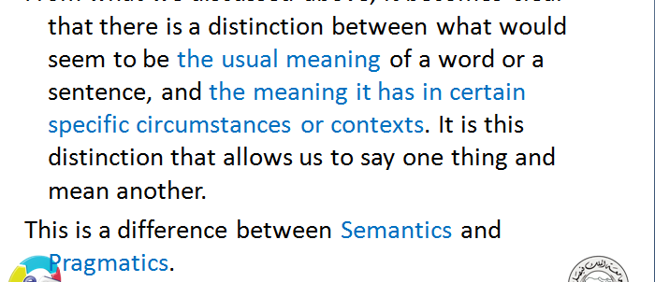
المحاضره 1 شريحه 12

- The study of meaning that a sentence has in a particular context in which it is uttered. This definition refers to:
  - Syntactic
  - Pragmatic
  - Semantic
  - B and C
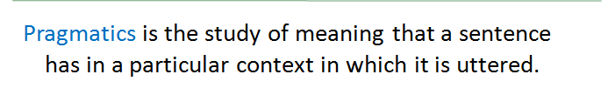
المحاضره 1 شريحه 14

- When the word "mean" is used in the sense of “be equivalent to”, we are looking at the meaning from the:
  - Pragmatic point
  - Semantic point
  - Both
  - Neither

