Semantics and Pragmatics

Lecture 1

What is Semantics?
ماهو علم المعاني ( علم الدلاله-علم دلالات الالفاظ-علم دراسة المعاني)؟
lSemantics is the technical term used to refer to the study of meaning.
علم المعاني هو مصطلح فني يستخدم للاشاره الى دراسة المعنى..
This term is a recent addition to the English language. One of the earliest uses of the term was in 1894, in a paper entitled: “Reflected meanings: a point in semantics.” In this case, the term was used to refer not to meaning only but to its development which is what we call now “historical semantics”.
هذا المصطلح هو اضافة حديثة الى اللغة الانجليزية . واحدة من اقدم الاستخدامات للمصطلح كان عام 1894, في ورقة بعنوان :"المعنى المنعكس: نقطة في علم المعاني"كان في هذه الحاله ,يستخدم هذا المصطلح للاشارة الى المعنى لا فقط ولكن لتنميتها وهو مانسميه الان "علم المعاني التاريخي"
In 1900, a book called “Semantics: studies in the science of meaning” was published. The term Semantics was treated in this book the way we use it today, to refer to the “science” of meaning not the changes of meaning from a historical point of view.
في عام 1900 تسمى كتاب علم المعاني :" دراسات في علم المعنى " نشر- مصطلح علم المعاني كان يعالج في هذا الكتاب الطريقة التي نستخدم اليوم ,للاشاره الى " العلم " من معنى لا معنى التغييرات من الناحيه التاريخيه
• The use of the word “semantics” in popular language:
في اللغة الشعبية استخدام كلمة " علم المعاني"
In popular language, especially in newspapers, the word “semantics” is used to refer to the manipulation of language, mostly to mislead by choosing the right word. For example, the following headline in The Guardian in 1971: “Semantic manoeuvres at the Pentagon”.
In this article the term “mobile manoeuvre” was being used to mean “retreat”.
في اللغة الشعبية , وخاصة في الصحف , يتم استخدام كلمة "علم المعاني" للاشارة الى التلاعب في اللغة, و معظمهم لتضليل عن طريق اختيار الكلمة الصحيحة.على سبيل المثال , مايلي العنوان في صحيفة الجارديان في عام 1971:"المناورات الدلالية على وزارة الدفاع"
في هذه المقالة مصطلح "المناورة المتنقلة" لقد كان يستخدم ليعني "تراجع-انسحاب"
What is “meaning”?
ماهو "المعنى"؟
“Meaning” covers a variety of aspects of language, and there is no general agreement about the nature of meaning.
Looking at the word itself, the dictionary will suggest a number of different meanings of the noun “meaning” and the verb “mean”.
معنى يشمل مجموعة متنوعة من جوانب اللغة, وليس هناك اتفاق عام حول طبيعة المعنى.
وعند النظر الى الكلمة نفسها, فان القاموس اقترح عددا من المعاني المختلفة للاسم "معنى" والفعل "تعني"
The word mean can be applied to people who use language, i.e. to speakers, in the sense of “intend”. And it can be applied to words and sentences in the sense of “be equivalent to”. To understand what meaning is, one has to keep in mind whether we are talking about what speakers mean or what words (or sentences)mean.
وكلمة تعني يمكن تطبيقها على الاشخاص الذين يستخدمون اللغة, أي للمتكلمين, بمعنى "ينوي" ويمكن تطبيقه على الكلمات والجمل بمعنى "مايعادل" لفهم معنى ما, وعلى المرء أن يأخذ في الاعتبار ما اذا كنا نتكلم عن مايعني المتكلمين او ماذا تعني الكلمات (او الجمل)..
• Utterance Meaning (Speaker Meaning) is what a speaker means (i.e. intends to convey)when he uses a piece of language. It includes the secondary aspects of meaning, especially those related to context.
الكلام بمعنى ( معنى المتكلم ) مايعنيه المتكلم (أي ينوي ان ينقل) عندما يستخدم قطعة من اللغة انه يشمل الجوانب الثانويه من معنى, وخاصة تلك المتعلقه بالسياق..
• Sentence Meaning (or Word Meaning) is what a sentence (or word) means, i.e. what it counts as the equivalent of in the language concerned.
معنى الجملة (او معنى الكلمة) هو ماتعني الجملة (او الكلمة), أي مايعادل حسابها في اللغه المعنيه..
Example:
“Nice day.”
This sentence is equivalent to something like “This is a lovely day.”
"يوم جميل". هذه الجملة مايعادل شيء من هذا القبيل
"هذا يوم جميل"
However, depending on the situation and the speaker’s facial expressions, tone of voice, or the relationship that exists between the speaker and hearer, it can mean the exact opposite, i.e. “This is not a nice day.”
ومع ذلك, تبعاً وتعبيرات وجه المتكلم, نبرة الصوت, او العلاقة القائمة بين المتكلم والسامع, وقد يعني العكس تماماً, أي "هذا ليس يوماً جميل"
From what we discussed above, it becomes clear that there is a distinction between what would seem to be the usual meaning of a word or a sentence, and the meaning it has in certain specific circumstances or contexts. It is this distinction that allows us to say one thing and mean another.
من ماناقشناه اعلاه, يصبح من الواضح ان هناك فرقاً بين ما يمكن ان يبدو ان المعنى المعتاد للكلمة أو الجملة والمعنى لها في ظروف معينة او السياقات وهذا هو التمييز الذي يسمح لنا أن نقول شيئاً واحداً ويعني اخر..
This is a difference between Semantics and Pragmatics.
هذا هو الفرق بين علم المعاني والبراغماتيه..
What is Pragmatics?
Pragmatics is the study of meaning that a sentence has in a particular context in which it is uttered.
As we mentioned earlier, the difference between Semantics and Pragmatics is that the study of Semantics is independent of context.
e.g. There’s a car coming.
This sentence out of context simply gives information that a car is coming, but in a specific context it can be understood as a warning.
البراغماتية (التداولية) هي دراسة معنى يحتوي جملة في سياق معين التي تلفظ بها.كما ذكرنا سابقاً, والفرق بين علم المعاني والبراغماتية ان دراسة علم المعاني مستقلة عن السياق.
على سبيل المثال هناك سيارة قادمة.هذه الجملة من سياقها يعطي ببساطة معلومات ان السيارة قادمة, ولكن في سياق محدد يمكن ان تفهم على أنها تحذيرالتداولية: يبحث في كيفية اكتشاف السامع مقاصد المتكلم أو دراسة معنى المتكلم.فمثلاً حين يقول شخص:
أنا عطشان (فقد يعني أريد كوب ماء)وليس من الضروري ان يكون اخباراً بأنه عطشان. فالمتكلم كثيراً مايعني أكث مما تقوله كلماته..

اسئلة

By: Abu Bakr
تدقيق : نوني و سلطان
1. Semantics is the technical term used to refer to:
a. The reason behind meaning
b. The study of meaning.
c. The study of formation
d. The reason behind formation

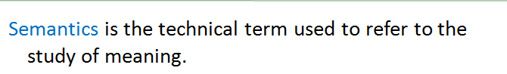
المحاضره1 شريحه4

2. The term "Semantics" was used to refer not to meaning only but to: a. Its development
b. Its formation
c. Its category
d. All true
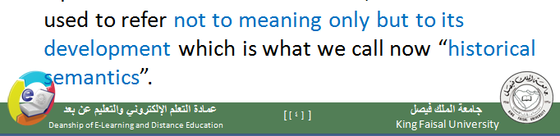
المحاضره1 شريحه4

3. “Historical semantics” is a term that is being used now:
a. When we look at the meaning only.
b. When we look at the development of meaning only.
c. When we look at the formation only
. d. When we look at both the meaning and the development.

المحاضره1 شريحه4

4. The term "Semantic" earliest use was in:
a. 1794
b. 1894
c. 1925
d. All false
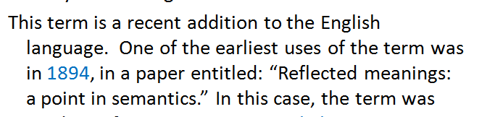
المحاضره1 شريحه4

5. In 1900, a book called “Semantics: studies in the science of meaning” was published. The term Semantics was treated in this book:
a. The way people at that time understood semantics.
b. The way we use it today.
c. The wrong way which had to be abandoned.
d. A and C
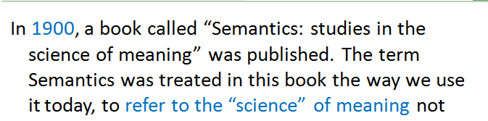
المحاضره1 شريحه5

6. The way we use the term "Semantics" today is when it refers to:
a. The “science” of meaning.
b. The changes of meaning from a historical point of view.
c. Both true
d. All false

المحاضره1شريحه5

7. When the word “semantics” is used to refer to the manipulation تلاعب of language, this happens in:
a. Formal language
b. Aggressive language
c. Popular language
d. Political language

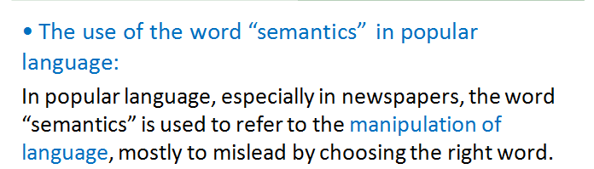
المحاضره1شريحه6

8. Manipulation of language mostly occurs in:
a. Newspapers
b. History books
c. Encyclopedias
d. All false
المحاضره1شريحه6

9. The reason behind manipulation is to:
a. Make things more appealing to public.
b. Mislead the public
c. Inform the public.
d. All true
المحاضره1شريحه6
10. To understand what meaning is, one has to keep in mind whether we are talking about what speakers mean or:
a. What the listener might understand.
b. What words (or sentences)mean.
c. What the speaker wants to say.
d. A and C
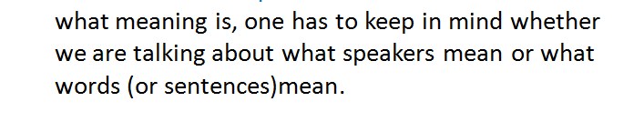
محاضره 1 شريحه 9

11. In utterance Meaning (Speaker Meaning), a word meaning includes the secondary aspects of meaning, especially those related to:
a. Context.
b. Weather
c. Emotions
d. All false
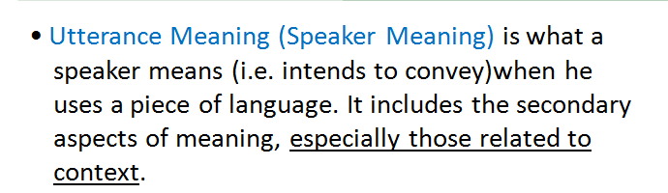
المحاضره 1 شريحه 10

12. There is a distinction between what would seem to be the usual meaning of a word or a sentence, and the meaning it has in certain specific circumstances or contexts. This is, in fact, the difference between:
a. Semantics and Systematic
b. Semantics and Pragmatics.
c. Semantics and syntactics.
d. All false
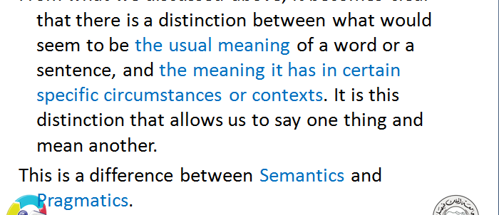
المحاضره 1 شريحه 12

13. The study of meaning that a sentence has in a particular context in which it is uttered. This definition refers to:
a. Syntactic
b. Pragmatic
c. Semantic
d. B and C
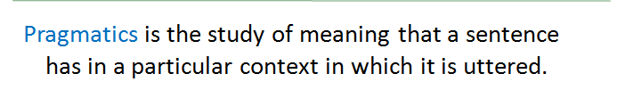
المحاضره 1 شريحه 14

14. When the word "mean" is used in the sense of “be equivalent to”, we are looking at the meaning from the:
a. Pragmatic point
b. Semantic point
c. Both
d. Neither

-------------------------------------------------------------------------------------------------------------------------------

-------------------------------------------------------------------------------------------------------------------------------

-------------------------------------------------------------------------------------------------------------------------------

-------------------------------------------------------------------------------------------------------------------------------

