Semantics and Pragmatics

Lecture 2

Sense and Reference
معنى الكلمه ودلالتها

Sense and reference are two very distinct ways of talking about the meaning of words and other expressions.
Sense deals with the relationships inside the language.
Reference deals with the relationship between the language and the world.
المعنى و (المرجع ــ الاشاره) : طريقتان متميزتان جداً من الحديث عن معنى الكلمات و التعبيرات الاخرى.
المعنى: يتناول العلاقات داخل اللغة.. (الكلمات التي ليس لها وجود أو معنى خارج اللغه) ..
الاشارة: يتناول العلاقة بين اللغة والعالم.. (الكلمات التي لها معنى أو وجود خارج اللغة) ..

Sense

The sense of an expression is its place in a system of semantic relationships with other expressions in the language.
E.g. The relationship between “big” and “small” is oppositeness of meaning (antonymy).
The relationship between “rich” and “wealthy” is sameness of meaning (synonymy).
المعنى تعبير هو مكانه في نظام من العلاقات الدلاليه في التعبيرات الاخرى في اللغه..
مثل: العلاقه بين "كبير" و "صغير" هو التضاد من معنى عكس..
العلاقة بين "الاغنياء" و "الاثرياء" هو التشابه في المعنى الترادف..
• We will talk more about sense relations in a coming lecture.

Notes:
- In some cases, the same word-form can have more than one sense. E.g. Look at the word-form “bank” in the following sentences:
في بعض الحالات ,يمكن للنفس شكل الكلمه لها اكثر من معنى. انظروا مثلاً شكل كلمة
" البنك ــ ضفه "في الجمل التاليه"bank"
“I have an account at the bank.”
"لدي حساب في البنك"
“We took the boat to the other bank of the river.”
"أخذنا القارب الى الضفه الاخرى من النهر"
In these examples, “bank” has a different sense in each sentence.
في هذه الامثله كلمة
بمعنى مختلف في كل جمله Bank

- We can talk about the sense, not only of words, but also of longer expressions such as phrases and sentences.
يمكننا الحديث عن المعنى ,ليس فقط من الكلمات, ولكن ايضاً من تعبيرات اطول مثل العبارات والجمل..
e.g. “Rupert took off his jacket.”
"روبرت خلع سترته"
“Rupert took his jacket off.”
"خلع سترته روبرت"
We say that both of these sentence have the same sense.
نقول ان كلاً من هذه الجمله لديهم نفس المعنى.
- One sentence can have different senses.
جمله واحده يمكن ان يكون لها معاني مختلفه..
e.g. “The chicken is ready to eat.”
مثلاً"الدجاجه جاهزه للاكل"
This sentence has two different senses. The first sense is that the chicken is ready to be eaten. The second sense is that the chicken is ready to eat something.
هذه الجمله بمعنيين مختلفيين.. الاول هو أن الدجاجه جاهزه بأن تؤكل. ( من قبل شخص ) ..المعنى الثاني هو أن الدجاجه على استعداد لكل شيئاً ( كالقمح ) ..
Reference

Reference is a relationship between parts of a language (words and phrases) and things outside the language (in the world).
By reference a speaker indicates which things and persons in the world are being talked about.
e.g. My son is in the house.
“My son” here refers to a person in the world and “the house” refers to a thing in the world.
الاشاره ــ المرجع هي العلاقه بين أجزاء من لغة ( الكلمات والعبارات ) وأشياء خارج اللغه (في العالم)
بواسطة اشارة المتكلم يشير الى الاشياء والاشخاص في العالم التي يتم الحديث عنها. مثلاً ابني في المنزل.
"ابني" هنا يشير الى أي شخص في العالم و "البيت" يشير الى شيء في العالم..
To make the term reference clearer to you, hold a book in your hand and describe it in a sentence. For example: “This book is about Semantics.”
The English expression “this book” is part of the language. This expression can refer to any book. In the example, we used it to refer to part of the world which is the book you are holding in your hand. “Reference” is the relationship between the language expression and the real world object.
لجعل مصطلح الاشاره اكثر وضوحاً لك.امسك الكتاب بيدك وصف ذلك في جمله. مثلاً "هذا الكتاب هو عن علم الدلاله"
التغبير الانجليزيه "هذا الكتاب" هو جزء من اللغه..هذا التعبير يمكن ان يشير الى أي كتاب. في المثال, استخدمنا للاشاره الى جزء من العالم الذي هو الكتاب الذي تمسكه في يدك..
"مرجع" هي العلاقه بين لغة التعبير وموضوع العالم الحقيقي..
After looking at the previous example, we can give the following two definitions:
• A referring expression is any expression used in an utterance to refer to something or someone.
• A referent is the person or thing in the world speakers refer to by using a referring expression.
The relation between a referring expression and a referent is what we call reference.
بعد النظر في المثال السابق,يمكن ان نقدم تعريفين هما:
ــ التعبير بالاشاره (التعبير المحدد بالاشاره) هو التعبيرالمستخدم في الكلام للاشاره أي شيء ما او شخص ما..
ــ المشار اليه هو الشخص او الشيء في العالم يشير الى المتحدثين بواسطة استخدام تعبير الاشاره..
العلاقه بين تعبير الاشاره والمشار اليه هو مانسميه اشارة ــ مرجع..
Notes:
1. The same referring expression can, in some cases, be used to refer to different referents.
e.g. The referring expression “this book” can be used to refer to different books.
2. Two different referring expressions can have the same referent.
e.g. The two expressions “Riyadh” and “the capital of Saudi Arabia” both refer to the same place.
1ـ نفس التعبير بالاشاره يمكن في بعض الحالات, ان يستخدم للاشاره الى مرجعيات مختلفه..
مثلاً التعبير بالاشاره "هذا الكتاب" يمكن ان تستخدم للاشاره الى مكتب مختلفه..
2ــ اختلافين بتعبير الاشاره يمكن ان يكون لها نفس المرجع..
مثلاً العبارتين "الرياض" و "عاصمة المملكه العربيه السعوديه" كليها تشير لنفس المكان..
Comparing Sense and Reference

1. The referent of an expression is often a thing or person in the world; whereas the sense of an expression is not a thing at all.
The sense of an expression is an abstraction in the mind of a language user. When a person understands fully what is said to him, it is reasonable to say that he grasps the sense of the expression he hears.

2. Every meaningful expression has sense, but not every meaningful expression has reference.
e.g. The words “almost”, “if” and “probable” have sense, but they do not refer to a thing in the world.
1ــ التعبير بالاشاره غالباً مايكون شيء أو شخص في العالم, في حين ان التعبير بمعنى لاشيء على الاطلاق.
التعبير بمعنى هي فكره مجرده في ذهن مستخدم اللغه.. عندما يكون الشخص يفهم تماماً ما يقال له, فمن المنطق أن نقول أنه فهم التعبير بمعنى يسمع..
2ــ كل تعبير ذو معنى له معنى. ولكن ليس كل تعبير ذو معنى لديه مرجعيه..
مثلاً عبارة "تقريباً" ,"اذا" و "محتمل" لديهم معنى, لكنها لاتشير الى شيء في العالم..

-------------------------------------------------------------------------------------------------------------

-------------------------------------------------------------------------------------------------------------

-------------------------------------------------------------------------------------------------------------

-------------------------------------------------------------------------------------------------------------
الاسئله
Semantics and Pragmatics
Instructor: Abdulrahman A. Alsayed
Prepared by: Abu Bakr
تدقيق none/sultan

2nd lecture

- When we talk about the meaning of words and other expression, we have to consider:
  - Sence
  - Reference
  - Since
  - A and B
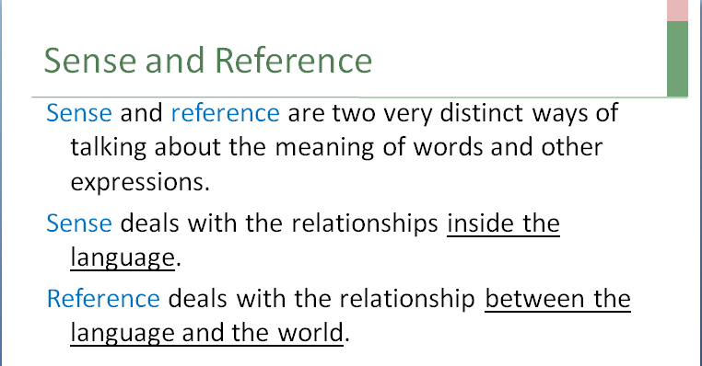
المحاضره2 شريحه4
- Sense and reference are two very ………….ways of talking about the meaning of words and other expressions.
  - Similar
  - Distinct
  - Confusing
  - A and B
المحاضره2 شريحه4
- Sense deals with the relationships:
  - inside the language.
  - Outside the language.
  - Both inside and outside.
  - All true
المحاضره2 شريحه4
- Reference deals with the relationship between the language and:
  - The environment
  - The world.
  - The dictionaries.
  - History
المحاضره2شريحه4
- The sense of an expression is its place in a system of semantic relationships with other expressions in the language. An example of these relationships:
  - oppositeness of meaning (antonymy).
  - Sameness of meaning (synonymy).
  - Both true
  - Both false
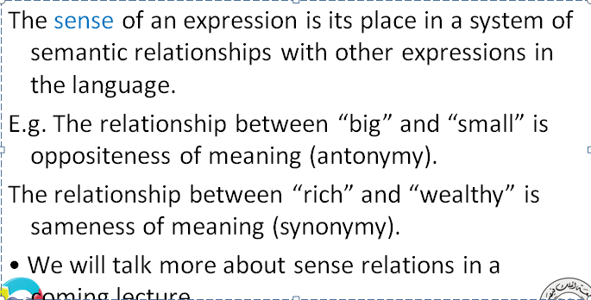
محاضره2 شريحه6
- The same word-form has more than one sense.
  - This happens all the time.
  - This happens in some cases.
  - This never happens in English.
  - All false
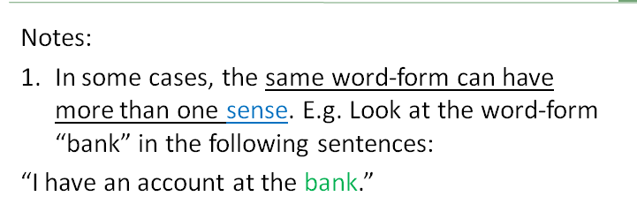
محاضره2 شريحه7
- Talking about "sense" applies:
  - Only to words.
  - Only to sentences or phrases
  - To A and B
  - Neither A nor B

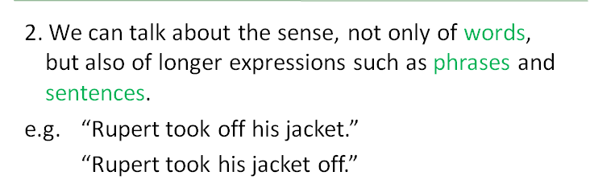
المحاضره2 شريحه8
- One sentence ……….have different senses.
  - Can
  - Can't
  - Must
  - All false
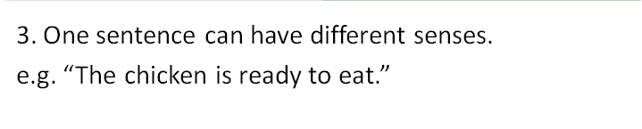
محاضره2شريحه9
“I have an account at the bank.”
“We took the boat to the other bank of the river.”
- In these examples, “bank” has a ………………..in each sentence.
  - Similar sense
  - Different sense
  - Confusing sense
  - A and B
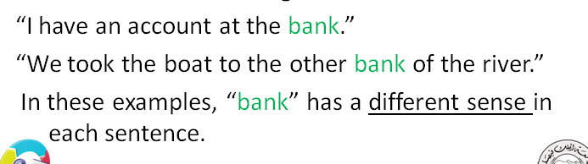
محاضره2 شريحه7
“Rupert took off his jacket.”
“Rupert took his jacket off.”
- In the above two examples, we say that both of these sentence have the ……….sense.
  - Confusing
  - Different
  - Same
  - All false
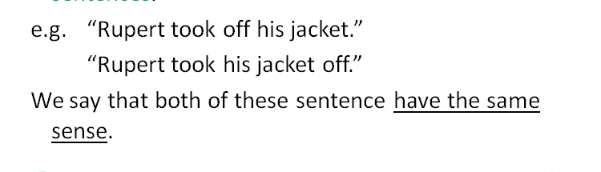
محاضره2 شريحه8
“The chicken is ready to eat.”
- The above sentence is an example of:
  - A sentence has two different senses.
  - A sentence has two similar senses.
  - A sentence has only one sense.
  - All true
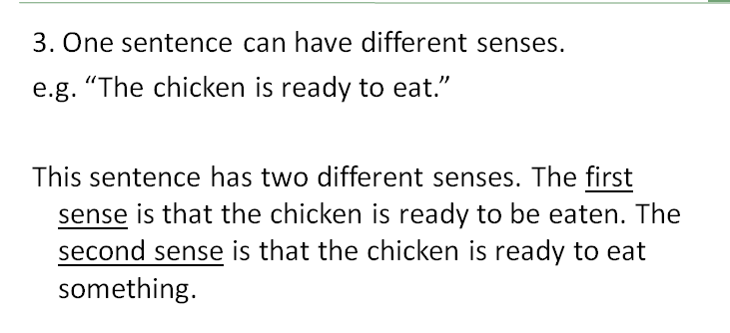
المحاضره2 شريحه9
- As we know that "Reference" deals with relationship between the language and the world, we got to know the term " referent" and the term:
  - "referring pronoun"
  - "referring expression"
  - "Referent expression"
  - Subject
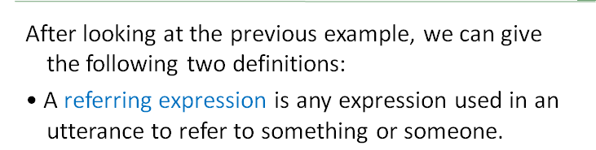
محاضره2شريحه13
- The relation between a referring expression and a referent is what we call:
  - Reference.
  - Utterance.
  - Occurrence.
  - All false
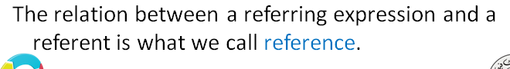
محاضره2شريحه13
- In the example:" This book", the word (This) is:
  - A referring expression
  - A referent
  - A phrase
  - All false
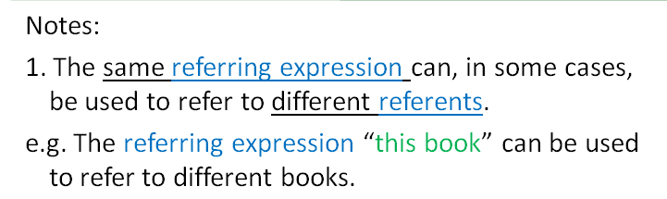
محاضره2شريحه14
- In the example:" This book", we can find that the same referring expression ………………..be used to refer to different referents.
  - Can't
  - can, in some cases,
  - Must
  - All false
محاضره2شريحه14

- While a referent of an expression is often a thing or person in the world, the sense of an expression:
  - The same
  - May be a thing
  - Must be a thing
  - Is not a thing at all.
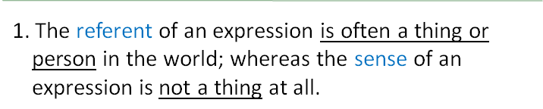
محاضره2شريحه16
- Every meaningful expression has sense, ………….every meaningful expression has reference.
  - but not
  - and
  - but also
  - all false
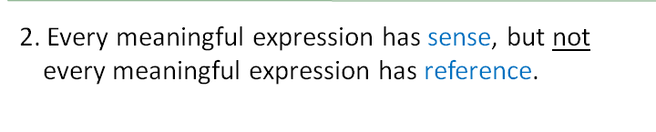
محاضره2شريحه17

