Lecture 6
General Revision
المحاضرة السادسة مراجعه لما سبق .. وما حبيت اعيد تنسيقها ..
Lecture 7
practical 1
In light of the theoretical background outlined before, discuss the strategic decisions that you have to take before starting detailed translation of the following text then translate it into English:
أن ترى واحدا يجري في منية النصر فذلك حادث .. وكأنه صوت السرينة في عربة بوليس النجدة فلابد ان وراء جرية أمرا مثيرا .
وما أجمل أن يحدث في البلدة الهادئة البطيئة امر مثير !
وفي يوم الجمعه ذاك لم يكن وحد فقط هو الذي يجري في منية النصر ، الواقع أنه كانت هناك حركة جري واسعة النطاق . ولم يكن أحد يعرف السبب .. فالشوارع والأزقه تسبح في هدوئها الأبدي وينتابها ذلك الركود الذي يستتب في العادة بعد صة الجمعة ، حيث ترش أرضها بما الغسيل المختلط بالرغوة والزهرة ورائحة الصابون الرخيص ، وحيث النسوة في الداخل مشغولات باعداد الغداء والرجال في الخارج يتسكعون ويتصعلكون الى أن ينتهي اعداد الغداء ..
واذا بهذا الهدوء كله يتعكر بسيقان ضخمة غليظه تجري وتهز البيوت، ويمر الجاري بجماهة جالسة أمام بيت فلا ينسى وهو يجري ان يلقي السلام ، ويرد الجالسون سلامه ويحاولون سؤاله عن سبب الجري ولكنه يكون قد نفذ.
حينئذ يقفون ويحاولون معرفة السبب وطبعا لا يستطيعون ، وحينئذ يدفعهم حب الاستطلاع الى المشي ثم يقترح أحدهم الإسراع فيسرعون ويجدون أنفسهم آخر الأمر يجرون ، ولا ينسون أن يلفوا السلام على جماعات الجالسين فتقف الجماعات ولا تلبث أن تجد نفسها تجري هي الأخرى.

According to scholars we referred to before what sort of text is this ?
Basil Hatim & Ian Mason (1990): argumentative, expositive and instruction based
Peter Newmark( 1988): Expressive, Informative , Vocative.
Katharina Riss ( 1970s): Informative , Expressive, Operative, Audio medial.
James Dickins, Sandor Hervey and Ian Higgins(2002): Literary, Religious Philosophical, Empirical , Persuasive.
Before you begin translating any text, you need to ask yourself the following important Questions:
- What is the message content of this particular ST?
This part of text is taken from a short story which mainly aims at entertainment and humor.
- What are its salient linguistic feature?
There are various kinds of word-play, metaphor of water, narrative, repetition.
- What genre dose it belong to and what audience is it aimed at?
Literary genre.
- What are the functions and intended audience of my translation?
Entertainment and humor / general audience : educated and non-educated .
- How to (translate) deal with names of people? places?things? Figures of speech?
Discuss the presence of the translator!
The setting of text is in Egypt.
Using Google!
Translation of the text into English:
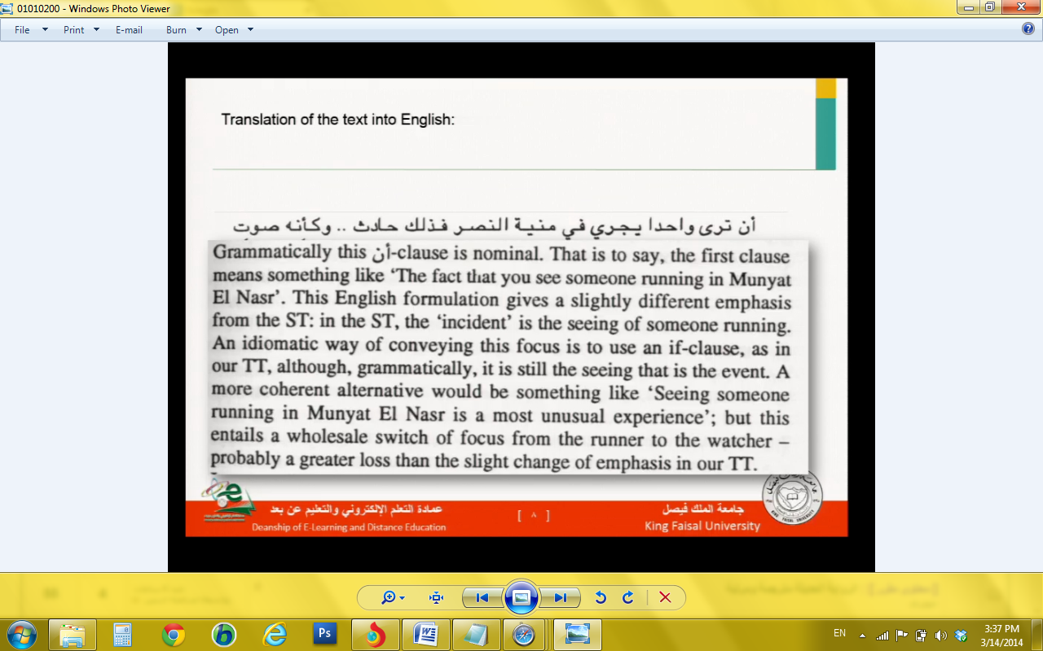
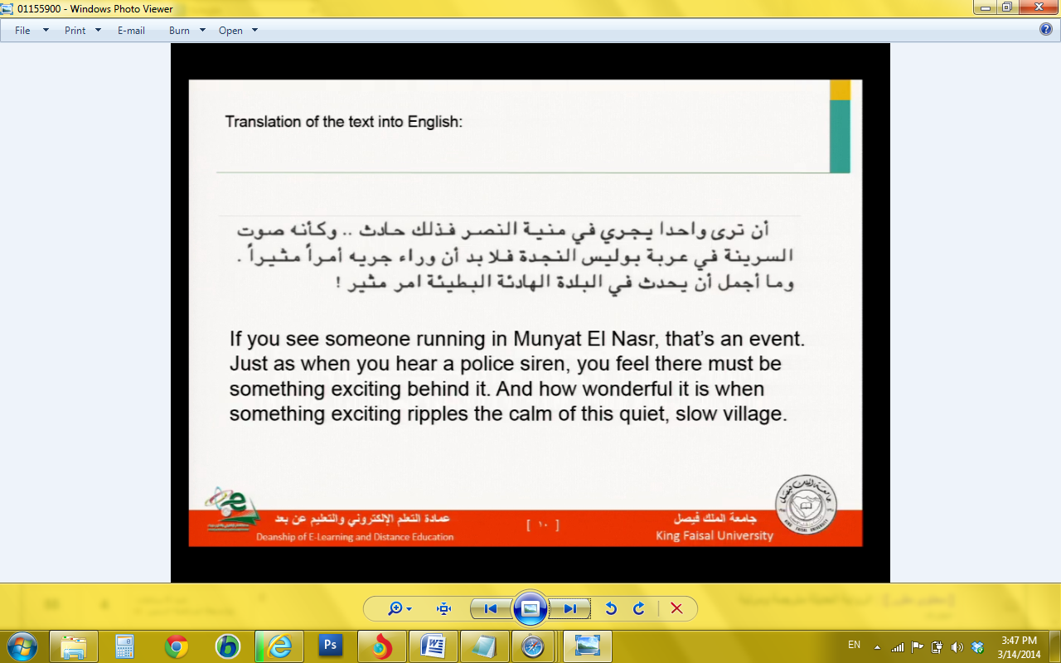
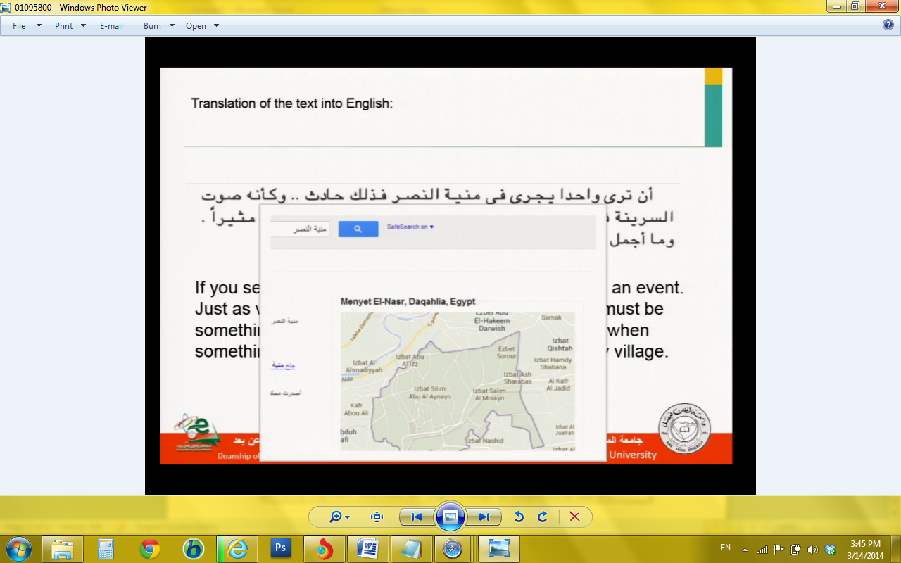

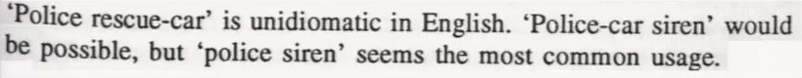

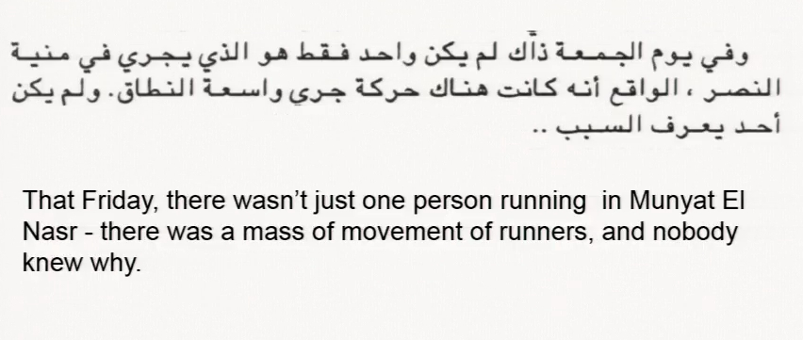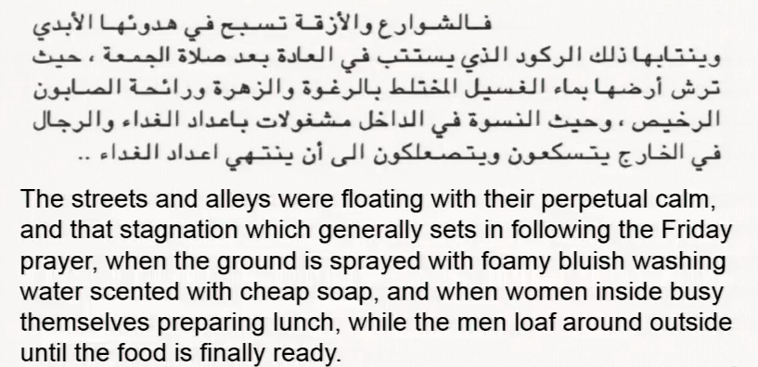
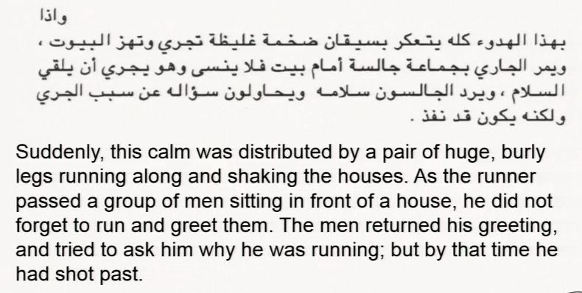
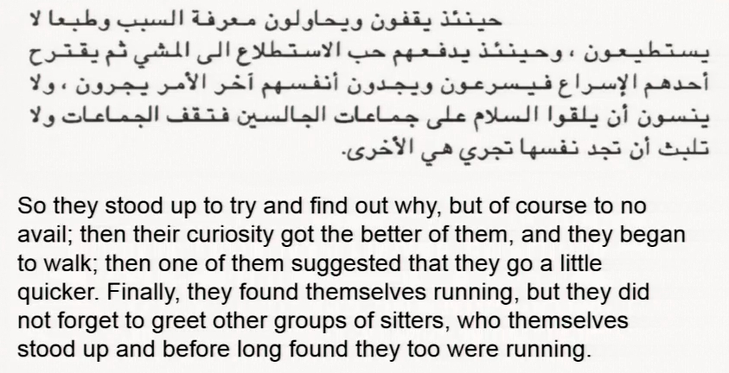
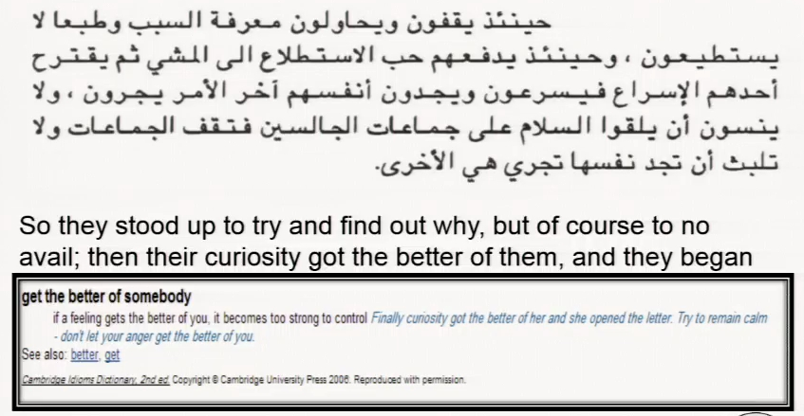

Lecture 8
Practical Translation 2
Practical 2
In light of the theoretical background outlined before, discuss the strategic decisions that you have to take before starting detailed translation of the following text then translate it into English. The translation will be presented to educated people
Small Change
HOPES deferred rather than hopes dashed: that sums up the reaction of the transport lobby to the £1.8 billion in additional funding over the next three years that was announced this week. Representing a 25% increase in comparison with a 25% cut in the last parliament under the Tories, it represents a clear shift in priorities. But given the problems noted by the chancellor in Britain's “overcrowded, under-financed, under-planned and under-maintained transport system”, the additional spending is relatively small. Public transport does not come cheap—a single light rail scheme can easily swallow up several hundred million pounds.
The public spending statement, so far as transport was concerned, was a case of a dog that didn't bark. Before the chancellor got up, officials in the transport department had been told by Treasury colleagues that he would announce that in future local authorities would be allowed to spend revenues raised by urban congestion charges and taxes on non-residential parking. The odd silence on this point has led to speculation about last minute Downing Street intervention. But sources close to the deputy prime minister, John Prescott, insist that an announcement on road charges and parking taxes is imminent. The formal retreat from the Treasury's long-sustained opposition to earmarking tax revenue is now expected in the transport white paper to be published on July 20th.
The concession is an important breakthrough, for which local authorities have long campaigned. London First, a business pressure group, estimated in a study, published last month, that a non-residential parking tax levied at an average of £750 per parking space in central and outer London could raise £300m per year, enough, for example, to bridge the investment backlog of London's Underground.
Nothing, however, will happen quickly. When the transport minister, Gavin Strang, said recently that “high earning car owners need have no fear from next month's white paper”, he was off-message but almost certainly correct. Both road pricing and non-residential parking taxes require primary legislation. But a major transport bill appears to have been ruled out for the next session of Parliament. All that is now being promised is a bill setting up a new Rail Authority. Even this will take at least 18 months before it is established. And even when it is, there are questions whether it will have the powers and funding necessary to have much influence on the poor performance of many of the train operating companies.
The central thrust of the transport white paper will stress the need for regional initiatives to solve Britain's transport problems. Part of the increased funding announced this week will be used to pay for 150 local plans aimed at restraining car traffic by making bus travel more attractive, and improving facilities for cyclists.
From The Economist Jul 16th 1998 | printed edition
Link to the article
http://www.economist.com/node/144363
- The target country assumed of this translation is Saudi Arabia. The currency used in Saudi Arabia is Saudi Riyal.
- This is a newspaper article which is, in terms of text typology, mainly informative and, to some extent, expressive.
When the writer talks about figures (£1.8 billion), rates (£750 per parking), percentages (25% cut) facts and names, he informs the reader with these facts.
(Informative)
- Through his commentary on these facts, the writer expresses his opinion e.g. “ public transport does not come cheap: a single light rail scheme can easily swallow up several hundred million pounds". " … a case of a dog that didn't park." and the title itself ( Small Change ).
- Assuming that this translation is going to be presented to (educated generalist), and because the text contains specific cultural expressions and words related to Britain, it’s essential to opt for exoticism with its maximum presence of translator.
Actually, the financial system expressions and words in Britain are different from those in Saudi Arabia. So some expressions will be replaced by the most suitable equivalents in the Saudi system.
Maximum presence of the translator is seen primarily in newspaper articles where additional information is systematically provided throughout the main body of the text.

- Through his commentary on these facts, the writer expresses his opinion e.g. “ public transport does not come cheap: a single light rail scheme can easily swallow up several hundred million pounds". " … a case of a dog that didn't park." and the title itself ( Small Change ).
- Assuming that this translation is going to be presented to (educated generalist), and because the text contains specific cultural expressions and words related to Britain, it’s essential to opt for exoticism with its maximum presence of translator.
Actually, the financial system expressions and words in Britain are different from those in Saudi Arabia. So some expressions will be replaced by the most suitable equivalents in the Saudi system.
- small change
- the problem ……………. wordplay
- parameters : functions of the ST and the TT
function of the pun
This word may have two meanings :the first one is ( the 25% increase which is a slight change ) meaning the amount of money ,1.8 billion, is relatively like a small change as far as the huge budget of the government is concerned while the second is (coins with low value).
- equivalence :تغيربسيط
- back translation: simple change
£ 1.8 billion + - £750 + several hundred million pounds + -£ 300m

- problem ………. currency
It's important to know how the amounts of money the text contains are going to be used.
- parameters : target country ( Saudi Arabia), exchange rate :
The exchange rate at that time , time reference : 18 July 1998
and typographical conventions.
- procedure: cultural substitution
several hundred million pounds
The word ( several) in" several million hundred pounds" will simply be omitted because in Arabic hundred cannot be qualified with words like many or several. It is translated as مئات الملايين back translation: hundred millions of Riyals.
- equivalence : ٨, ١ مليار جنيه إسترليني ( ما يعادلها في ذلك الوقت من الريال السعودي)
- back translation: 1.8 billion sterling pound()
-£ 300m : In Arabic, the numbers are transcribed in letters and the abbreviation "m" is replaced by the word million.
- equivalence: ثلاثمائة مليون جنيه إسترليني(ما يعادلها في ذلك الوقت من الريال السعودي)
- back translation: 300 million sterling pounds
- £750
- equivalence:
جنية إسترليني (ما يعادلها في ذلك الوقت من الريال السعودي)750
- back translation: 750 sterling pound
- the chancellor + treasury
- problem …………….. cultural reference
- parameters : text functions, cultural coherence, and readership's knowledge of source culture
- procedure: The two terms mentioned above have specific connotations in the British financial system which appears to be sophisticated when compared to the Saudi system which refers only to the minister and ministry of finance. Both of the terms will be substituted to compensate the loss.
- equivalence : 1. chancellor وزير المالية
2. Treasury وزارة المالية
- back translation: 1. Minister of Finance
2. Ministry of Finance

- Britain's " overcrowded, under-financed, under-planned and under
maintained transport system"
- problem : ( grammatical equivalence ) This relates to morphological and syntactic difference between English and Arabic.
- parameters : Compound words are translated into Arabic as an adjective and a noun. The rules of combination and word order of the target language should be taken into consideration.
- procedure: substitution
- equivalence نظام النقل البريطاني شديد الازدحام وقليل التمويل والتخطيط و الصيانة
- back translation: the British transport system which is overcrowded and lacks for finance, planning and maintenance.
- urban congestion charges and taxes on non residential parking +
- road charges and parking taxes
- problem : (cultural reference )This system is not used in Saudi Arabia because parking is free depending on the fact that there is no congestion made by traffic which may lead to a legislation with regard to this issue.
- The parameters I used are: functions of the ST and the TT, readership's knowledge of the source culture.
- procedure: The concept itself does not exist . The aim here is to render the meaning not the concept. Literal translation and definition are used.
- equivalence: رسوم الاختناقات المرورية و الضرائب المفروضة على الزوار لاستخدام المواقف غير السكنية للسيارات .
- back translation: fees imposed at the time of traffic junk and taxes imposed on
visitors for using non residential parks.
The equivalent of " road charges and parking taxes" is رسوم استخدام الطرق و المواقف
back-translated as : fees for using roads and parking
- Downing Street
- problem : ( cultural reference ) This is a name of a place which is related to the British government headquarter.
- parameters: cultural coherence, and readership's knowledge of source culture.
- procedure: This word is to be rendered by definition.
- equivalence مقر الحكومة البريطانية
- back translation: the British Government headquarters
To be continued next lecture

