- Language acquisition is the process by which humans acquire the capacity to
Perceive and comprehend language.
- The psycholinguistic study of morphological processing: seeks to understand how morphological principles play a role in the representation of words in the mind
- Transfer non native like production by second language learners can be result of rules from the first language being incorporated into the second language .
- Psycholinguistics studies how language is represented and processed in the mind
- observable behavior is what some people call slips of the tongue or speech errors
- Mental Lexicon is organized a little bit different of the dictionary because :
- It can accommodate new words
- It can be accessed very quickly
- Tip-of-the-tongue phenomena this is the situation where you are unable to access a word (or remember a word)in your mental lexicon and all you needed was the:
meaning of the word - the sound of the word - the first letter or what the word rhymes with
- A technical term The technical term for the items in the lexicon is entries instead of words

- Big problem
((The mental lexicon cannot be observed !))
- Lexical Decision Experiment
- Lexical Decision is a method used to understand how words are represented in the mind
A lexical decision experiment is conducted by asking a native speaker to sit in front of a computer screen where he/she is asked to judge as quickly as possible if the word that appears on the screen is a real word. If the word is real the participant clicks “yes”; if not, the participant clicks “no”. in this task we are looking for

- Response latency is the time it takes for the a participant to respond “yes/no”.

- Response accuracy is whether or not the participant responded accurately

((This test measures the speed and accuracy in which the mental lexicon is accessed.))

((½ a second for frequently word ….. ¾ second for less common words.))

( This is commonly known as the frequency effect)
mental lexicons are probably organized in a way that words we use often are more easy to access.

- Priming Experiment can be considered as an extension of lexical decision task.
in this task before the participant is asked to choose “yes” or “no” the target word is preceded by another stimulus (called the prime). What is measured is the extent the prime influences the participant’s lexical decision on the target stimuli.
- Parsing is the unconscious ability to understood the meaning of the words and analysis its structures .
- Timed-Reading Experiments

- bar-pressing test
In this test the participant is asked to sit in front of a computer screen and read a sentence one word at a time. The participant presses a bar on the keyboard to read the next word till he/she reaches the end of the sentence
- We can learn about the amount of time required to process certain words
- How long participants pauseوقفة at the end of clauseجملة boundariesحدود

- Eye Movement
Tracking eye movement on words during reading revealed that eye fixation time is usually longer for less frequent words and that the points of fixation are usually content words rather than function words.
- Research has shown that the more difficult the sentence is in structure the more regressive
saccades there are in addition to longer fixation times.

- Event-Related Potentials (ERPs)
ERP experiments measure electrical activity in the brain. That is voltage fluctuations resulting from the brain’s electrical activity.
(Those things they put on a person’s head are called “electrods”)

- “bottom-up processing”
a phonetic analysis is used to isolate phonemes and word boundaries and relate these items in the mental lexicon.
- “top-down processing”
the information you know about the words and what to expect from one another (e.g. The dog bit the cat)
- Phonemes
- cohort model a word’s cohort consists of all the lexical items that share an initial sequence of phonemes.
((the phoneme is the fundamental unit of auditory word recognition))
- Language is Species Specific language is likely to be part of the genetic makeup of members of the species
- Universal Grammar languages of the world are similar because all humans have the same language capacities.
- The critical period an age restriction on acquiring a first language.
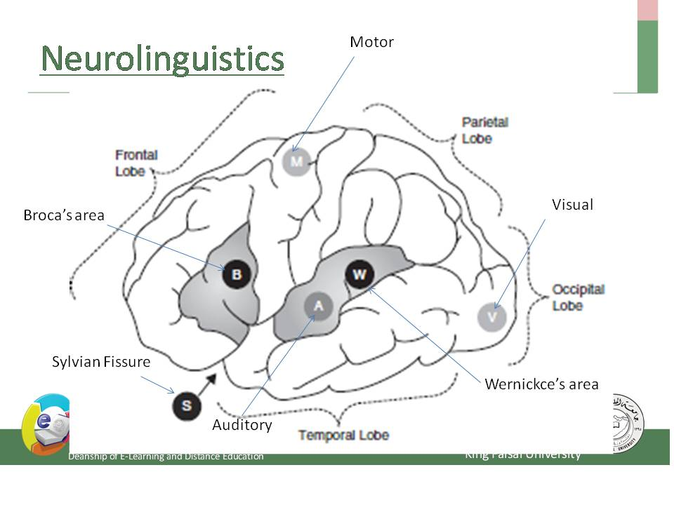
- Neurolinguistics is the study of the representation of the language in the brain
- Aphasia is a language impairment linked to brain injury.
- Broca's aphasia is also known as non-fluent aphasia
- halting , effortful speech because of damage in the frontal lobe of the left hemisphere
- Wernicke's aphasia is also known as fluent aphasia
- fluent meaningless strings because of damage in the temporal lobe of the left hemisphere.
- Lateralized language function is located in one of the two hemispheres.
- contralateral the left hemisphere controls the right side of the body and the right hemisphere controls the left side of the body.
- Wada test one common procedure for determining the hemispheric location of language functions in preoperative patients.(Sodium amytol is injected into one of the two hemispheres of patient’s brain)
- The dichotic listening Experiment
In this experiment the participant is given two different inputs to each ear at the same time.
Usually the participant reports what he/she heard in the right ear.
This is called the right-ear advantage for language
- interlocutor is Participate in conversation
- preverbal message the speaker’s intention to communicate an idea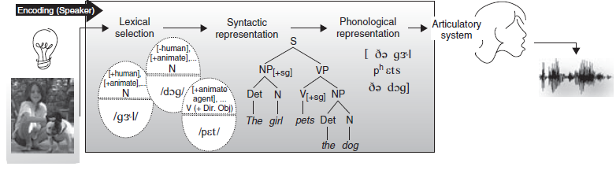
- When a bilingual is speaking in a unilingual mode (only one language), only one of the grammars is consulted to build structural representations, and the active language’s lexical entries are activated.
- When in a bilingual mode (when the bilingual’s two languages are being used in the same conversation), access to both grammars and lexical items from both languages must be possible.
- Code-switching is switching between two codes (two languages, or two distinct dialects of the same language) within the same discourse.
- Intersentential code-switching a switch can also occur within the same sentence.
- Tag-switching the insertion of frequently used discourse markers, like so, you know, I mean, etc
- Barrowing a word from one language is incorporatedإدراج into the lexicon of another language.

((Remember that speech begins with an idea in the speaker’s brain.))
- Lexical Retrieval
((Remember that the lexicon is a dictionary of all the words a speaker knows))
((A word can be retrieved using two different kinds of information: meaning or sound))
- The word must also be of the appropriate grammatical class (noun, verb, etc.) and must be compatible with the structure that is being constructed.
- the words and the structure are so closely related that the two processes take place practically simultaneously
- This means that a speaker must enter the lexicon via information about meaning, grammatical class, and structure, only later to retrieve the phonological form of the required word.
((The hearer’s task, is the mirror image of the speaker’s.))
- Tip-of-the-tongue phenomenon
the speaker knows the word but cannot retrieve it
((Usually lexical retrieval produces an appropriate set of words required for the speaker’s sentence ))
- Grammatical Encoding the creation of sentence structure during sentence planning
- Word exchange errors the exchange between two words.
- Word exchange errors never occur between content words and function words and are usually limited to words of the same grammatical class
- Creating agreement relations

(another class of errors is subject–verb agreement)
Example:
a. The bridge closes at seven.
b. The bridges close at seven.
- Plural attraction When a plural feature intervenesيتدخل between a singular subject and its verb error can occur.
Example:
a. The time for fun and games are over.
b. The illiteracy level of our children are appalling.
- Preservation error segment perseveres and intrudes in a later word
A. Said: "I can't cook worth a cam".
B.يقصد Intended: "I can't cook worth a damn".
- Anticipation errorتحسباً للخطأ توقع حدس
a speech sound that has not yet been produced intrudes in an earlier word.
A. Said: "taddle tennis".
B. Intended: "paddle tennis".
- Segment exchange error the exchange is between two phonological elements: the final consonants in the two words.
A. Said: "hass or grash".
B. Intended: "hash or grass".
- Phoneme Restoration book Page 180
The Hearer
- post-access matching
After a word has been retrieved, its full phonological representation is checked against what has been heard.
- Orthography is the study of writing systems
- Impossible non-words, like TLAT, ZNER, and MROCK, are rejected very rapidly in a lexical decision task.
- possible non-words, like SKERN, PLIM, and FLOOP, take longer to reject
- A word's neighborhood
A factor that affects retrieval times for words is neighborhood density . A word's neighborhood consists of all the lexical items that are phonologically similar.
Example
the word cot has many words that are phonologically similar to it, so it is said to come from a dense neighborhood; in contrast, the neighborhood for a word like crib is less dense.
- Recognition point of the word book page 195
- The brain’s response to word category errors, that is when the category of a new word does not fit into the current structure being built by parser . The brain responds slightly differently to morphosyntactic violation.
- Positive Evidence is to provide information about the language the child is acquiring
- Lexical ambiguity

- E.G. for A Garden path sentence is ((the horse raced past the barn fell))
The structure in above e.g. includes a reduced relative clause for Example : Danielle emailed me a photograph of the Corvette raced at the Daytona Speedway.
- Other example for garden path:
((the two masked men drew their gun and approached the bank, but the boat was already moving down the river))

The language gene
The search for a genetic basis for language
- Researchers began genetic investigations by conducting pedigree studies.
- pedigree studies These are studies that examine the heritability of a particular trait (or disorder) in several generations of a family.
- FOXP2 specific gene that was implicated in the language disorders of an extended family
- The FOXP2 gene is associated with the development of other parts of human anatomy unrelated to language, including the lung, the gut, and the heart. It is also a gene that is not confined to Homo sapiens; it is also found in other mammals, including mice (Marcus and Fisher 2003).

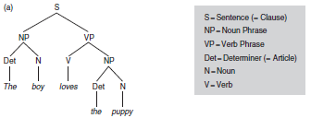
- postlexicon decomposition: Both the whole-word form and its constituent morpheme are automatically activated
- prelexicon decomposition : Morphological decomposition occurs first and whole-word access occurs second
