Lecture 7
The Acquisition of Language (1)

Contents:

- Language Acquisition Device (LAD)
- Early Stages of Language Acquisition:
    - Before birth to 12 months
    - 12 months to 24 months
    - The pre-school years

Language Acquisition Device (LAD):

LAD can be defined as: a property of the child’s brain that gives it a tendency for acquiring language

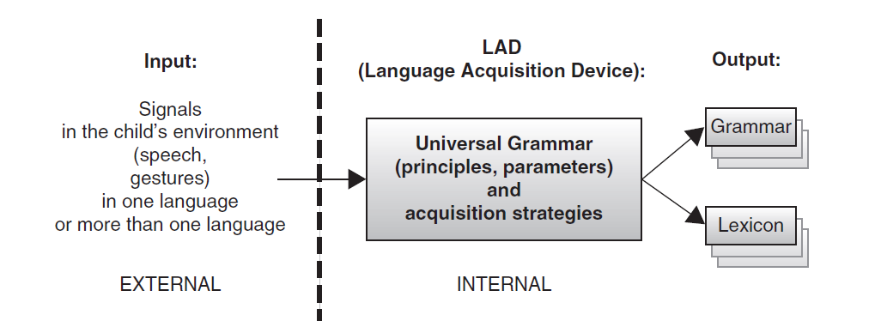

Early Stages of Language Acquisition:

- Before birth to 12 months:
Before birth:
- Hearing begins to develop at around 18 weeks
- Soon after the development of hearing, the fetus starts to respond to auditory stimulation.
- Hence, it can be argued that humans’ sensitivity to language start even before birth
From birth to 12 months:
- Infants have had access to the general prosody (the rhythm and intonation) before they were born
- Thus, they are able to recognize their mother’s voice
- Most children start to discriminate many phonemic contrasts at this stage
- - Newly-born infants have had access to the general prosody (the rhythm and intonation) before they were born
- Thus, they are able to recognize their mother’s voice
- Most children start to discriminate many phonemic contrasts in this period (before they are 12 months old)
- Babbling: Infants start to babble (i.e. produce consonant-vowel strings) after the 6th month.

- From 12 months to 24 months:
- Children spend a few months in the holophrastic stage (one-word stage). One word, such as milk, can be used to convey the meaning of an entire phrase.

- Pre-school years:
Vocabulary spurt: Soon after the child leaves the holophrastic stage, vocabulary acquisition speeds up rapidly.
In average, the child acquires from 4 to 8 new words everyday in his/her pre-school years.

Exercise

- The holophrastic stage is:
- Before birth
- Between birth and 12 months
- Between 12 months and 24 months
- After 24 months

The answer is C

