Check the comments
Send it as final draft before 18.12.2014



Graduation Project

Student Name: | Nonee
Student ID: | 2125xxxxx
Supervisor: | Dr. Ghassan Adnan

Title:
The impact of educational technology and YouTube channels on children's English language acquisition
I certify that all the articles in this special search of my effort, but does not have any work prior to this work, but I quoted some words of scientists.
Signature ( Nonee )

Table of Contents:
Page Number | Section
3 | Abstract
3 | Introduction
3 | Literature review
4 | Significance of Research
4 | Research Question
4-5 | Research Methodology
5 | Ethical Considerations
5 | Limitations of the study
5-6 | Expected results
6 | References
7 | Appendix

Abstract:
To know the impact of YouTube channels in English language acquisition in children, and whether that impact, positive or negative, and a direct encounter with one of the children speaking fluent English.

Introduction:
YouTube is one of the media, and communication task in these days, which has a positive effect and negative impact on the children in the acquisition of the English language, and we care about in this field of research on the impact of YouTube on the active and mastery of this language. Where there is a famous saying about the wrong Humanity is acquiring all the wrong reasons ~ R. Buckminster Fuller.

Literature review:
We are in speed, time which abounded by varied uses. Among these applications, we find YouTube tutorials abound. Unfortunately, this technique is used wrongly on other hand, there are several scientists wrote about the technique, such as the ~ R. Buckminster Fuller.

"Humanity is acquiring all the right technology for all the wrong reasons." (Buckminster Fuller, n.d.)

Just like YouTube allows people to open video channels on other subjects, it also allows educationists to post their educational content on their YouTube channels. Several philanthropic teachers have started channels that will help in explaining, to your child, most of the things they learn in school. For starters, these videos are categorized into different age groups and grades depending on the level of education for your child. The content ranges from alphabets, nature, science and geometry. Since kids are thrilled by technology, they will find it fun learning from YouTube educational channels. (Shaw, 2013).

Where we note that in the recent period affected by the technical began on the humanity of human beings, where scientist says. ~ Albert Einstein.

"It has become appallingly obvious that our technology has exceeded our humanity". (Einstein, n.d.).

Be it school work or just any amazing educational video you want your child to learn, then YouTube provides a perfect opportunity for you and your child to learn new stuff. Not only is it informative to learn with YouTube, but it is also fun. You can watch music videos for your breaks and refresh your minds. While all the content is found here, you do not pay anything to access it-how cool can it get! But as you have fun; be careful not to get too addicted to the internet like most of us! (Shaw, 2013).

Significance of Research:
It is to know how to take advantage of technology on the right way for English Language Acquisition, which should be developed for a child, such as the girl Majd Asiri who will be in a live encounter to know how she acquired English skill.

Research Question:
What is the impact of YouTube channels active and passive in the English language acquisition in children?

Research Methodology:
Technology means vary as needed , but I can single out the computer programs where there are in YouTube lessons, phonetics and linguistics. There are also tales, poems and plays that help a child in mastering the language.

Some of the advantages:
Mastering speaking and listening skill, and the proficiency in dialogue. Although, loving the English language and enjoying it. After a period of time, a child becomes proficient in the English language.

We should not forget that the child will be self-taught in the acquisition of the English language. One of the advantages is helping the child to overcome any barrier in the English language acquisition. There are many advantages that cannot be accounted for.

Disadvantages:
Using some slurs because of some clips shown on YouTube channels. On other hand, not being able to write properly because YouTube channels do not teach the basics of proper writing.

Dear Majd Tell me about yourself and how was the English Language Acquisition since childhood and to this day.

At the beginning, my father was trying to teach me some words in English. However, he taught me simple sentences that can be used in the daily life. As a result, I started to love the language. In order to improve my language, I watched some teaching videos. After a period of time, I noticed that my language has become better, and I can speak English fluently. Actually, I decided to teach some students because of different reasons. First, I can keep practicing English. Then I will be happy when I help others.

Thank you dear. Bye

http://youtu.be/X9mqURyCOMw

We will meet the mothers of students of the first-grade primary school in one of the primary schools after the approval of the school.

First, we will give them short lecture, talking about the proliferation of technology in our daily lives and singled out YouTube and provoked negative and positive that can be spread among children in the acquisition of the English language. Then we are distributing a questionnaire to moms and give them 15 minutes to answer it. At the same time, we are giving others mothers of whatsapp group a similar questionnaire.

We are communicating them and explaining YouTube and its impact on their children's English language.

Ethical considerations:
This research speaks about the impact of technology and YouTube in English language acquisition in children and explains the pros and cons of this type of education and research will be a study on children from age 4 to 12 in Saudi Arabia may be applied to this study to other countries, the result is different.

And has been approved by the observance of this school, which retains the name of a secret and has the approval of the mothers in the answer to the questionnaire and to keep their name's secret.

Limitation of the Research:
I have studied with some of the moms on the extent of their conviction about the use of YouTube to make their children and mastering the English language and fluent speaking skills.

Expected results:
I expect that about 90% of moms agree that their children use modern technology and educational YouTube channels to acquire the English language They find that it is useful and has a positive impact. But when we distributed an electronic questionnaire, we find this result, 58% believe that modern technology is good, 36% find it helpful and 6% deem injurious. However, there were 26% agreed to learn the English language through YouTube, 66% agreed with that. On the other hand, there were 6% reject this type of education. There were 84% believe that this type of education affects positively on their children, while 12% believe it affects negatively.

Moreover, after we have an inventory of mothers of students in the elementary school questionnaire turned out that 33% believe that modern technology good while 60% found it helpful and 7% deem injurious. In fact, there were 7% approve of the acquisition of the English language through educational channel's YouTube while 87% disagree, but limit 6% reject this type of education.

In addition, 93% believe that this type of education affects positively on their children, while 7% believe it affects negatively. Finally, we went back to Twitter and Alhastag in the proportion of 95% agrees with English language teaching via YouTube while 5% rejects it.
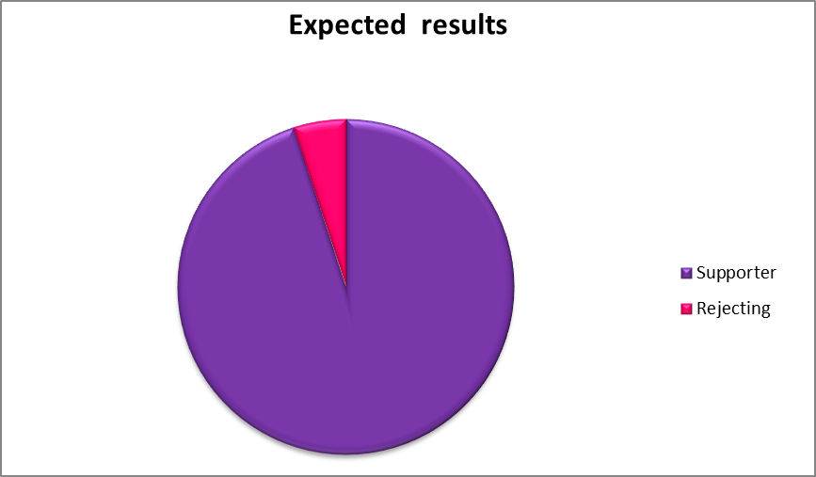

References:
Buckminster Fuller, R. (n.d.). Humanity is acquiring all the right technology for all the wrong reasons.. [online] Old.studyworld.com. Available at: http://old.studyworld.com/quotes/humanity-acquiring-all-right-technology-all-wrong-reasons [Accessed 31 Oct. 2014].

Einstein, A. (n.d.). Albert Einstein Quotes at BrainyQuote.com. [online] Brainy Quote. Available at: http://www.brainyquote.com/quotes/quotes/a/alberteins161262.html [Accessed 3 Nov. 2014].

Shaw, C. (2013). . How to Use YouTube to Benefit your Child's Education | theonehandman - Adoption Blog. [online] Theonehandman.co.uk. Available at: http://www.theonehandman.co.uk/parenting/how-to-use-youtube-to-benefit-your-childs-education/ [Accessed 3 Nov. 2014].

Shaw, C. (2013). How to Use YouTube to Benefit your Child's Education | theonehandman - Adoption Blog. [online] Theonehandman.co.uk. Available at: http://www.theonehandman.co.uk/parenting/how-to-use-youtube-to-benefit-your-childs-education/ [Accessed 3 Nov. 2014].

Appendix:
What do you think of modern technology?
#Good
#Injurious
#Useful
Do you agree that your children use the technology?
#Yes
#No
Do you find that YouTube may help your children to acquire English?
#Yes
#No
#Maybe
Do you support your children to learn the English language through YouTube?
#OK
#Dismissive
#OK, but limits
Do you find that this type of education may affect your child?
#Yes
#No
What kind of impact?
#Positive
#Negative

